What is Apache Kafka?

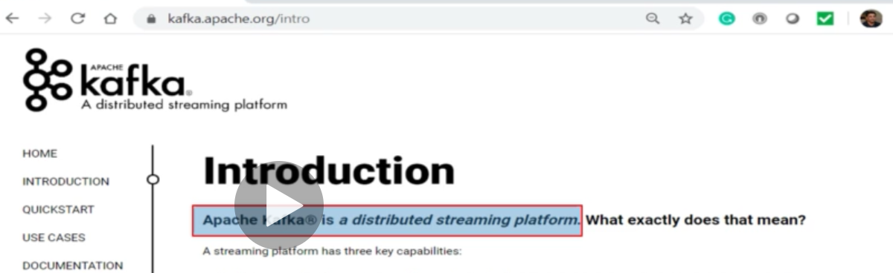

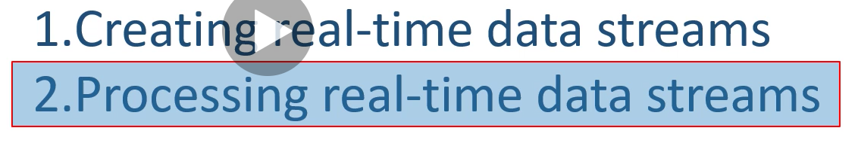

1. **So Kafka is a distributed streaming platform which creates and process real-time data streams.**

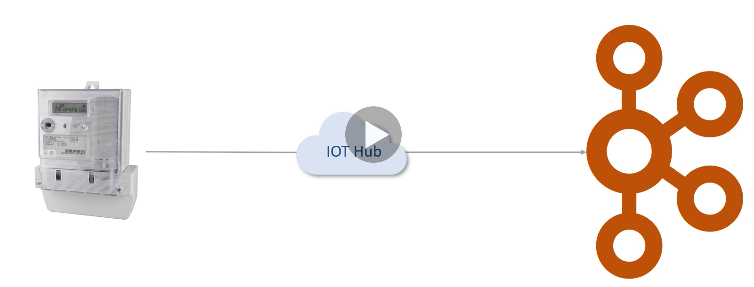

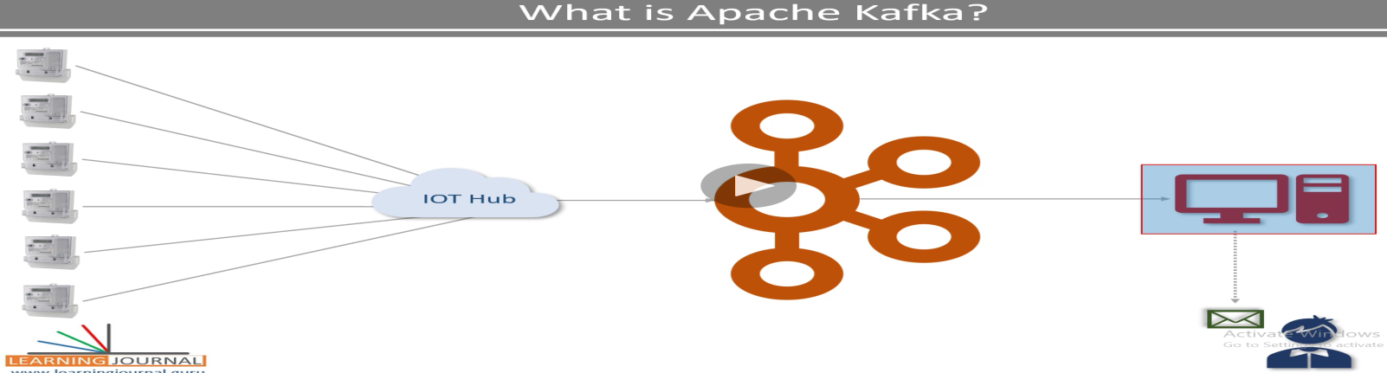

**For example:** Multiple electric meter of the Area sending-> readings to apache Kafka.

We have created an application which reads the real time data from the Kafka and process it according to need- like if load reaches to 2 KVA then it will send an alert message to consumer immediately within a second or minute.

So continuously data should come to Kafka and as soon as data arrives at Kafka it must be start reading and processing to send the real time reading to the consumer. So finally

**So Kafka is a highly scalable and distributed streaming platform which creates and process real-time data streams.**

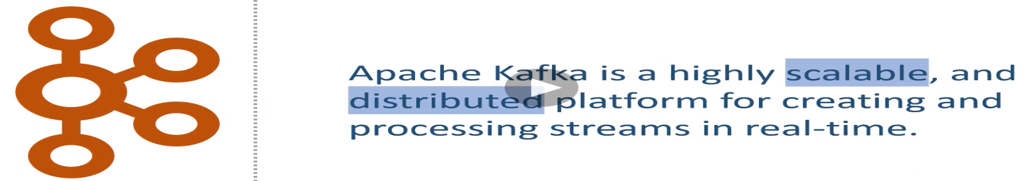

It is highly scalable and distributed platform for creating and processing streams in real time.

**Next**: How the Kafka works?



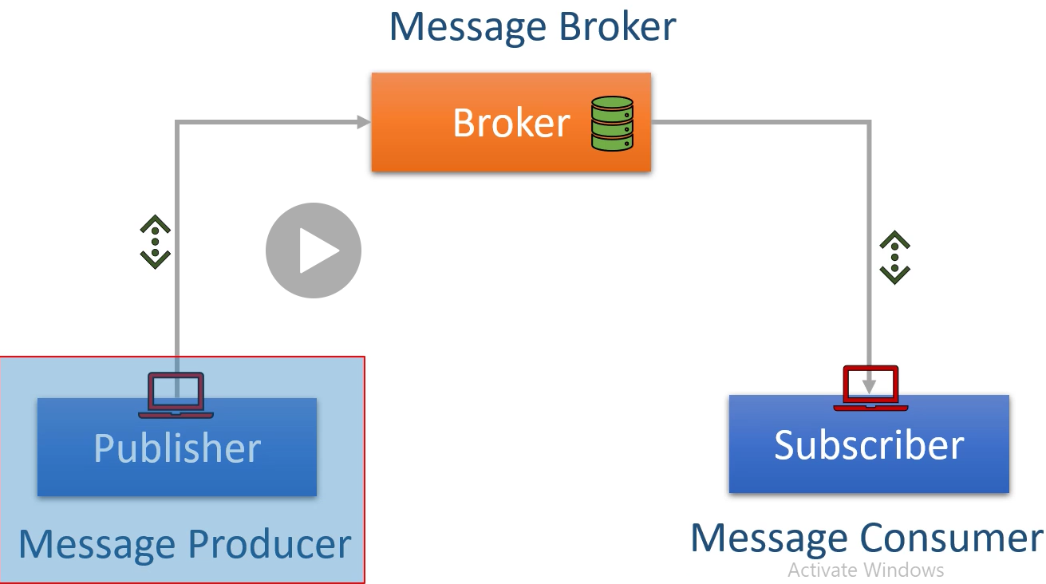

A typical messaging system we have three systems or component:

1. **Producer or Publisher:** Client Application that sends data records. These data records are called messages.
2. **Message Broker:** Responsible for receiving the messages from the producer and storing them into local discs. Broker locates at centre and acts as middle man between producer and consumer.
3. **Consumer or subscriber:** This also a client application which read the messages from the broker and processes them.

**So finally Kafka works as Pub-Sub** **messaging system** where we create producer applications to send data as streams, we install and configure Kafka server to act as a message broker and finally we create consumer application to read and process the data or messages in real time.

Next: Where does it come from?



* Kafka initially conceptualises and developed by LinkedIn and later it became open sourced in 2011.
* Initially Kafka was designed to handle data integration problems as shown in below diagram.

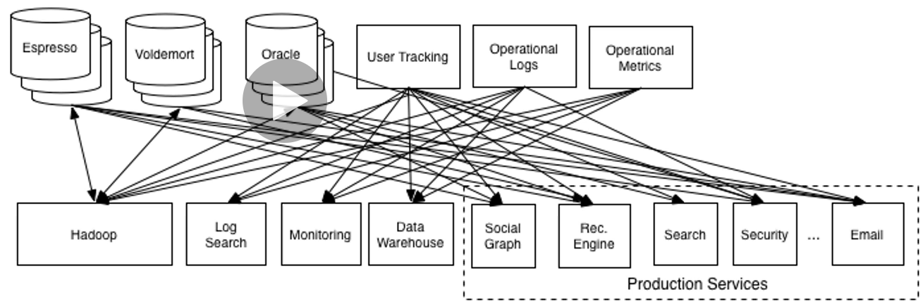

* In this diagram all these boxes are different application backend. They all generate and store some data and data generated by one application is needed by another application.
* So here we have the requirement to generate the data in one application and to send on another application.
* All the arrows show the movement link among the source and destination application.
* In a growing organization the number of source and destination application keeps growing. And finally we will end up the situation like shown below diagram.

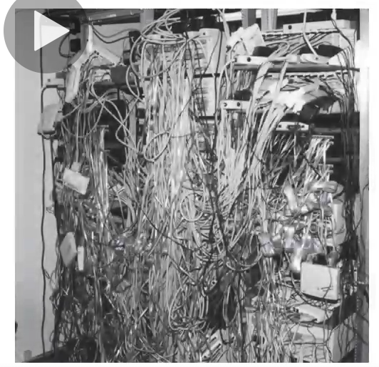

* Some part of the pipe lines keep breaking every day and after some time it will be very difficult to maintain.
* LinkedIn tried to **solve this problem using pub-sub messaging architecture** and then the result looked like as given in the below image.

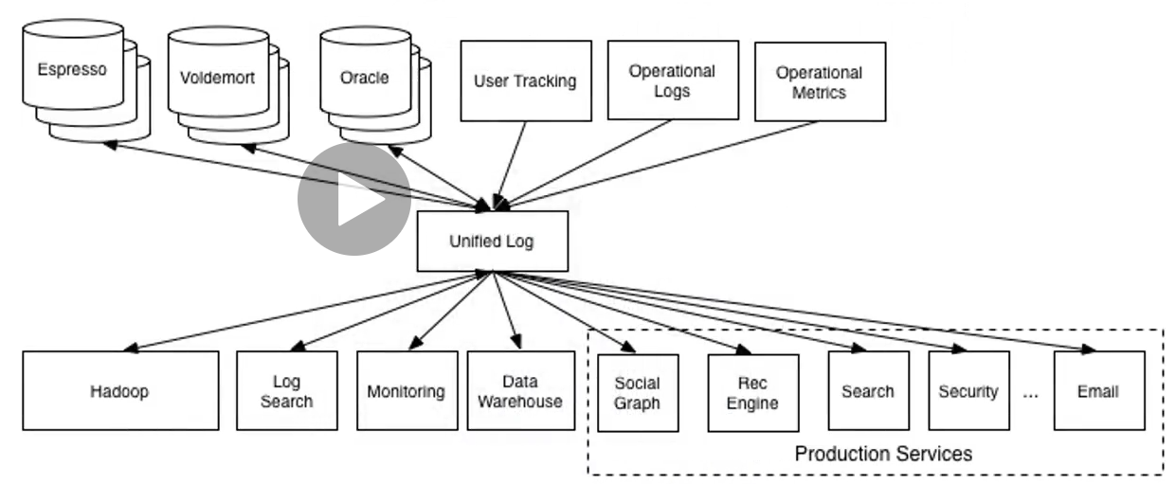

Here they placed the broker (Unified log) in the middle and other applications start working as producer & consumer.

This architecture offered a bunch of advantages and simplified the problem.

Next: How the Kafka got evolved from data integration to data streaming form?



**Kafka initially stared with two things.**

1. **Server Software** – Broker that we can install and configure to work as a message broker.
2. **Client API**- Java Library to create Producer and Consumer application.

But later Kafka become real time full fledges data streaming system. And then augmented (or increased) Kafka with **three more components**.

1. **Kafka Connect** : Still Open source component
2. **Kafka Streams**: Still Open source component
3. **KSQL:** Offered by confluent as a commercial tool with licence

So finally from 2011 to 2019 Kafka **evolved to five components.**

1. **Kafka Clients :** (Producer and Consumer) API Libraries
2. **Kafka Broker :** is central server system
3. **Kafka Connect:** Address the initial data integration problems for which Kafka was initially designed
4. **Kafka Streams:** other libraries for creating real time streams processing application.
5. **KSQL**: With KSQL Kafka is not aiming to become real time database and capture some market sharing databases.

**Finally Next: Where does it fit into an Enterprise Application Ecosystems?**



By Adopting Pub-Sub semantics Apache Kafka is becoming the circulatory system of your data ecosystem. In this case just like our body circulatory system carries bloods, in the same way Kafka brings data to various members of the infrastructure.

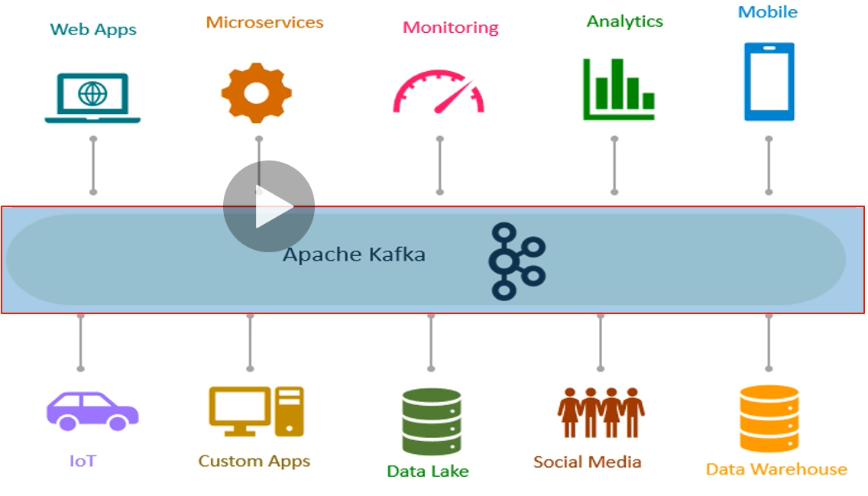

* Kafka is placed in the central location in our real time data integration infrastructure. The Data producers (top) can send data like messages to Kafka brokers as quickly as any business events occurs.
* Data consumer (down) can consume the messages from the Kafka brokers as soon as the data arrives at the brokers. With carefully designed the messages can send from producers to consumer in a millisecond.
* The producers and consumers are completely decoupled, they do not need to have direct or tight coupling between them. They always interact with Kafka brokers using an Interface.
* Producers do not need to be concerned about who is using the data and they just keep sending the data without worrying how many consumers would be reading it.
* Produces and Consumer can be added, removed and modified as per the business requirements.

Apache Kafka Core Concept:

As in the earlier, we have discussed about five core concept about Kafka

1. Kafka Broker
2. Kafka Clients API
3. Kafka Connects
4. Kafka Streams
5. KSQL

Now we will discuss about some fundamental core concept which are associated with Kafka

1. Producer
2. Consumer
3. Broker
4. Cluster
5. Topics
6. Partitions
7. Offset
8. Consumer Groups

**What is Producer:** It is an application that sends data (messages or message record). The message records can have different kind of schema, or structure for us, but **for Kafka these messages or records are nothing but an array of bytes**.

**For example** if we want to **send a file to Kafka**, we will create a producer application and send each line of the file as a message, in this case a message is a line of text but for Kafka it **is just an array of bytes**

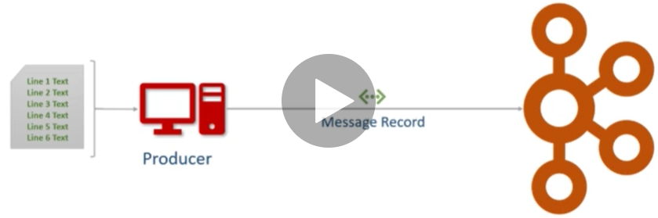

Similarly if we want **send all record from a database table then we will post each row as a message**.

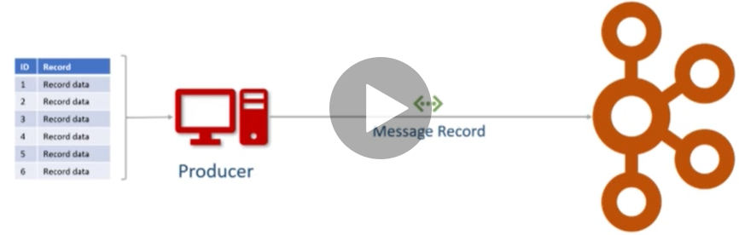

Similarly if we want to **send a result of a database query then we are going to create a producer application**, the producer is going to fire a query against our database, collect the result and start send each row as a message.

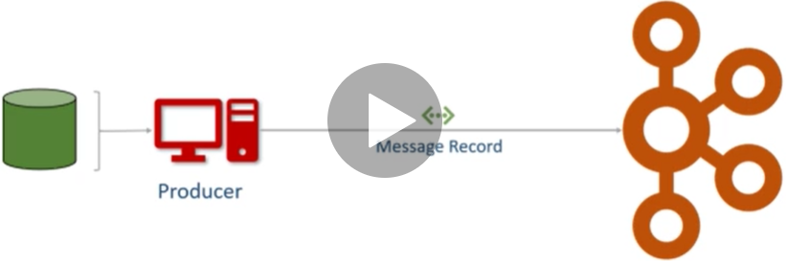

**So while working with Kafka if want to send some data then we always have to create producer application**

**What is Consumer:** **It is a recipient application that receives data**. But remember it does not receive data directly from the producer. Producer just sends the data to the Kafka server and a **producer** who is interested for these data can request the data from Kafka server and can read the data from the Kafka server if they have permission.

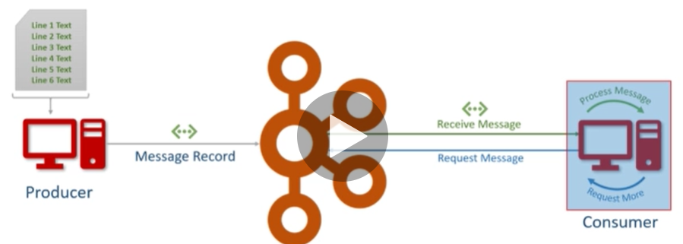

As here we can see that producer sends the message record to the Kafka server, Consumer on the other hand request for the message and receive the messages from the Kafka server and process the messages according to business requirements. And this loop keeps going until Kafka keep receiving messages from producers.

**What is Broker?**

* **The broker is the Kafka server**.
* It is just meaning full name that is just given to the Kafka server because it works as middle man like an agent between producer and consumer to exchange the messages
* Producer and consumer do not talk to each other directly

**What is Cluster?**

* **Cluster is a group of computers acting together as single unit for a common purpose**.
* Kafka is a distributed system and hence cluster means the same thing for Kafka.
* So Kafka cluster is group of computers and each running one instance of the Kafka broker.

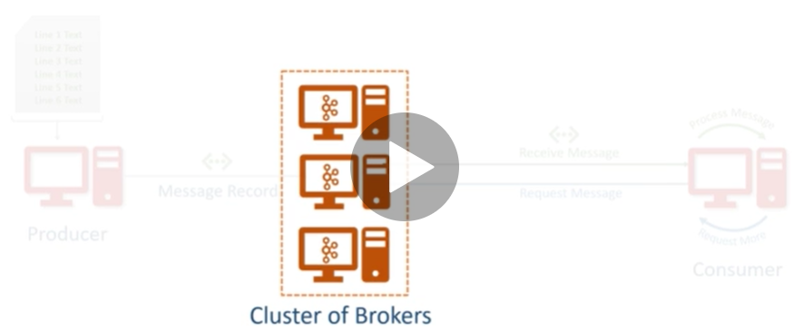

**What is Kafka Topic?**

We already learned that producer will be sending data to the broker and on the other side consumer will be asking for the data from the broker. But now the question is what data? Which Data?

The broker might say guys I am collecting data from multiple producers. Which one do you want?

Now the Consumer will say Ok give me the data sent by the smart meter producer.

|  |  |
| --- | --- |
| The broker might say guys I am collecting data from multiple producers. Which one do you want? | Now the Consumer will say Ok give me the data sent by the smart meter producer. |
| Now Kafka will say I have three different type of data messages   1. Current Load 2. Consumed Unit 3. Input current fluctuations | Now consumer will say OK:  Give me Current Load messages: |

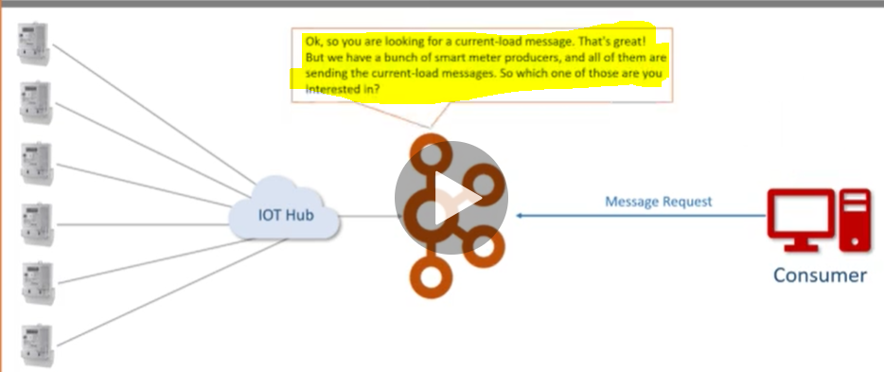

Now Kafka will say Ok: So you are looking for a current load messages. But we have a bunch of smart meter producers and all of them are sending the current-load-messages. So which one of those you are interested in?

Now hence we can see that there is lot of question and answer between Kafka server and consumer.

**To avoid this kind of confusing forth and back questioning Topic got introduced**.

So the **Topic is an arbitrary unique name give to a data set or data streams**.

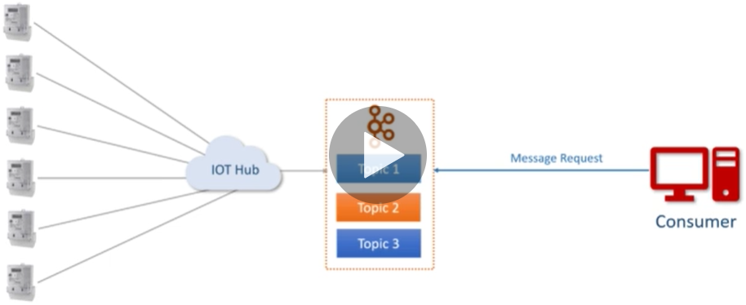

**It is very similar to DB table creating at the time application design, in the same way creating a Topic is design time decision**.

So when we are designing our application, we as an architect are responsible for creating one or more Topic.

**Once Topic is there the producers and Consumers are start sending and receiving the data by the Topic.**

Now let’s say we have created three topics related to Current Meter.

|  |  |
| --- | --- |
| Now when Current Meter producer start sending data they will send all the current load messages to the🡺 “Current Load” Topic.  Consumed Unit 🡺 Consumed Unit Topic  [Input Fluctuation messages🡺 Input Fluctuation Topic]  will be sending to their own topics respectively . | Topics: 🡺Current Load Topic, Consumed Unit Topic, Input Fluctuation Topic |

Now let’s see the communication between consumer and broker.

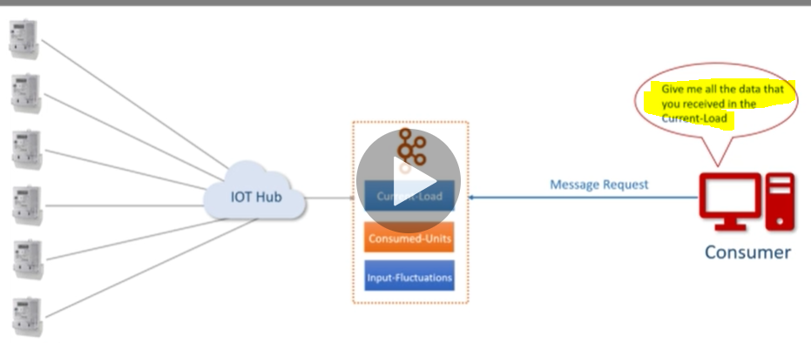

Give me all the data that you received in the **Current Load Topic** and now broker knows the topic and it won’t have any further question to consumer.

In the database we can think of the Kafka Topic as a Database tables. Producers can insert new records in the table and hence to the Topic. Consumer can read those records from the same table and hence from the same Topic. But remember all the communication happens via broker only.

**So if any if any producer wants to send data to Kafka server then it can send data to the particular topic only and in the same way if any consumer wants to consume data from the Kafka server then it must know the particular topic name to read the data.**

**What are the Topic Partitions?** By now we have learned that broker would store data in the Topic and Topics are just like a Database table. This data could be massive, and it may be larger than the storage capacity of a single computer. So now broker is going to face capacity challenge. One oblivious solution is to break the topic into multiple smaller parts and distribute it to the multiple computers in the Kafka cluster.

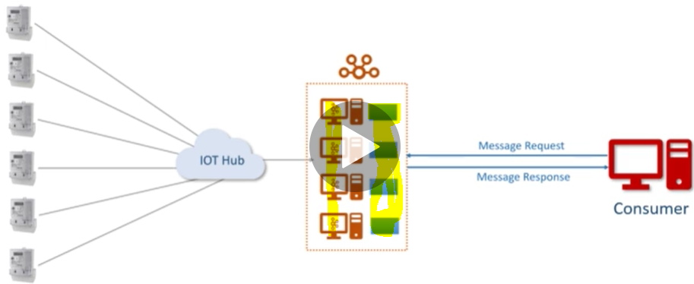As we have already learned that Kafka is a distributed system and it runs on cluster (group) of computers. So it is evident that the **Kafka can break the topic into smaller partitions and store those partitions on the different machines**. This approach will solve the storage capacity problem and that is what the Topic partition means.

**Now the question comes that how will Kafka decide the number of partition for a Topic?**

So the answer is it depends on the design architect who will decides the number of partition for a topic, Kafka does not take any decision for Topic partition automatically.

**When we create a topic then we need to decide number of partition that we need and the Kafka broker will produce it.**

So Partition is a small and independent portion of the Topic that will store independently on a single computer and we cannot break it again. So we have to be very careful during the partition.

**So the Topic is divided into several partitions at the time of topic creation just to solve the storage capacity problem.**

**What is partition Offset?**

**It is a unique sequence id or number of a message in the partition.**

The sequence Id is automatically assigned by the broker to every message record as it arrives in the partition and once it is assigned then these id is not going to change or modify i.e. they are immutable.

So when the first message arrives in the partition, it gets the number zero (0) the next one gets 1, 2 and so on.

This sequencing means that messages are stored into partition in the order of arrival and **offset id is nothing but the arrival order number of message in the partition**.

But remember these **offset are local within the partition**. There is no global ordering of messages in the topic across partition.

So if we have three partitions in the Topic then in each partition, offset is going to start from zero (0) only and increased by one.

**So if we want to locate a specific message then we must know three things.**

**Topic Name > Partition Number > offset Number**

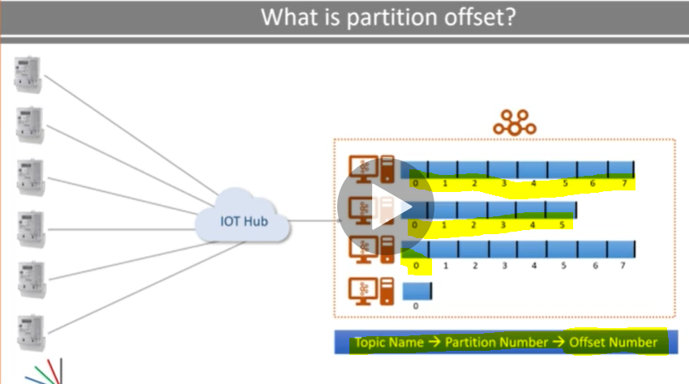

So if we have these three things the we can directly locate a message in the Kafka cluster.

**What is Consumer Group?** As we already learnt about the consumer, so now let’s talk about the consumer group. So as name suggest, it is the group of consumer. **Multiple consumers can form a group to share the work load**.

Let’s say we have big massive message, and we want to divide and share it among multiple people. So we will create a group and members of the same group are going to share the work and accomplish the bigger task together.

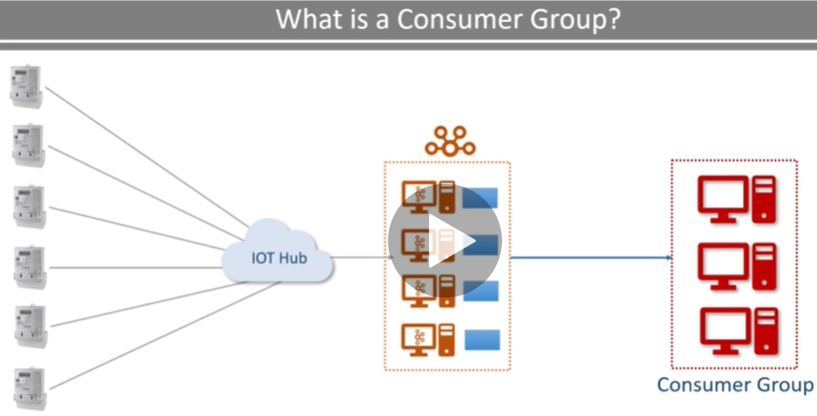

Let’s take an example from retail industry. In this example we will put everything all together.

Let’s assume we have a retail chain and on every retail store we have bunch of invoicing (billing) counter and we want to store all the invoices from every billing counter to a data centre.

Now since we know the Kafka so we will implement Kafka to solve this. We will create producer at every billing location. These producers are going to send invoices as a message to the Kafka topic. The next thing that we want to create a consumer. The consumer is going to read the data from the Kafka topic and write it to data centre.

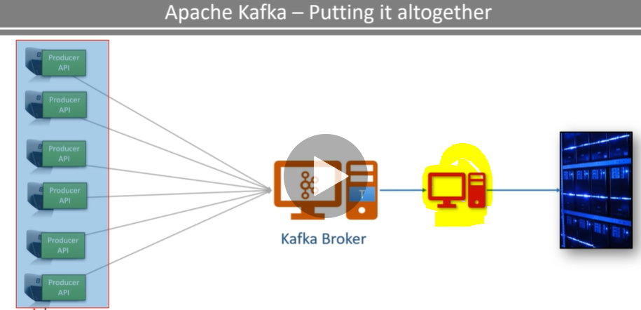

The idea looks very simple but it is not as simple when there is big scale, let’s say if we have 1000s of producers pushing data into a single topic then how do we handle the Volume and velocity at the broker.

So to solve this, we will divide the large Kafka topic into several small partitions. So now topic is partitioned and distributed in multiple clusters (computers). So now every broker has got a partition (particular cluster or computer) so now it can take the data from producer and store it in the partition. This is the solution from the producer and Kafka broker end we have created scalable and distributed platform as per the Kafka definition.

Now Producer can keep sending messages to Kafka topic partition and we can save large volume of data at the Kafka broker end.

But now to share this work load we will have to create a group of consumer in the same group and then will divide the work. But the question is how we will divide the work? Let’s say we have 500 topic partition and we are starting 100 consumers I a group. So according this, each consumer will take 5 partitions and all together they will process 500 partitions. We will monitor the load for some time and will see if a single consumer can handle 5 partitions if not we can start some consumers in the same group we can go up to 500 consumers so that each consumer can have one partition to read. So now we can understand that topic partition is nothing but a tool for scalability and maximum possible parallel consumer can be equal to the number of partitions in the topic.

Kafka does not allow more than one consumer to read and process data from the same partition simultaneously and this restriction is necessary to avoid the double reading of records.

**Section 1.3- Kafka Connect Core Concept**

In the earlier discussion we have talked about 5 core concept of Kafka ecosystem

1. Kafka Broker : Already done
2. Kafka Client API: Already Done
3. Kafka Connect
4. Kafka Streams
5. KSQL

Now here will discuss about Kafka Connect. Here we will learn about the following things.

1. What is Kafka Connects?
2. How Kafka connect works?
3. Kafka Connect Scalability
4. Kafka Connect Transformations
5. Kafka Connect Architecture.

We already learned earlier that Kafka was initially developed at LinkedIn to solve the data integration problem

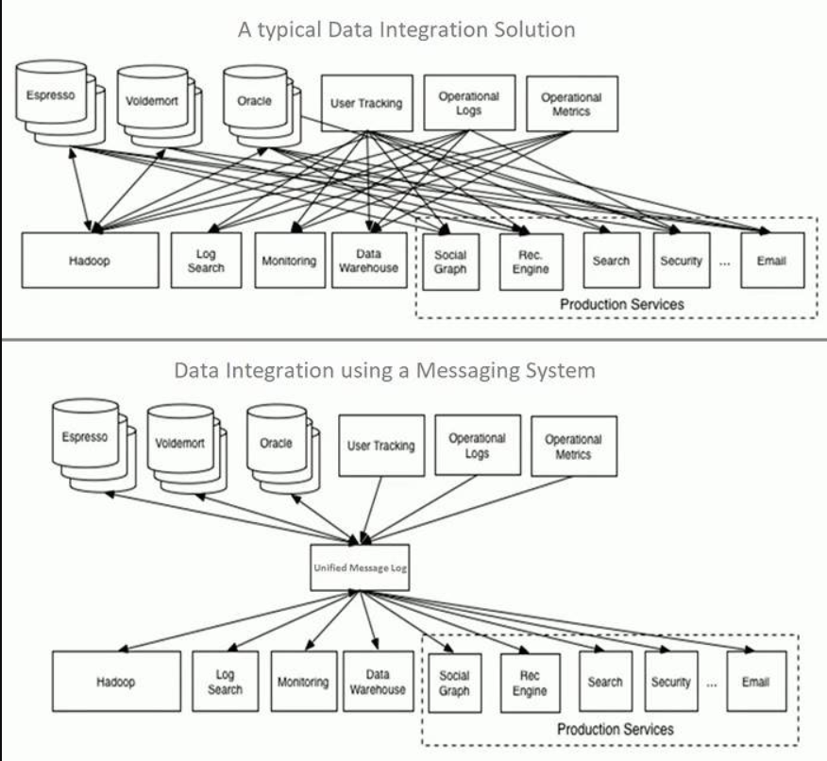

As we know that we cannot produce single standalone application that does everything in an enterprise, because practically it is impossible and not economical. So in a typical enterprise we may have a bunch of independent and running applications. Some of them are custom design and developed in house others may have been purchased from third party vendors. They all might me generating data and owning it also and some of the system need the data from other system as per the below diagram.

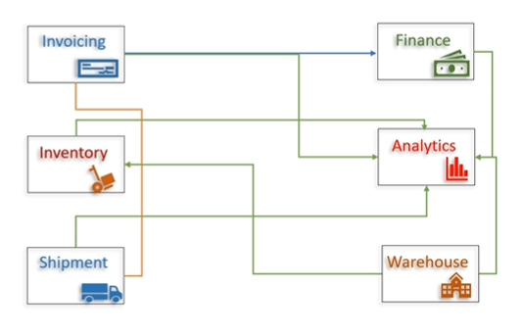

As here we can see that Finance System needs data from invoicing system, Analytics System needs data from all systems and so on…So data integration is most important and it is a common problem. Initially it looks simple to manage but over the time when some more system involves then it becomes messy and very much difficult to manage. LinkedIn created and use Kafka and use this to simplify these data pipelines. So the same solution we will also use here. As per the below diagram we have invoicing system which save the data into Invoicing data base. So now we will push the entire Invoice database into Kafka (or Kafka clusters) and whenever we need we will take it from Kafka clusters. And if other system also needs the same data then they can connect to the Kafka clusters and can take the data. Similarly other system also can send their data into Kafka cluster to be used by other system. Hence we can solve the data integration problem using Kafka. The first diagram shows the data integration using Kafka one to one connection while the second diagram shows the data integration without using Kafka which shows one to-many connection and difficult to maintain.

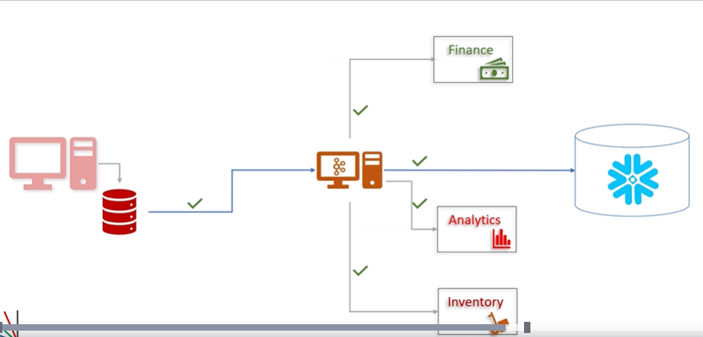

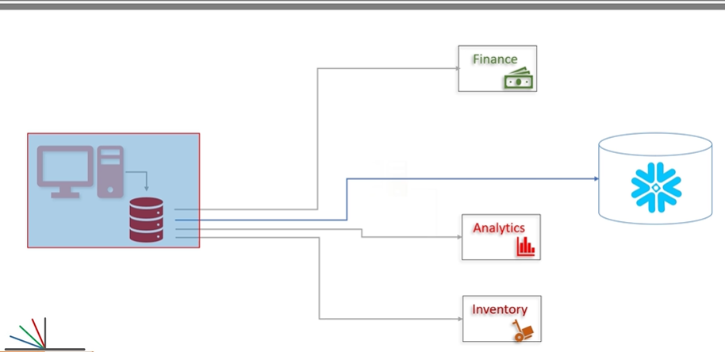

So now the question comes that how do we bring the data from the Invoice application to Kafka? So the answer is by using Kafka producer API. There are two ways to get the data from the Invoice application using Kafka producer API.

The first one is if we have the access to the Invoice Application source code then we will embed our producer API into Invoice application to send the Invoice data into the Kafka clusters. In this case Producer API will become the part of Invoice application.

The second one is if we don’t have the access to the Invoice application then we will create an individual producer application using Kafka producer API which connect to the Invoice application data base and send the data to Kafka clusters.

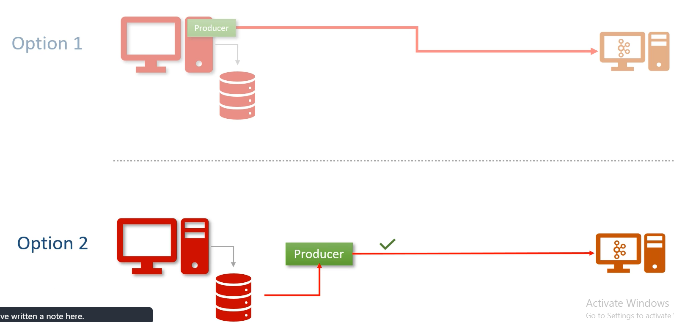

The second option is more feasible because in this way we don’t need do any modification into the Invoice source code and it is more practical also. So the same thing Kafka connects also does.

The Kafka connect is a system which we can place in between the data source and the Kafka clusters. Only we just need to configure it to consume data from the source system and send it to the Kafka clusters. We do not need to write a single line of code. Everything is already done and made available to us, we just need to configure and run and Kafka connect will do the job for us. But we have not done yet. We also need to bring data from Kafka cluster to the destination (like snowflake data warehouse) so again we will place the Kafka connect between these two system(Kafka cluster & Snowflake) and configure it and now Kafka connect will read data from Kafka cluster and write it to the Snowflake database)

The left side connector is called Kafka Source Connector and right side Kafka connects is called Sink Connector.

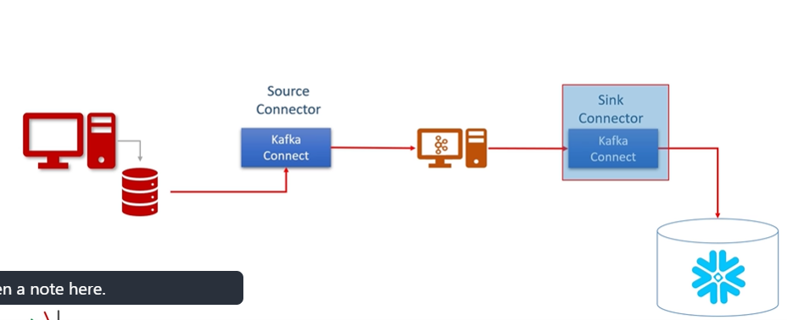

So we use the Source Connector to pull the data from source system and send it to the Kafka cluster. Source connector internally will use Kafka Producer API. Similarly we use the sink connector to consume the data from Kafka topic and sink it to an external system and these sink connector internally will use the Kafka Consumer API.

They are ready to use (Component) connectors to import data from databases into Kafka (topic/clusters) or export data from Kafka to external databases. These are not just only the box connectors but also a framework to build specialized connectors for any other application. We have two types of connectors

1. Source Connector
2. Sink Connector

**How Kafka Connect works?**

As already learned that we can place Kafka connect in between the Source, Destination and Kafka cluster and then we configure it and Kafka connect will take care of copying data from one to another, we don’t have write a single line of code. How it is possible? Because we have bunch of different source and destination system (e.g. relational data base, Teradata,Twitter, File System, Cloud, Mongo DB) and all of them have different mechanism of reading and writing. How it is possible for Kafka connect without writing a single line of code?

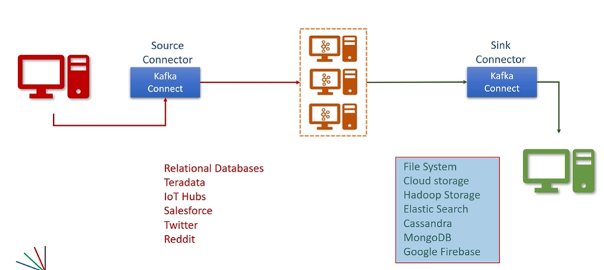

So the answer is Kafka developer developed Kafka Connect Framework and made it open source for us. Kafka connect framework allows us to write connectors. These connectors are implemented in two ways.

|  |  |
| --- | --- |
|  | The Kafka connects framework takes care of all the heavy lifting, scalability, fault tolerance, error handling etc. As a connector developer all we need to do is to implement two java classes.  **The first one** is : Source Connector & Sink Connector  **The second one is**: Source Task & Sink Task |

Once our connector is developed we can packaged it as an uber jar or as a zip archive and share it with other to use it. And that is what the other out sourced and target vendors are doing.

An **uber-JAR**—also known as a fat JAR or JAR with dependencies—is a JAR file that contains not only a Java program, but embeds its dependencies as well. This means that the JAR functions as an "all-in-one" distribution of the software, without needing any other Java code.

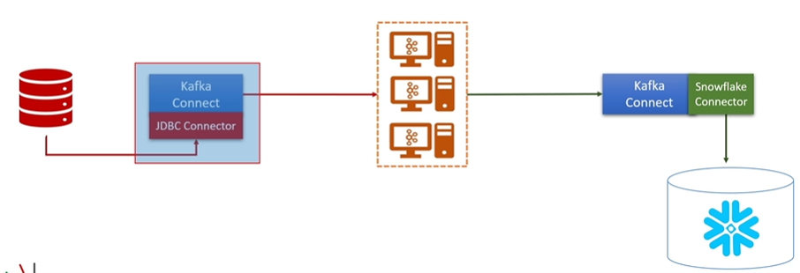

As per the above image we want to get the data from RDBMS data base to Kafka cluster, we will have to take the appropriate source connector. For example in case of RDBMS source database we will have to take JDBC Connector, after that install it into our Kafka connect, configure it and run it and now JDBC Kafka source connector will take care rest. Similarly at the destination end when we want to move data from Kafka cluster to snowflake database then get the snowflake sink connector, now install it into our Kafka connect, configure it and run it and now we are done.

This is how the Kafka connects works.

**Kafka Connect Scalability? Can we scale Kafka connectivity?**

As we already learned the Kafka Producer & Consumer scalability. We are able to scale producer by adding more producers to send data in parallel. We can scale the Kafka cluster by simply adding more brokers (By doing Kafka partition). Similarly we can scale the consumer by adding more consumers in the consumer group. So now what about Kafka connect scaling?

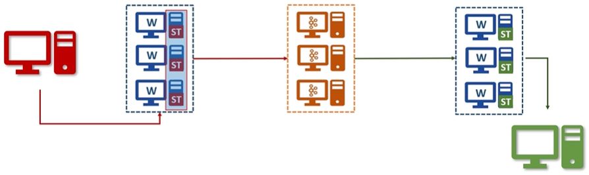

So the answer is simple, The Kafka connect is itself is a cluster. Each individual unit in the connect cluster is called a connect worker. We can think of a group of computers and each running a one Kafka Connect worker. Parallel we have a bunch of SOURCE TASK (ST) running with the worker to share the work load. For example one task might be pulling data from database from one table in the database and other task might be pulling data from another table. We can configure them in the way our connector developer has designed and allows. Similarly on the other side (Sink connector), we will have a bunch of SINK TASK (ST) to share the work load. Here nothing to worry about the scalability. We can play with the number of tasks and scale the Kafka connects cluster capacity by adding more workers.

As per the diagram it seems we have two Kafka connectors (one for source and another one for sink). So absolutely not. The above diagram can be actually will look like as below.

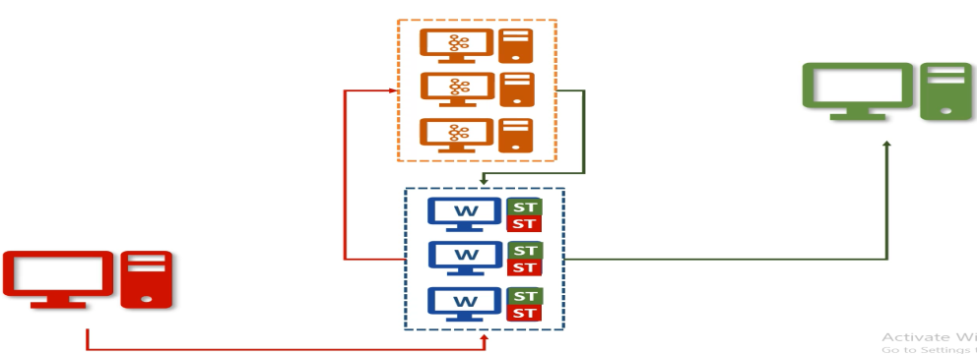

As per the above diagram we can have one Kafka connector cluster and run as many connectors as we want. In the above diagram we have one source connector and one sink connector running in the same Kafka connect cluster. If our Kafka connects still have capacity then we can install another connector (Sales force connector) and start one more connector in the same cluster. If our cluster is fully utilized then we can scale just by adding more workers in the same cluster and we can do it dynamically without stopping any existing connector.

**Kafka Connect only copy the data or does it some process or transformation of data?**

Kafka connect was designed to plane copy or data movement between third party systems and Kafka. In Both the cases source or sink one side must be a Kafka cluster. However **Kafka connects also allows some fundamentals single message Transformations-SMTs i.e. we can apply some transformations or changes to each message on the fly and this allowed with both source and sink connectors.** We have some list of commons SMTs.

1. Add a new field in your record using static data or Meta data.
2. Filter or rename field.
3. Mask some fields with Null values.
4. Change record key
5. Route the record to a different Kafka topic.

**Kafka Connect Architecture: How does it work?**

**To understand Kafka connects architecture we have to learn three things.**

1. **Worker**
2. **Connector**
3. **Task**

**We already learned that Kafka connect is a cluster and it runs one or more workers.**

|  |  |  |
| --- | --- | --- |
|  |  | Let’s assume we have started a Kafka connect with three workers. These workers are fault tolerance and use group id to form a cluster. This group id mechanism is the same as we have consumer group. So what we need to do is that we need to start worker with same group id. And they all join hand to form a Kafka connect cluster. These workers are main work horse of the Kafka connect. In other way each worker works like a container process and they will responsible for starting and running connector and the task. These workers are fault tolerant and self managed, it means if any of the worker process stops or crashes, then other worker will recognize it and reassigned the connecter and task that ran on that worker to the remaining workers. If a new worker join the connect cluster, then other worker will notice that and assign the task to it and make sure that the load is balanced. |

So in a nut shell these workers will give us the following good things

1. Fault Tolerant & Self Managed
2. Reliability
3. High Availability
4. Scalability
5. Load balancing

So now we need to copy the data from the source. Let assume we need to copy the data from Relational Database.

|  |  |
| --- | --- |
|  |  |

1. So we will download the JDBC source connector and install it within the cluster (installing is nothing but to add all the necessary jars dependencies and files to the workers).
2. The next thing is to configure the connector. Configuration means provide all the necessary information

* DB connection details
* Source Table List to copy
* Polling frequency to poll the new data from the source
* Max parallelism like max number of tasks

All configurations go into a file and we will start the connector using some command line tool like (CMD)

Kafka connects also offers to REST API so we can begin the connector using REST API instead of command line tool. Since we already know that workers are like container so one of the three workers will start our connector process so this time it will be known as connector process. The connector process is mainly responsible for two things.

1. To determine the number of parallelism i.e. how many parallel task can I start to copy the data from the source. Using split mechanism. So the first thing is to decide how to split the data copying work. For example if want to copy the data from 5 table then we can list five table in the configuration file as shown above in the diagram and start the JDBC connector. Now it will become easy for the connector to do the splitting mechanism i.e. one table per task. So the maximum number parallelism is 5 in this case as mentioned in the diagram also, however the splitting mechanism is written in the connector code and we gives the configuration options accordingly.

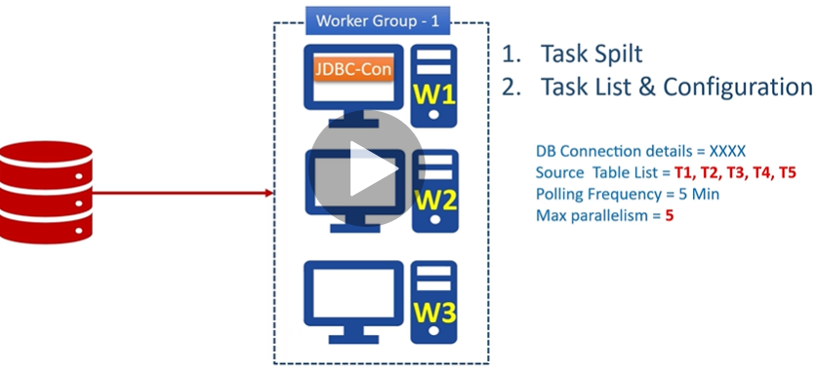

So now the connector knows that it can start 5 parallel tasks and assign one table to each task of copying data from the source system.

1. The connector is not going to copy the data. It is only responsible for defining and creating a task lists. Each task will be configured to read data from an assign list of tables. In our example it is just one table.

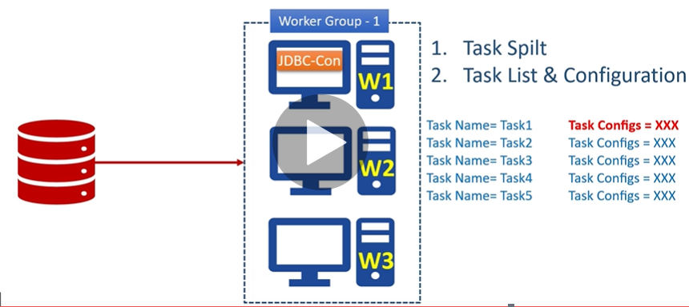

Connector will also includes some additional configurations, like database connection details and other thing just to make sure that the tasks can be run indecently.

|  |  |
| --- | --- |
|  | Now finally the list of task will be given to all workers and they will start the tasks. This way the entire task are defined by the connector and gets distributed across the workers for balancing the cluster load.  Now the task is responsible for connecting to the source system, poling the data at a regular interval, collecting the records, and handing over it to the workers.  Task do not send the record to the Kafka clusters, the task is only responsible to interacting to the external systems. The source task will hand over the data to the worker and worker only is the responsible for sending the data to the Kafka topic. |

In case of sink task they get the record from the Kafka Connect workers and the task is only responsible for inserting the record into the target system.

This is all over reusable design of the Kafka connect framework architecture.

Reading and writing data to a Kafka Cluster is a standard activity so it is taken care of by the framework. Only two things that keeps varying for different source and target system.

1. How to split the input for parallel processing? And this is taken care by the connector class
2. How to interact with the external system? And this taken care by the task class.

So these above two thing the connector developer needs to take care. And most of the other stuffs like (interacting with Kafka, handling configurations, errors, Monitoring connectors and tasks scaling up & down and handling failures are taken care by Kafka connect framework.

**Section 1.4- Kafka Streams Core Concept:**

In the earlier discussion we have talked about 5 core concept of Kafka ecosystem

1. Kafka Broker : Already done
2. Kafka Client API: Already Done
3. Kafka Connect : Done
4. **Kafka Streams**
5. **KSQL**

So far we have discussed in detail first three core components, these three component help us to create a simplified and manageable integration solution among the different applications.

The next two remaining component (Kafka Streams & KSQL) will take our Kafka implementation beyond the data integration and allows us to create scalable and fault tolerant real time stream process application.

Here we will discuss about the core concept of Kafka streams and will try to find the answer of the following questions.

1. What is Real-time Processing?
2. What is Kafka Streams?
3. Kafka Streams Architecture.

**What is Real-time Processing?**

As we already know that Data Streams are….

Unbounded (No definite starting and ending) Infinite & Ever Growing sequence of data in small packets (KB)

Some common examples:

1. **Sensors**: Sending data from transportation vehicles( Like Fast tags, Speed), Industrial equipments, health care devices
2. **Log Entries**: Generated by mobile apps, Web applications, Infrastructures components
3. **Click Streams**: Generated by e-commerce application, News and Media websites, video streaming, Online gaming
4. **Transactions:** Transaction coming from stock markets, Credit Cards, ATM machine, E-commerce order, payment orders.
5. **Data Feeds:** Social Media activities, Traffic Activities, Security & Thread Systems,

**And so on ……..So if we look around us the almost everything can be seen as a sequence of small data packets and these are unbounded i.e. infinite & ever growing, once started they never ever end.**

**Now we have the challenge to process them.**

|  |
| --- |
| **One common approach is to collect and store them into a storage system. Now we can do two things.**   1. Query the data to get answer to a specific question. This is nothing but request/ response approach and usually handle with SQL statements. In this approach we are asking question one time and getting the answer ASAP 2. The second approach is to create one big job (Batch of query) to find answer a bunch of queries and schedule the job to run at regular intervals. In this approaches we are asking question only once and repeating the question every hour or day. This approach is called batch processing.   The stream process sits in between of these two approaches. In this approach we ask the question once and the system should give you the most recent version of the answer all the time. So Stream Processing is a continuous process and business reports are updated continuously based on the data available till the time. As we receive more data, the reports are updated & refreshed with new information. |

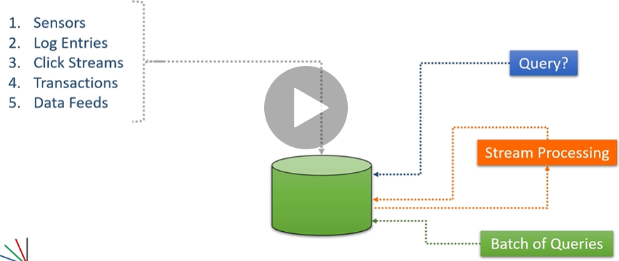

However under the hood we might be doing the same usual operations like as joining two streams, grouping the data, computing aggregates and other general thing that we used to do in database queries and batch processing systems because stream processing is also a data processing work. But we do it in a continuous and ongoing process.

**Now the question comes that can we use databases or batch processing systems to perform stream processing?**

The answer is Yes & No. Technically it is possible to use databases and batch system to do the stream processing so the answer is yes. But if we use these systems in stream processing then our solution will become too complex also there are some new concepts and considerations which will make our work more difficult. So we need tool which are specifically designed for stream processing and Kafka stream is one of the exact solution for stream processing.

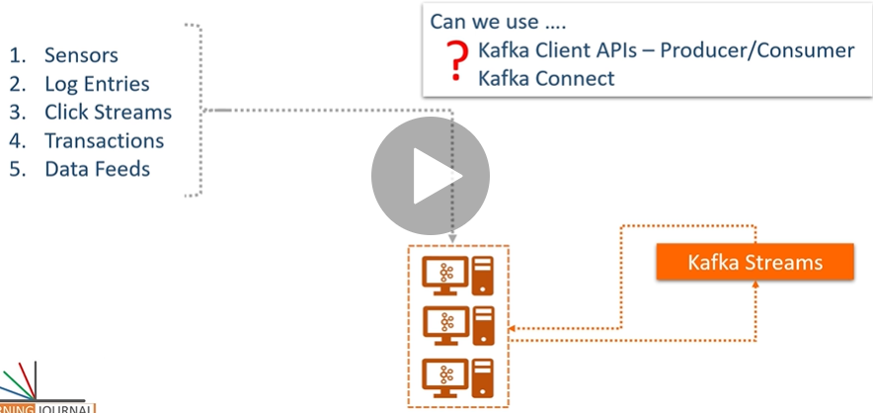

Now the question comes that are we going to use Kafka client APIs – Producer / Consumer & Kafka connect in the stream processing?

The stream processing is not as straight forward as data integrations. It poses some new challenges and we cannot solve those using tools designed for data integration problem. So Kafka Producer / Consumer & and Kafka connect cannot be used for stream processing. We need new tool specifically designed for stream processing and that is Kafka streams all about.

**So now question comes what is Kafka Stream and how it solves stream processing challenges?**

So first of all at the most basic level Kafka stream is a java / Scala library for building applications and microservices where the input data are streamed into Kafka topic. So we cannot use Kafka streams if the data is not coming into a Kafka topic. The starting point of Kafka stream is one or more Kafka Topic. Now the most important feature of Kafka streams is that being as a library, we can create a simple standard java or Scala application to perform real time stream processing and we can deploy the application to any machine (VM) or container or on Kubernative clusters. This application is just a simple application with fault tolerance, and parallel processing which is given to us by the Kafka stream library for handling stream process.

**What Kafka Stream offers?**

1. We can work with steams or tables or both of them for stream processing i.e. it provides mix and match facility. Even we can convert stream into table and vice-versa.
2. It allows us to group our streams and compute continuously updating aggregates.
3. We can join streams, table and combination of both.
4. We can create and manage fault tolerant efficient local storage.
5. We can create different window of different type and can deal all the time with different complexities. For example event time, processing time, latecomers, high watermark, exactly once processes etc.
6. It also allows us to server other microservices using request/response interface.
7. It gives a set of tools for unit testing.
8. It provides inherent fault tolerance and dynamic scalability.
9. We can deploy stream application in any container and can manage by using Kubernetes.

**Now the concluding question: How it works? Kafka Streams Architecture.**

As we know that Kafka stream is nothing but continuous reading a stream of data from one or more Kafka topics and then develop our application logic to process those streams in real time and take necessary action.

Let’s assume we have created Kafka stream application and deployed in a single machine. As per the image our Kafka stream application continuously reading data from two Kafka topics (T1 & T2) and each topic having three partitions.

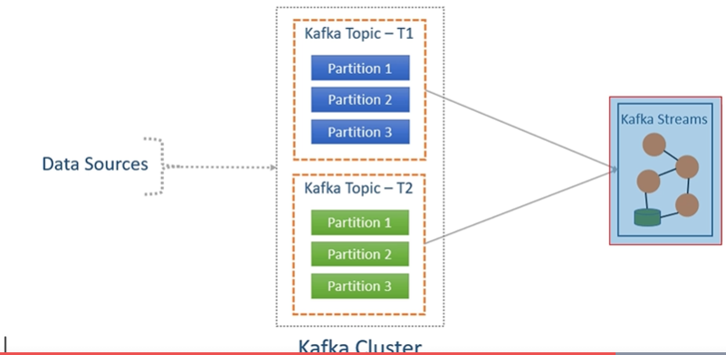Here the Kafka stream application could be doing anything according to requirement like as Monitoring Traffic Data. Here we are just trying to understand scalability and fault tolerance of the Kafka Stream application. So we have deployed Kafka stream application on a single machine. Now the Kafka stream application will create three logical tasks internally because the number of the partition across the topics T1 & T2 are three. So now Kafka stream frame work got to know that we can create three consumers and each could be consuming stream data from one partition in parallel. The most exciting part is we don’t have to code this thing. The Kafka streaming framework smartly detects it and creates three logical tasks.

|  |  |  |
| --- | --- | --- |
|  |  |  |

Now the next step is to assign partition to these tasks. In this case the Kafka stream framework would allocate the partition evenly i.e. one partition from each topic to each task. So finally every task will have two partition data to process as shown above in the second cell of the table.

After assigning the partition to each task now these tasks are ready to be assigned to application threads or instances. Let’s assume we have configured the application to run with two threads then Kafka first of all assign one task to each thread and then remaining task will be assign to one of these two thread because we do not have any other thread. In this case the task distribution is not even and Thread 2 running task might be slow, but the good thing is all the task are running and all the data would be processed.

So now the question comes why we have only two threads in the Kafka stream application?

So the answer is it depends on the requirement, based on the requirement we can increase the number of thread just by setting the number of thread to be run in the Kafka stream framework. So let’s assume if we have increased one more thread then the task automatically would be reassigned to third thread and this would happen automatically without stop any tasks. In this way we can scale up and down Kafka stream application thread based on the requirement. This all process is known as task re-assignment. And hence Kafka stream framework automatically re-balances the entire task based on the number of partition in the Kafka topic and number of the thread running in the Kafka stream application.

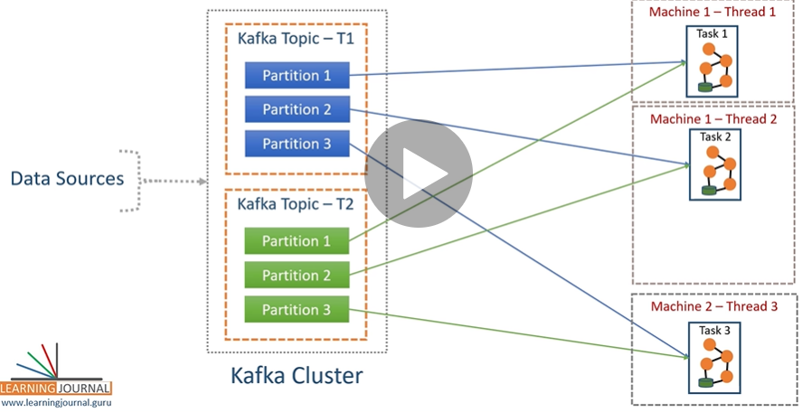

Now again if we keep adding more instances or thread in the Kafka stream application the it will be of no use and will be in ideal stage because the task assignment happens based on the number of the partition and number of task created in the stream application.

In case of fault tolerance:

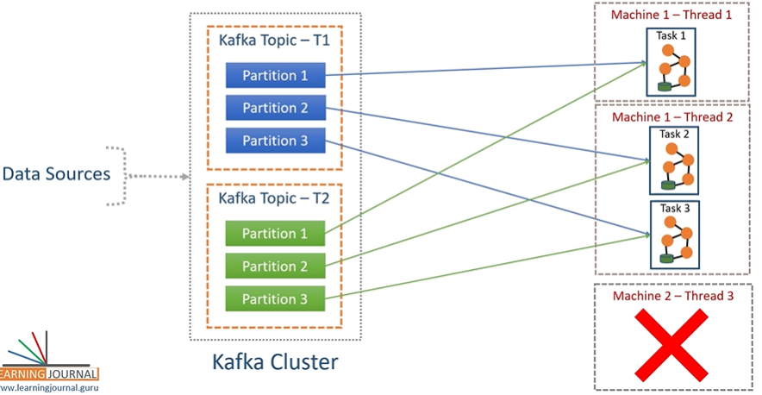

**Section 1.5 – KSQL**

1. **What is KSQL?**

It is SQL interface to Kafka Streams. In short most of the things which you can do using Kafka streams are available to us in KSQL.

It means we can create scalable and fault tolerant stream processing workload without writing any code.

KSQL has two operating modes.

* **Interactive Mode:** Here we use command line CLI or web based UI to submit KSQL and get an immediate response. This mode mostly use in develop environment.
* **Headless Mode:** It is non interactive mode that allows us to submit our KSQL files which are executed by the KQL server. This mode is ideal for production environment.

1. **KSQL Architecture – How does it work?**

**KSQL** comes with three **components**:

* KSQL Engine
* REST Interface
* KSQL client (CLI/UI)

|  |  |
| --- | --- |
| KSQL Engine and REST interface together form KSQL Server and KSQL server can be deployed in one of the available mode interactive mode or headless mode. We can also deploy multiple KSQL server to form KSQL Server cluster, but all the KSQL server that run in the cluster must be deployed in the same deployment mode. |  |

**The KSQL Engine** is the core component which is responsible for KSQL statements and queries. Under the engine is going to parse our KSQL statement and build corresponding Kafka streams topology and run them as stream tasks and these stream tasks are executed on the available KSQL servers in the cluster. We can dynamically add more cluster to scale up the resources and fault tolerance is an inherent feature of the Kafka streams.

Note: KSQL cluster is separate from the Kafka cluster and our KSQL server internally communicates to the Kafka cluster for reading inputs and writing outputs.

**The REST Interface** is used to power the KSQL clients. So KSQL clients can send the command to REST interface which will internally communicate with KSQL engine to execute the KSQL commands.

1. **What can you do with KSQL?**

In a null shell KSQL allows us to use Kafka topic as table and fire SQL like query over those topics. With this power in our hand we can imagine the kind of the things that we can do.

|  |  |
| --- | --- |
|  | As here we can see that KSQL allows different kind of operation like SQL |

Now as we have learnt all the basic core concept of Kafka like

1. Kafka Broker : Already done
2. Kafka Client API: Already Done
3. Kafka Connect : Done
4. **Kafka Streams**
5. **KSQL**

So now the main question comes that when to use what?

Basically we are seeing three patterns where we can use Kafka.

1. Data integration pattern
2. Real time stream processing using Micro service Architecture.
3. Real time data warehousing

**Kafka in Data Integration Pattern**: The first three component Kafka Broker, Kafka client API and Kafka connect can be used in data integration pattern to solve data integration problem

|  |  |
| --- | --- |
|  |  |

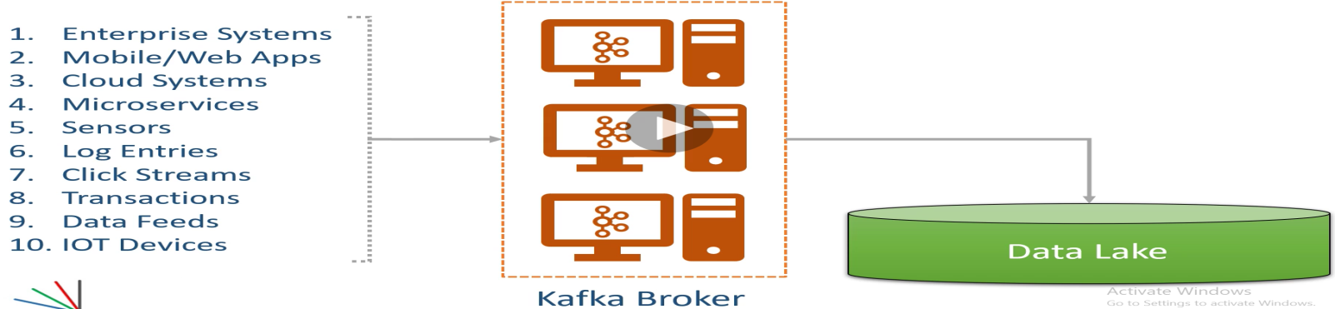

The most commonly used in case of creating data lake.

**Real time stream processing using Micro service Architecture.**

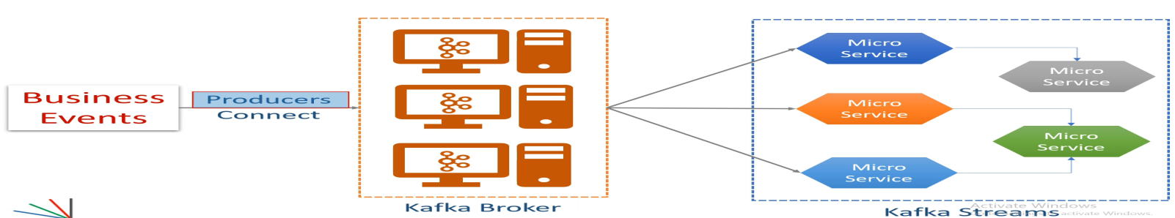

Here in this scenario we are using Kafka producer or Connect to get data from the source system and Kafka streams with micro service architecture to process the data streams. Here we cannot use consumer while using Kafka streams to achieve real time result.

**Real time data warehousing**

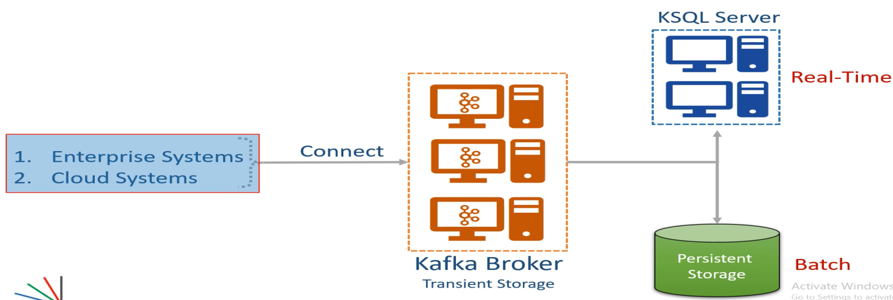

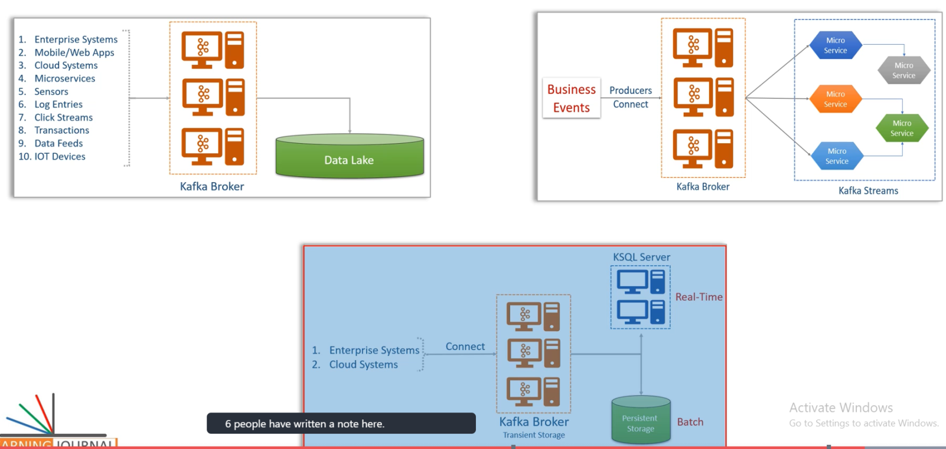 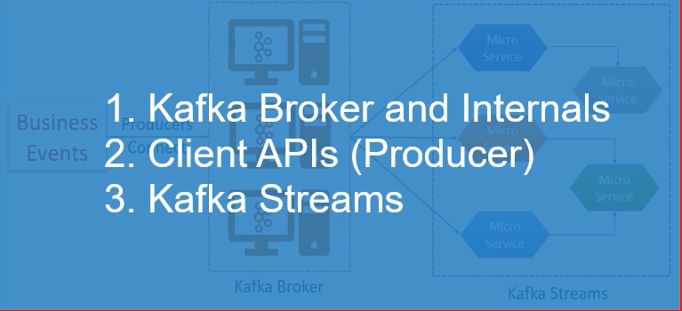

The above point is most used by java developer in Apache Kafka.

**Section2-**

1. Installing single Node Kafka cluster.
2. Using command-line Producer & Consumer.
3. Installing Multi-Node Kafka cluster.
4. Using Consumer group
5. Configuring the Development IDE Intelligent IDEA

**Section 2-8 Installing single Node Kafka cluster**

Kafka can be classified into three categories.

1. Open Source – Apache Kafka
2. Commercial - Confluent.io
3. Cloud Based - Confluent, Amazon, Aiven.io

All the above options are used to get just Kafka cluster. We still need to develop applications for creating and processing data streams.

Install Confluent Kafka: Go to the <https://confluent.io> > click on download

It downloads pre-configured single node Kafka cluster. Since Kafka is JVM based application so Java latest version should be installed into our machine to start Kafka services.

Kafka comes with bunch of command line tool that we can find them **in bin directory.**

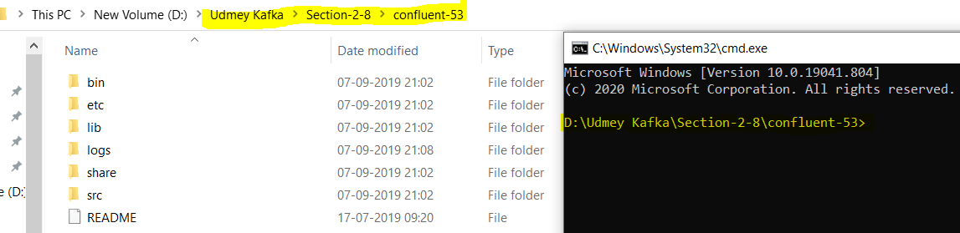

|  |  |
| --- | --- |
| All files inside the bin folder are shell scripts and we can find the window compatible file inside window folder as shown above. |  |

Since I am using windows machine so we will use windows bat file script.

So great we have set all the things to start single node Kafka cluster.

**Starting single node Kafka cluster:**

**Starting a Kafka cluster is two step processes.**

1. **Start the Zoo Keeper server using [zookeeper-server-start.bat]**

**(D:\Udmey Kafka\Section-2-8\confluent-53>bin\windows\zookeeper-server-start.bat )**

**This script also takes one mandatory argument “a zookeeper configuration file (zookeeper.properties) which is available in the etc\kafka directory this configuration file comes with ready to use. So now the above command will look like as below: The complete command to start zookeeper server**

**(**D:\UdmeyKafka\Section-2-8\confluent-53>bin\windows\ zookeeper-server-start.bat **etc\kafka\zookeeper.properties)**

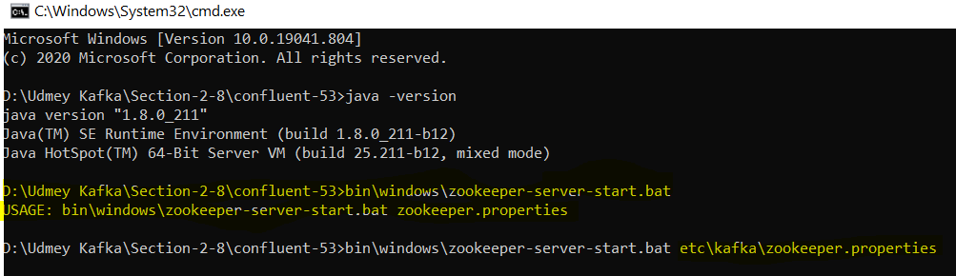

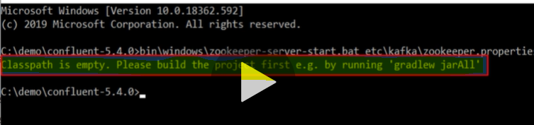

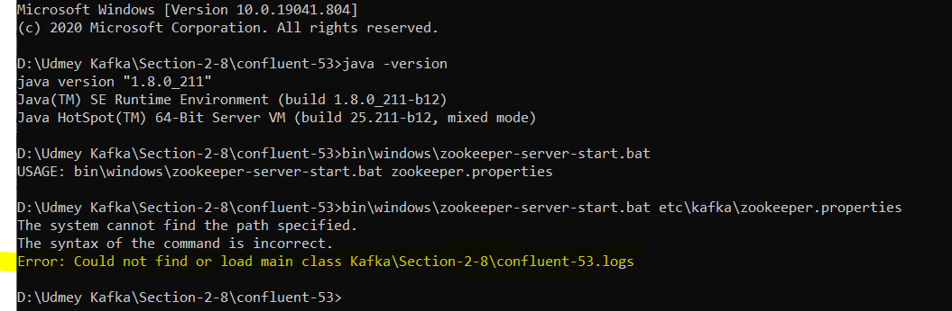

**If we get above error then it means our confluent kafka download hat got broken script for windows. Let’s fix it.**

**Goto bin> open karka-run-class.bat file in notepad > search for classpath addition for core**

Add following code to kafka-run-class.bat file for windows 10

rem Classpath addition for LSB style path

if exist %BASE_DIR%\share\java\kafka\* (

call :concat %BASE_DIR%\share\java\kafka\*

)

Now run the above script once again

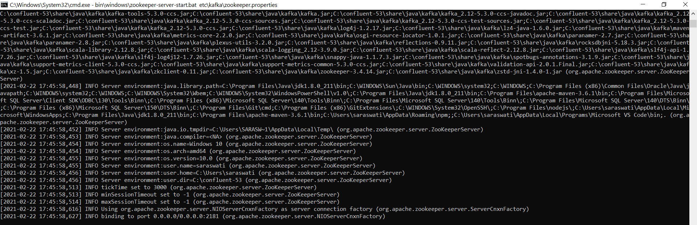

**And now zookeeper is running. Minimize this zookeeper CMD window and let’s start Kafka broker**

**Now the 2nd step is to start single node Kafka broker: use: kafka-server-start.bat**



**C:\confluent-53>bin\windows\kafka-server-start.bat etc\kafka\server.properties**

**In This command also need Kafka broker configuration file (server.properties) as an argument to start Kafka broker.**

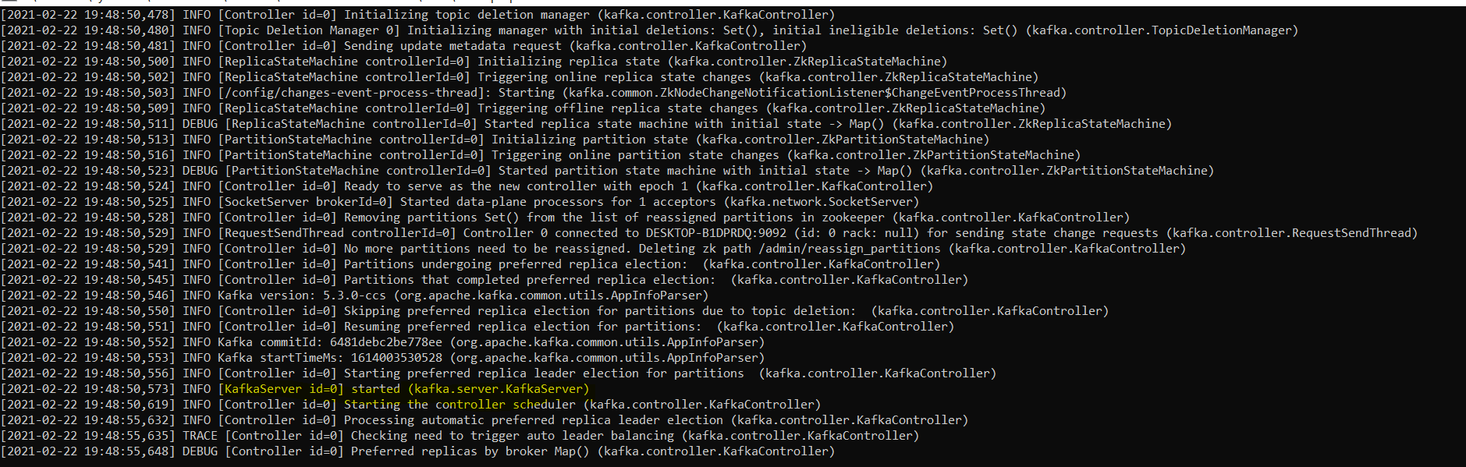

**Now the Kafka broker server started and running with id=0 which is the Kafka broker id. Now we are ready to play with this single node Kafka cluster. Now we are done, but we have one question here.**

**What is Apache Zookeeper?**

Zookeeper is a kind of database where Kafka broker would store shared information and it is used as shared system among multiple Kafka broker to coordinate among themselves for various things. Kafka community already announce that they will retire the zookeeper In the coming days but until then Kafka need zookeeper to coordinate among themselves for various purposes.

**Note: Kafka Zookeeper must have it running even in case of single broker also.**

**So this is how we can install and run Kafka confluent edition. Now let’s see about open source Apache Kafka to install and run.**

**How to install and run Apache Kafka?**

The steps are almost same with minor differences. Before running this open source Apache Kafka please stop the Confluent Kafka because this open source Apache Kafka also going to use the same port.

Download the Apache Kafka from <http://kafka.apache.org/downloads>

|  |  |
| --- | --- |
| Confluent directory Structure | Apache Directory Structure |

As here we can notice that some directories are missing from Confluent but this open source Apache Kafka carries the same thing. It is just directory structure .Confluent carries some additional capability that we will discuss in the coming discussion.

Here also start the Apache Kafka cluster include two steps

1. Start Apache Kafka Zookeeper
2. Start the Apache Kafka broker

Here in both, the starter script will be same. Only the location will be different of configuration files. Here the entire configuration file will be located in config folder instead of etc (as in case of confluent).

Start Apache Kafka Zookeeper



**C:\ApacheKafka\kafka_2.13-2.7.0>bin\windows\zookeeper-server-start.bat config\zookeeper.properties**

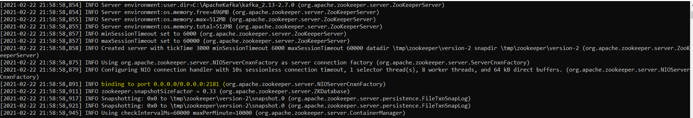

And now open source Apache Kafka zookeeper is running and listening at default zookeeper- port 2181.

Now start Apache Kafka broker:



**C:\ApacheKafka\kafka_2.13-2.7.0>bin\windows\kafka-server-start.bat config\server.properties**

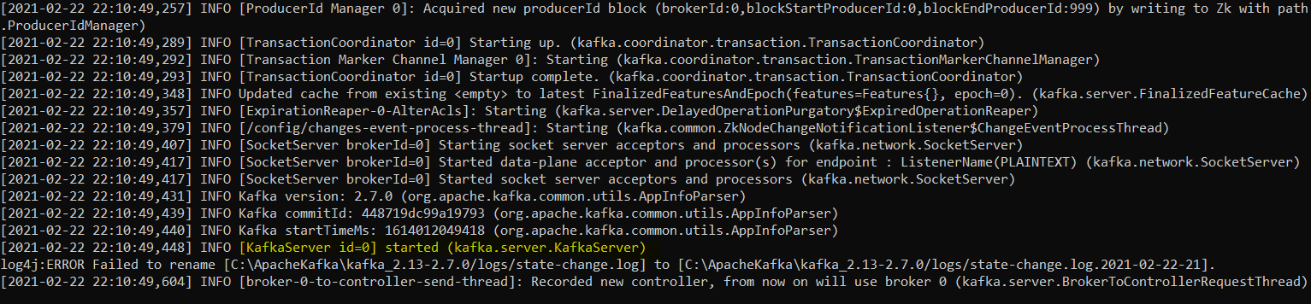

**Now open source Apache Kafka broker is running with KafkaServer id=0;**

**So we have learnt installing and running Kafka for single node cluster----**

1. **Confluent community Kafka**
2. **Open Source Apache Kafka**

**Section 2-9: Using command-line Producer & Consumer.**

Here we will learn to start Kafka Producer and Consumer. Here we are not going to write any code for producer and consumer to be run, instead we will use console command line tool for Producer and Consumer.

Here we will do the following things just to show the demo. Here we will have CSV file that contains some data and we want to send it to the Kafka cluster, however producer always send data to Kafka topic so we will do it in two steps

1. **Sending data file to Kafka**

Step1- Create Topic using Kafka topic using command line tool.

Step2- Sending data file to the Kafka topic using Kafka command line producer tool and once the data start coming to Kafka topic then we will move to step 3.

2- **Reading or consuming data from the Kafka Topic**

Step3- Using Kafka console (command line tool) consumer for reading data from topic and display on the console.

**How to create Kafka Topic: We will use the following things to create topic using command line tool.**

1. **Kafka-topic.bat**
2. **--create --topic topicName**
3. **--partitions numberOfPartitionForParallelProcessings**

**The Number of partitions is created just to have parallel processing of the data.**

1. **--replication-factor numberOfCopiesOfEachPartition**

**The number of copies for each partition used to create just to achieve fault tolerant feature when one of broker gets down**

1. **--bootstrap-server KafkaBrokerIP:portnumber**

**To create the topic in the cluster we need to tell the Kafka cluster coordinate using above command. Here the IP is broker or cluster IP where the topic is be created at given port number**

**So finally the command line tool for creating Kafka topic is given as below command.**



**C:\ApacheKafka\kafka_2.13-2.7.0>bin\windows\kafka-topics.bat --create --topic test --partitions 1 --replication-factor 1 --bootstrap-server localhost:9092**



**Now the topic got created and now we are ready to send data.**

**How to use Kafka Console Producer to send data to the Kafka Topic? We will use the following things**

1. **Kafka-console-producer.bat**
2. **--topic topicName**
3. **--broker-list localhost:9092 ( Mention the kafka broker coordinate cluster where the topic got created)**
4. **<..\data\sample1.csv ( file location to be sent in the topic)**

**So the finally the console command tool will be as given below.**

**C:\ApacheKafka\kafka_2.13-2.7.0>bin\windows\kafka-console-producer.bat --topic test --broker-list localhost:9092 <\data\sample1.csv**

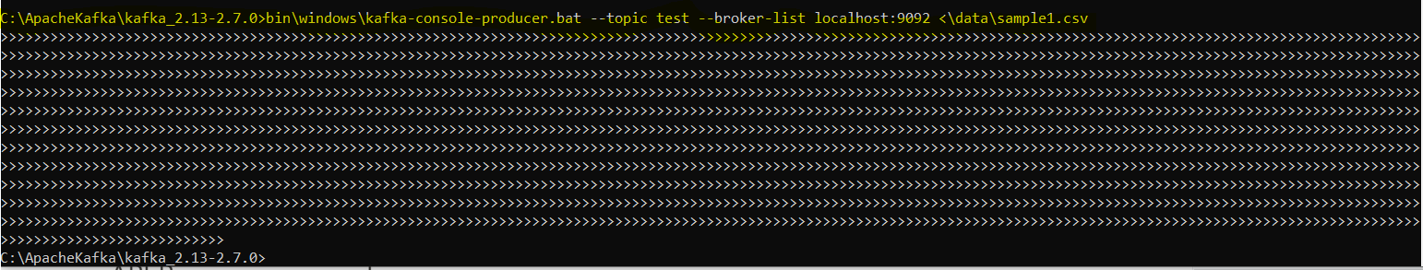

**So now we have sent the data to Kafka Topic test. Now we will read or consume the data from Kafka topic.**

**Using Kafka Console Consumer to read or consume data from the topic test: We will use the following things**

1. **Kafka-console-consumer.bat**
2. **--topic topicName**
3. **--bootstrap-server localhost:9092 ( Mention the Kafka broker coordinate cluster where the topic got created)**
4. **--from beginning**



**C:\ApacheKafka\kafka_2.13-2.7.0>bin\windows\kafka-console-consumer.bat --topic test --bootstrap-server localhost:9092 --from-beginning**

**Now when we run the above command then consumer starts reading data from topic test**

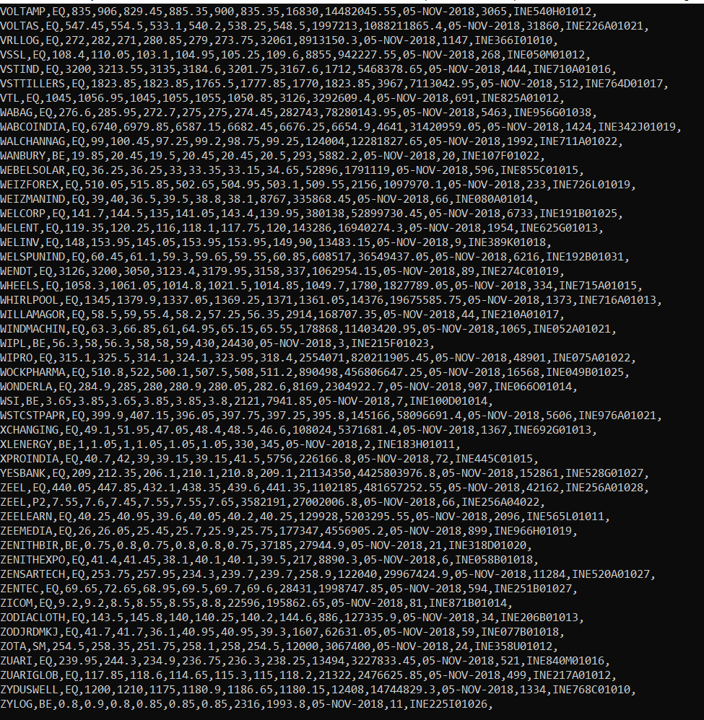

**So we got all the record from the topic. Now if we send another file then it will immediately start reading from the topic.**

**So we have simulated the following.**

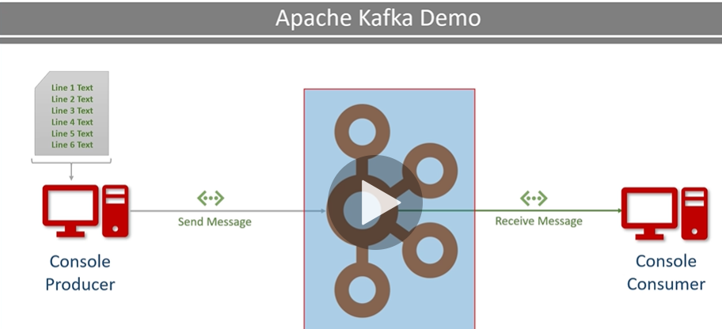

**Note: Here Kafka cluster (Kafka broker), Kafka Console Producer, Kafka Console Consumer are running on the same computer (localhost) but they could have been on different computer at the remote locations.**

**Section2- 10: Installing and running Multi-Node Kafka cluster.**

**server.properties (Kafka Broker Configuration file):**

Go to Kafka server.properties file. In case of Confluent it is available in etc/kafka/server.properties while if we are using open source apache Kafka then it is available config/kafka/server.properties.

The server.properties is the Kafka broker configuration file. When we start the Kafka broker then we used to supply this file as an argument and Kafka server start command is going to read broker configurations from this file.

Here we are planning to start three brokers, so we will have to have three copy of the server.properties and give a different name to all of them.

|  |  |
| --- | --- |
|  | So now we have four server.properties file as mentioned in the image. Now when we start the broker then we will supply these files accordingly.  **Server.properties to first broker**  **Server-1.properties to second broker**  **Server-2.properties to third broker** and so on the corresponding command line script will be given as below. |

**C:\confluent-53>bin\windows\kafka-server-start.bat etc\kafka\server.properties**

**C:\confluent-53>bin\windows\kafka-server-start.bat etc\kafka\server-1.properties**

**C:\confluent-53>bin\windows\kafka-server-start.bat etc\kafka\server-2.properties**

But before that we need to modify these file for each broker. Kafka is a highly configurable system and we can define many of those configurations in this server.properties file. Some of them are already pre-configure by default for Kafka broker. The list of configuration that we will modify according to each Kafka broker are given below

1. broker.id= 0 ( Each broker must have unique integer id). Broker.id=1 for second broker. Broker.id=2 for 3rd.
2. Listener Port: By default port config is comment out and broker listen on the default port. This port number on which the producer is going to send data to the broker. Similarly consumers are going to request the data using the same port. Since here we have three brokers, so all the broker should have different port. We will uncomment the port configuration and change it accordingly.

|  |  |  |
| --- | --- | --- |
| listeners=PLAINTEXT://9092 for first 1st broker | listeners=PLAINTEXT://9093 for first 2nd broker | listeners=PLAINTEXT://9094 for first 3rd broker |

Now the entire brokers have got different port number and now we won’t get port in use error. But in real time scenario we don’t need to change the port because each broker will be running in different machine in the cluster.

1. The change is Kafka log directory location and log name. This directory location where the Kafka is going to store the partition data. When we are running multiple brokers on the same machine then we need to assign different directory to each broker.

|  |  |  |
| --- | --- | --- |
| log.dirs=/tmp/kafka-log | log.dirs=/tmp/kafka-log-1 | log.dirs=/tmp/kafka-log-2 |

We have many more configurations which are not conflicting each other except these three so we don’t need to change them and we will leave them with default values.

So we have only three conflicting configurations changes ( broker.id , listenerPort, & logDirectory) when all the broker have to run on the same machine.

**Note**: When we want to run each broker on different machine then we don’t need to change anything except broker.id. And we can avoid that also by configuring Kafka to auto assign identifier to each broker.

Now we are set to start the entire three brokers on the same machine. Run the following command on different command prompt.

First run the Kafka Zookeeper and then run all three Kafka broker with given command below

|  |
| --- |
| C:\confluent-53>bin\windows\zookeeper-server-start.bat etc\kafka\zookeeper.properties      Now zookeeper is running on port : 2181 |
| **C:\confluent-53>bin\windows\kafka-server-start.bat etc\kafka\server.properties**      **First broker started with id=0** |
| **C:\confluent-53>bin\windows\kafka-server-start.bat etc\kafka\server-1.properties**      **Second Kafka broker started with id=1** |
| **C:\confluent-53>bin\windows\kafka-server-start.bat etc\kafka\server-2.properties**      **Third Kafka broker started with id=2** |

**So now the Zookeeper and all three Kafka broker are in running state.**

We can run as many broker as we want on a single machine the only thing that we need to do, is create a separate configuration file of (server.properties) for each broker and start it.

**Section2- 11 – Using Kafka Consumer Group:**

In the earlier discussion we have learnt to create three Kafka broker and run it with its corresponding server.properties file. Here are going to create a new Kafka topic and will make sure that it has three partitions, after this we are going to start two consumers in the same group. Both of the consumers will be reading data from the same topic, here both the consumer running in the same group, so they will share the workload.

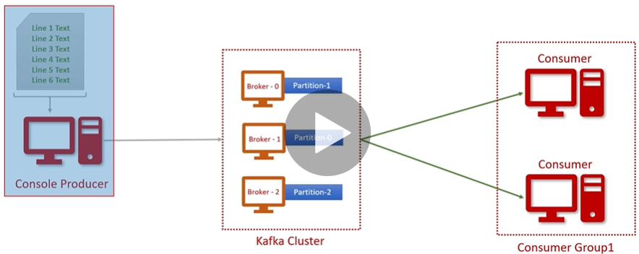

**So first of all create a new topic.**

Now first will **start the Console producer** and then will send data to the topic.

After that will create consumer group and start consuming data from the topic. Make sure your three nodes Kafka in running state.

**Creating topic using below command**

**C:\ApacheKafka\kafka_2.13-2.7.0>bin\windows\kafka-topics.bat --create --topic test --partitions 1 --replication-factor 1 --bootstrap-server localhost: 9092**

**Here in this case we will change the topic name and increase the partition and replication- factor. Now the above command will look like as given below.**

**C:\ApacheKafka\kafka_2.13-2.7.0>bin\windows\kafka-topics.bat --create --topic test --partitions 3 --replication-factor 1 --bootstrap-server localhost: 9092**



Now topic got created.

**Now start the first consumers: use the below command to run the consumer in the same group**

**C:\confluent-53>bin\windows\Consumer bat --bootstrap-server topicServerName&Port --topic TopicName --from-beginning --group group1**



**C:\confluent-53>bin\windows\kafka-console-consumer.bat --bootstrap-server localhost: 9092 --topic stock-ticks --from-beginning --group group1**

**We have started first consumer in the group1.**

**Now start the Second consumers: Now let’s open another console and start another consumer in the same group1. Command will be exactly same as we have used above.**



**C:\confluent-53>bin\windows\kafka-console-consumer.bat --bootstrap-server localhost: 9092 --topic stock-ticks --from-beginning --group group1**

**But we are not seeing anything because still we do have data in the topic. So now start a producer in new console and start sending data.**

**Now start the Producer and send data in the topic. Use the below command to start producer and send data into topic**

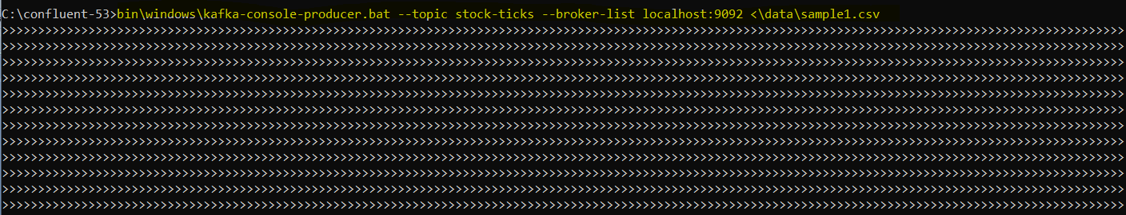

**C:\confluent-53>bin\windows\kafka-console-producer.bat --topic stock-ticks --broker-list localhost: 9092 <\data\sample1.csv**

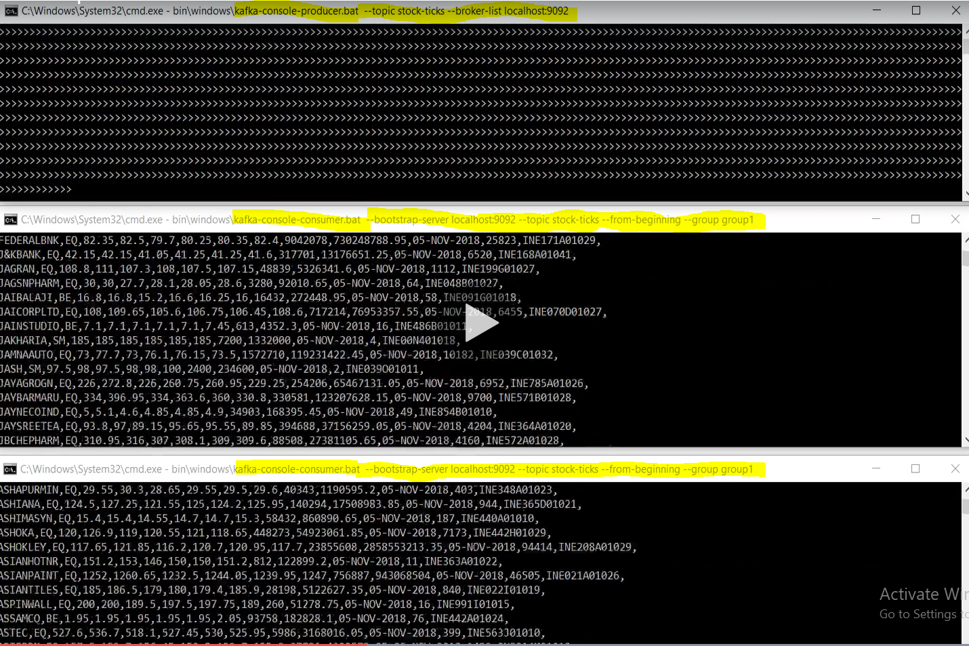

**And yes- as soon as we send data from producer to Kafka topic, simultaneously both the consumer of group1 start reading data from topic.**

**Note:** 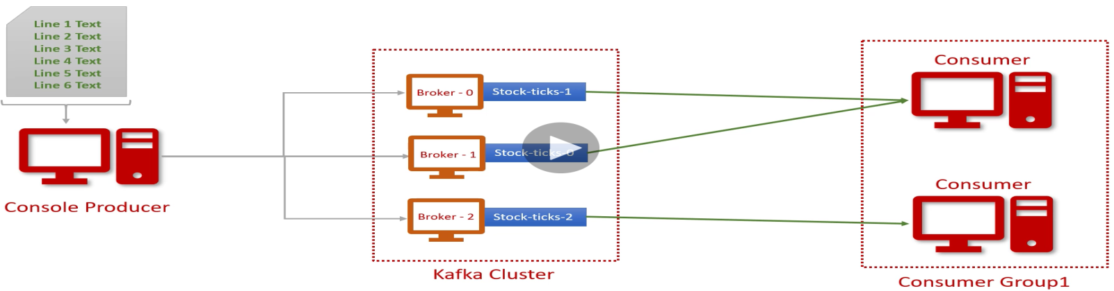

**So when we send data from produce to topic then all the data will be distributed into created all three partitions. Since we have created only two consumers, so one of the consumers will read the data from two partitions and another consumer will read data from third partition.**

**Now the most important part- Let’s see the log directory.**

|  |  |
| --- | --- |
|  |  |
|  |  |

So as per the configuration defined in the server.properties we have got the log directories for each of the broker. If further go inside each directory then we will see stock-ticks-0, stock-ticks-1, and stock-ticks-2. This is nothing but the topic’s partitions created inside each partition. This number shows the partition number associated with topic name.

Since here we have three partitions so when producer send the data into Kafka topic then data goes the each partition defined in the Kafka cluster.

Now if we go further inside any of the stock-ticks folder we will get Kafka data log file, where Kafka would store all the partition data.

**We can display or dump it using the below console.**



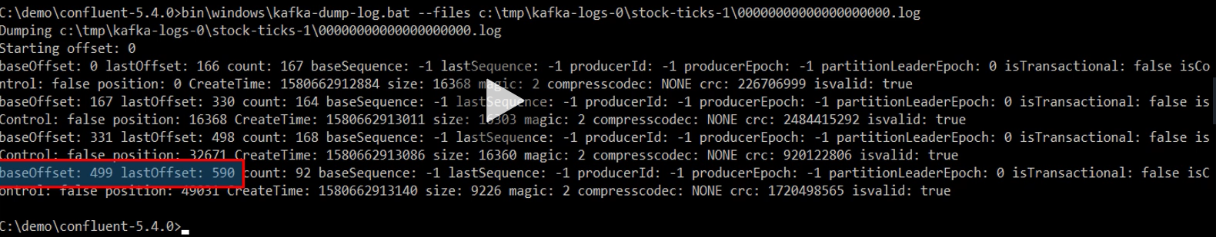

**Here we can see: baseOffset=499, lastOffset=590 & totalRecord (count) then next packets (marked with yellow) and so on…..**

**As per the last packet here we have 590+1 (because baseOffset start with 0, that is why added +1) record in this partition.**

**Means record count starts from baseOffset 0 and goes up to 591 and partition 0 got 592 records.**

**Let me dumb the other partition file.**

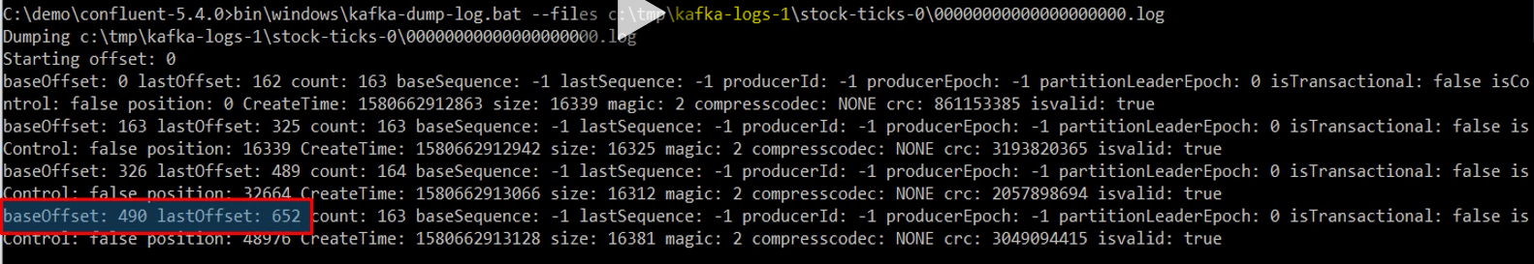

**Here partition 1 got 653 records**

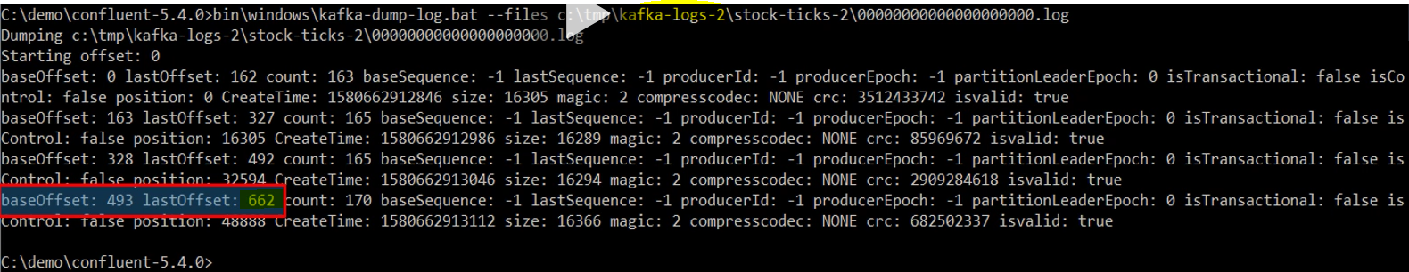

**And partition 2 has got 663 records.**

**A log dumb is a rich tool even we can print whole data set. Now we have got to know which partition has got how many records.**

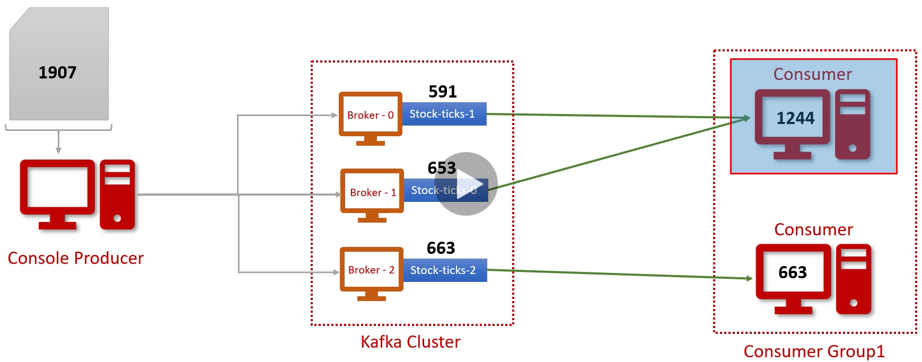

**And we can also guess that first consumer is reading data from two partitions and process 1244 records. The second consumer has got single partition and processed 663 records.**

**So here we have learnt that Kafka cluster will store data into topic partitions. Each partition is managed by a separate broker as a storage directory and the actual data stored inside the log files. We can use log dump file to investigate the log file.**

**Next thing we have learnt that consumers can work in consumer group to share the work load and try to achieve the work load balance.**

**So here we have learnt how partition and consumer inside the group can be used.**

**Section-2-12: Configuring Development IDE for Kafka Development.**

Here we will use Intellij Idea for Kafka development. Here we will setup the same thing what we have done so far.

Here we will use Kafka confluent edition for the development in IDE.

In the earlier configuration we have done the configuration to create log directory in tmp directory. This configuration is perfectly fine.

Here with IDE also we will use multiple brokers and here we will create the log directory in the same current directly instead of different directory what we have done in the earlier discussion. But before doing this let’s set the Kafka home directory variable to avoid typing absolute path using below command.

|  |  |
| --- | --- |
|  | C:\confluent-53>setx KAFKA_HOME c:\confluent-53  Now we are ready to use Intellij IDE. |

Let’s open the project structure in the IntelliJ IDE.

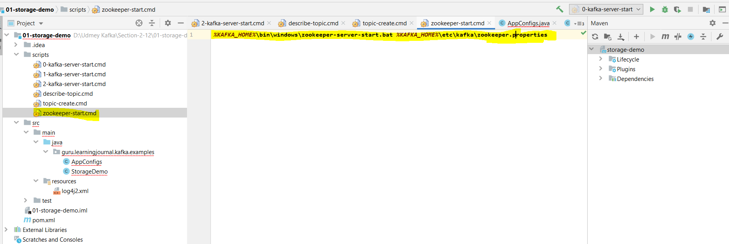

As here in the Intellij we can see that we have add the window bat command file to run

1. .bat file to start three nodes Kafka cluster with their respective argument properties file.

***%KAFKA_HOME%*\bin\windows\kafka-server-start.bat *%KAFKA_HOME%*\etc\kafka\server-0.properties**

***%KAFKA_HOME%*\bin\windows\kafka-server-start.bat *%KAFKA_HOME%*\etc\kafka\server-1.properties**

***%KAFKA_HOME%*\bin\windows\kafka-server-start.bat *%KAFKA_HOME%*\etc\kafka\server-2.properties**

1. .bat file to start Zookeeper

***%KAFKA_HOME%*\bin\windows\zookeeper-server-start.bat *%KAFKA_HOME%*\etc\kafka\zookeeper.properties**

1. .bat file to create topic

***%KAFKA_HOME%*\bin\windows\kafka-topics.bat --create --zookeeper localhost:2181 --topic invoice --partitions 5 --replication-factor 3 --config segment.bytes=1000000**

1. .bat file to describe topic

***%KAFKA_HOME%*\bin\windows\kafka-topics.bat --describe --zookeeper localhost:2181 --topic invoice**

In case of Linux the above command will look like as below.

***$KAFKA_HOME*\bin\windows\kafka-server-start *%KAFKA_HOME%*\etc\kafka\server-0.properties**

***$KAFKA_HOME*\bin\windows\kafka-server-start *%KAFKA_HOME%*\etc\kafka\server-1.properties**

***$KAFKA_HOME*\bin\windows\kafka-server-start *%KAFKA_HOME%*\etc\kafka\server-2.properties**

1. Pom.xml having all the dependencies

|  |
| --- |
| *<?***xml version="1.0" encoding="UTF-8"***?>* <**project xmlns="http://maven.apache.org/POM/4.0.0"  xmlns:xsi="http://www.w3.org/2001/XMLSchema-instance"  xsi:schemaLocation="http://maven.apache.org/POM/4.0.0 http://maven.apache.org/xsd/maven-4.0.0.xsd"**>  <**modelVersion**>4.0.0</**modelVersion**>  <**groupId**>guru.learningjournal.kafka.examples</**groupId**>  <**artifactId**>storage-demo</**artifactId**>  <**version**>2.3.0</**version**>  <**properties**>  <**java.version**>1.8</**java.version**>  <**kafka.version**>2.3.0</**kafka.version**>  </**properties**>  <**build**>  <**plugins**>  *<!-- Maven Compiler Plugin-->* <**plugin**>  <**groupId**>org.apache.maven.plugins</**groupId**>  <**artifactId**>maven-compiler-plugin</**artifactId**>  <**version**>3.8.0</**version**>  <**configuration**>  <**source**>${java.version}</**source**>  <**target**>${java.version}</**target**>  </**configuration**>  </**plugin**>  </**plugins**>  </**build**>  <**dependencies**>  *<!-- Apache Kafka Clients-->* <**dependency**>  <**groupId**>org.apache.kafka</**groupId**>  <**artifactId**>kafka-clients</**artifactId**>  <**version**>${kafka.version}</**version**>  </**dependency**>  *<!-- Apache Log4J2 binding for SLF4J -->* <**dependency**>  <**groupId**>org.apache.logging.log4j</**groupId**>  <**artifactId**>log4j-slf4j-impl</**artifactId**>  <**version**>2.11.0</**version**>  </**dependency**>  </**dependencies**> </**project**> |

**Now let’s start the zooker and all three nod of the Kafka broker. To start just click right on each batch file and click on run option**

|  |  |  |
| --- | --- | --- |
|  |  |  |

**If we don’t see this run menu option in the Intellij then we need to install batch script support plugin. Go to File>Settings**

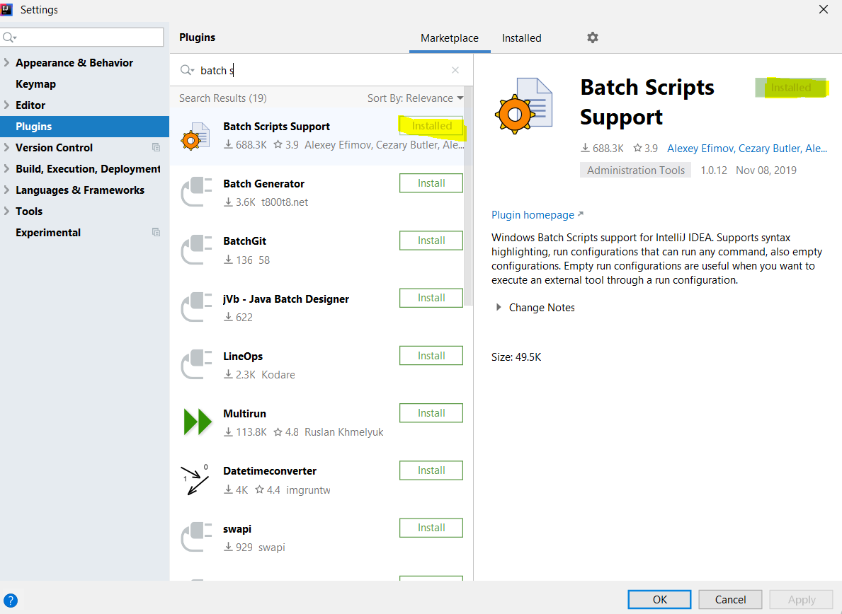

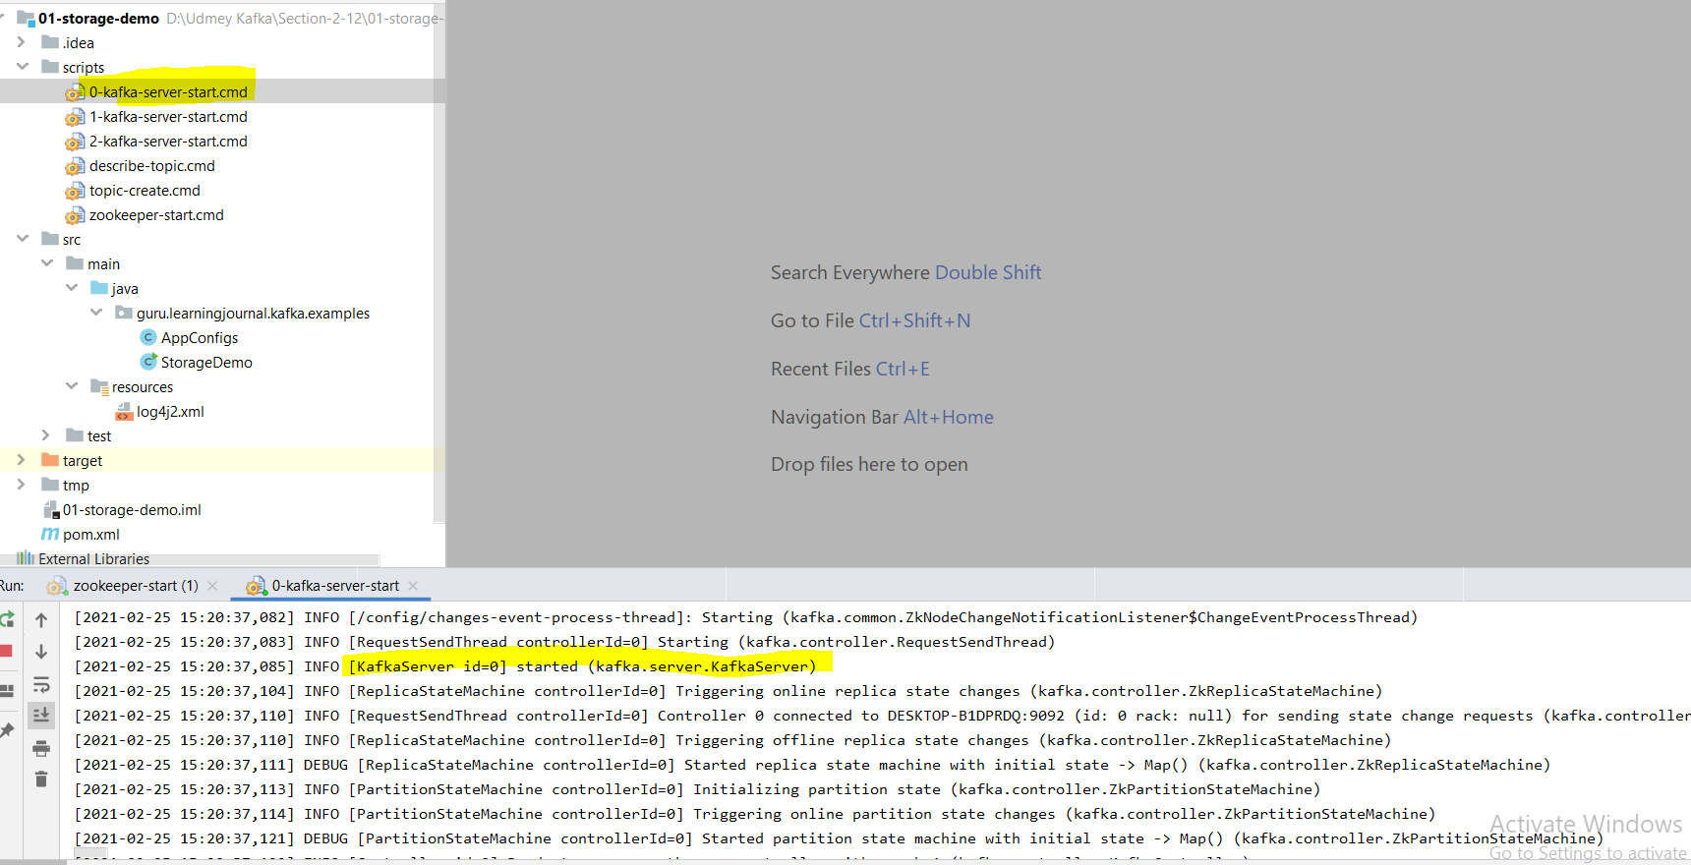

**Kafka broker with id=0 started.**

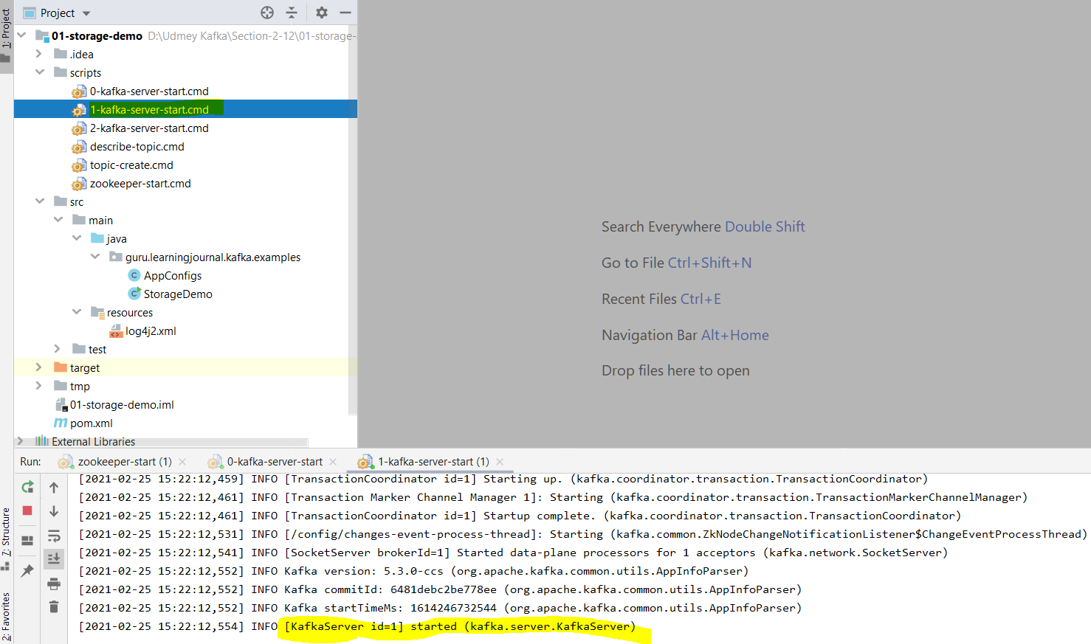

**Kafka broker with id=1 started**

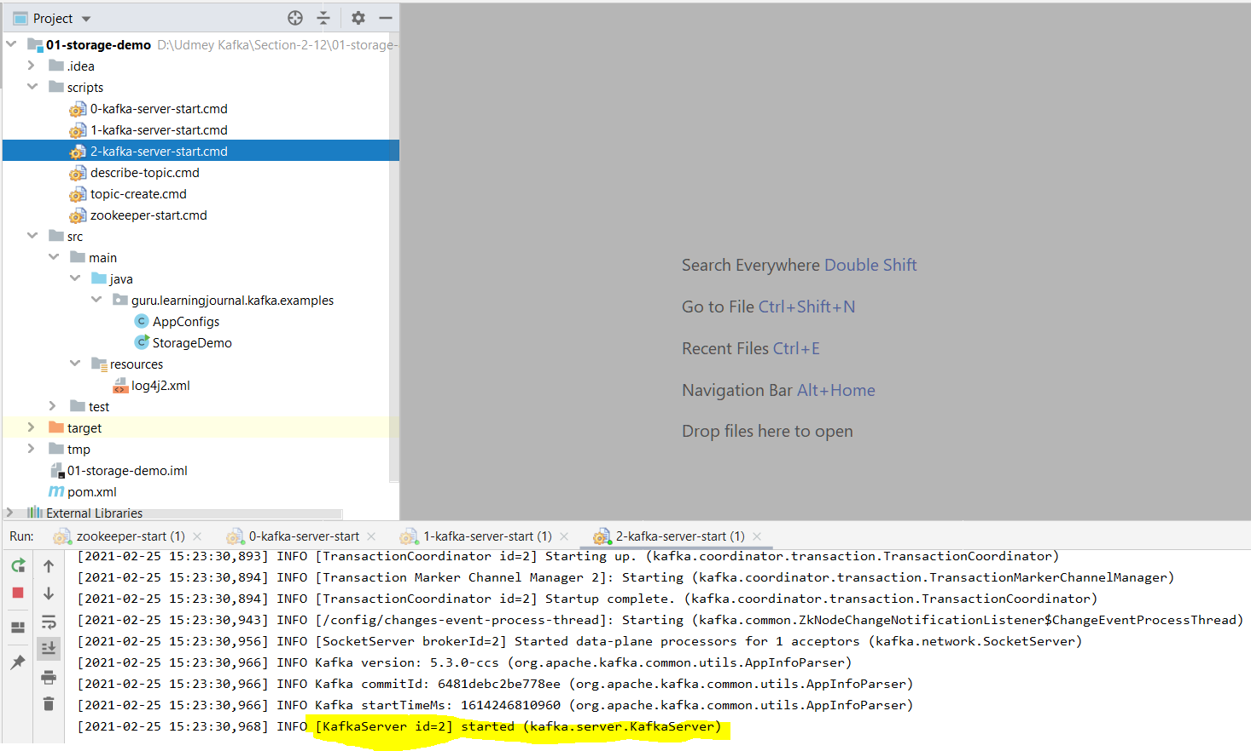

**Kafka broker with Id=2 started**

**So now Kafka zookeeper and all three node of Kafka got started.**

**Now let’s create topic with the command available in Intellij.**

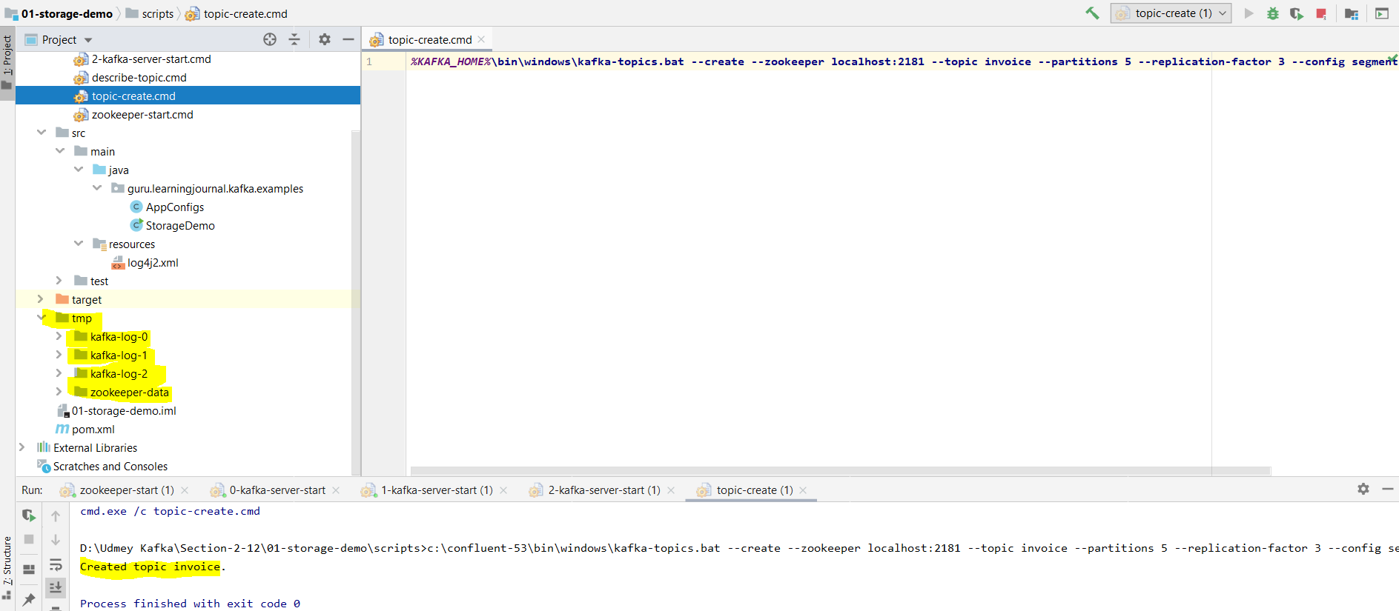

**Now the topic got created and apart from this we can see tmp directory of the zookeeper and Kafka brokers. This is the home log and data directory for Kafka broker and zookeeper that we have got in the current project directory. Now I can send some data, process it and can play with it in the way I want. All the data related to this project will be stored into this directory only. In this way for each project we can manage the data separately in the development phase.**

|  |  |
| --- | --- |
|  | ***%KAFKA_HOME%*\bin\windows\kafka-topics.bat --create --zookeeper localhost:2181 --topic invoice --partitions 5 --replication-factor 3 --config segment.bytes=1000000**  **So as per the above command topic got created into all five partition in each Kafka broker (0, 1, 2) with its replication factor 3. So the numbers of replica will 5x3 = 15 to get the fault tolerance as we can see in the image.** |

**Section-3-13Apache Kafka Storage Architecture: Understanding Kafka Storage Architecture:**

Here we will try to understand Kafka internals and architectural concept:

What is Apache Kafka?

It is just a messaging broker. Everything else is an API, library or a framework to either interact with the Kafka broker or work with the data in real time. Kafka broker is a middle man between producer and consumer and it plays three responsibilities.

|  |
| --- |
|  |

1. Receive messages from the producers and acknowledge the successful receipt.
2. Store the messages in the log file to safeguard it from potential loss.
3. Deliver the messages to the consumers when they request.

That is all at high level. This is what the Kafka broker does. The more elaborated answer could be like as given below.

Apache Kafka is horizontally scalable, fault tolerant, distributed streaming platform.

Based on the above definition let’s try to understand into three easy parts.

1. **Kafka Message Storage Architecture:** Here we will discuss the core concept such as Topic, logs, Partitions, Replication Factor, Segments, Offsets & Offset Index.
2. **Kafka Cluster Architecture:** We will discuss about Cluster formations, Zookeeper, & Controller.
3. **Work Distribution Architecture:** Finally will combine the above two architecture to understand the work distribution in the clusters. We will learn some concept such as Leader, followers, in-sync replicas, committed & un-committed messages.

**Section-3- 13: Kafka Storage Architecture : Kafka Topics and Partitions.**

We have already known that the Kafka organizes the messages in Topics and the brokers create a log file for each topic to store the messages. However these log files are partitioned, replicated and segmented.

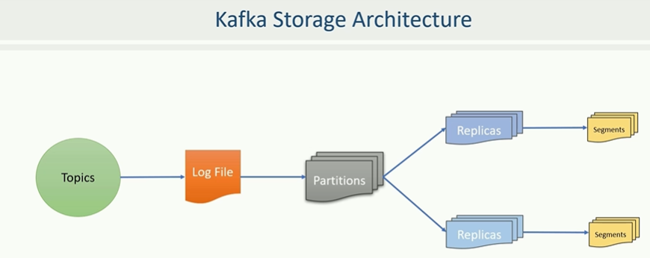

What is Kafka Topic?

|  |  |
| --- | --- |
|  | It is a logical name to group the messages. Like in a data base, we must create a table to store the data records. In the same way in Kafka, we must create a topic to store messages.  Let’s create a topic in the Intellij IDE where we have three node Kafka cluster running in the machine. Let’s try to understand more. |
|  | Here we can see the tmp directory which in-turn contains four directories.  Zookeeper-data: It is a zookeeper data directory where the zookeeper will keep its data.  Other three directories (Kafka-log-0, 1, 2) are the data directories for three Kafka brokers. If we go further in one of the directories then it contains some default created initial files when broker starts and most of the file would be empty at this point.  We have not created any topic yet that is why we do not have any topic file. This is an initial stage of the Kafka broker. Here are trying to understand how the topics are organized at broker level. Let’s create a topic using below command and investigate further to understand. |

**kafka-topics.bat --create --zookeeper localhost:2181 --topic invoice --partitions 5**

**--replication-factor 3 --config segment.bytes=1000000**



Here kafka-topics.bat is the windows batch command and the rest inside the red box are the argument of the command.

**--create** command to create a topic

**--zookeeper localhost:2181 is the zookeeper coordinate.**

**--topic invoice is the name of the topic**

The above three arguments are mandatory to create new topic. When we create a topic in Kafka then we must specify two more arguments, Number of Partition and replication factor. If we don’t provide these two parameter then Kafka assumes default value. But every topic must have some value for partition and replication factor.

After running above command topic got created. That is all about Topic Now let’s talk about topic partition.

**What is Kafka Partition?**

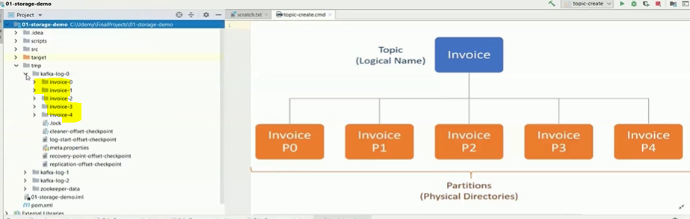

In Kafka a single topic may store millions of messages, and hence it is not practical to keep all messages in single file or computer. The topic partitions are the mechanism to break the topic further into smaller part. So for Kafka a partition is nothing but a physical directory i.e. Kafka creates a separate directory for each partition. Here we have created topic for invoice and specifies 5 partitions. It means Kafka will create 5 directories for invoice topic as shown in the above image.

So Kafka topic partition are noting but directories. If you create a topic with 3 partition then Kafka broker will create three directories, if we ask for 10 then broker will create 10 partitions.

**Section-3- 15: Kafka Storage Architecture: Kafka Topics Replication factor.**

Here we will talk about replication factor. Replication factor is specifying that how many copies you want to maintain for each partition.

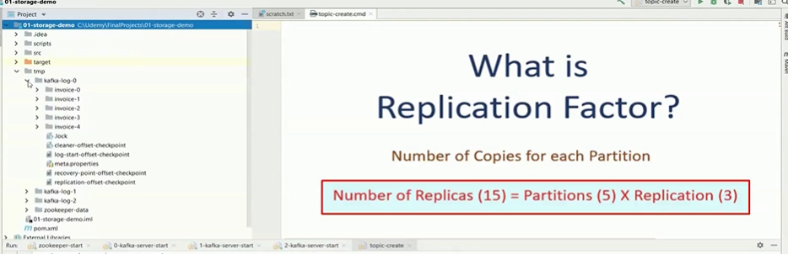

Number of Replicas = number of partitions X number of replication-factor.

For example here we have created topic with 5 partitions and 3 replication factors, then the number of replicas will be (5x3=15). So here we are trying to maintain 3 copies of each partition. Here in this case each of three brokers will have 5 partitions in its home directory kafka-log-1, kafka-log-2, and kafka-log-3 and these are called Partition replica and name will be automatically assigned according to the number of partition in each Kafka home directory start from 0 ( like each home directory have five partition replicas starting from 0 to 5). Hence the number of physical directories will be equal to (5x3=15).

**Section-3- 16: Kafka Storage Architecture: Partition Leaders & Followers.**

Let’s talk about the classification of the partition replicas. Here we will talk about Partition leaders and followers.

We can classify topic partition replicas into two categories.

1. Leader Partition
2. Follower Partition

While creating the topic then we specify the number of partition as 5 and hence Kafka creates 5 directories. These five directories are called the leader partition, so the leaders are created first. Then we also specify replication-factor as 3 it means Kafka will insure three copies for each of these five partitions. Out of three copies one is already there as leader, so now Kafka will create two more directories for each leader and we call these copies as followers.

So followers are the duplicate copies of the leader and all of them are nothing but directories.

|  |  |
| --- | --- |
|  | If we want know, which one is leader and which one is followers then we can use Kafka topic command once again to describe the topic.  c:\confluent-53\bin\windows\kafka-topics.bat --describe  --zookeeper localhost:2181 --topic invoice  And we will get the output as given in the below image. |

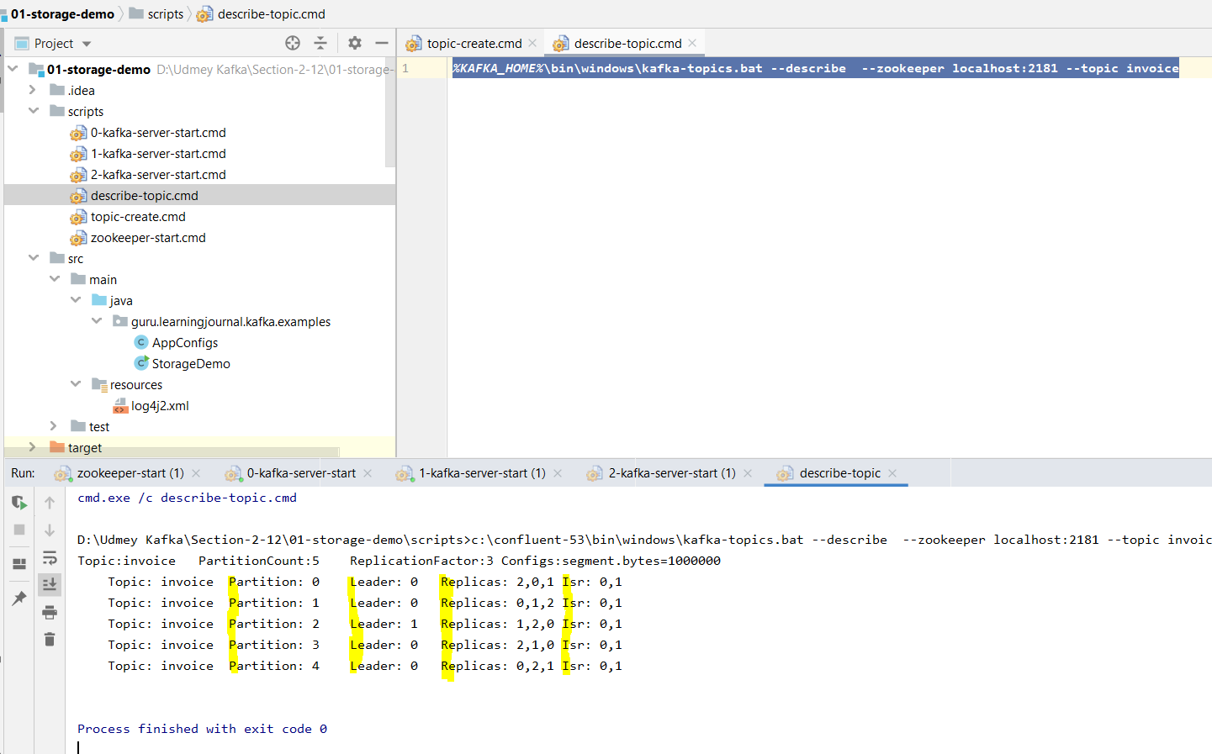

The output clearly tells where the leader resides for the given partitions. The number attached with leader is broker id which holds the leader partition for partition same partition id. For example for the Partition: 0, Leader partition is Leader: 0. for the partition: 2 the leader partition is Leader: 1 and so on.

For the Partition: 0 the Replicas: 2, 0, 1 and Isr (In-sync Replica) : 0,1 . Similarly for remaining.

The number of follower partition depends on replication factor. If replication-factor is 3 then one of the them will be Leader partition and remaining two will be followers.

**Section-3- 17: Kafka Storage Architecture: Kafka Log Segments.**

So we have done with the directories. These directories hold the log files where messages are stored. So now next thing will discuss about log files and log segments.

|  |  |
| --- | --- |
|  | As we know that the messages are stored within the directories in the log file. However instead of creating one large file in the partition directory, Kafka creates several smaller files. In other word Kafka log file gets split into smaller files known as segments.  As here we can seed that in one of the Kafka node we can see the log files in all the partition. These files are noting but segmented files. Similarly in all the partition we will get these segment files. |

Let’s run the producer to send the file in the Kafka topic partition and then will see the log in one of the partition.

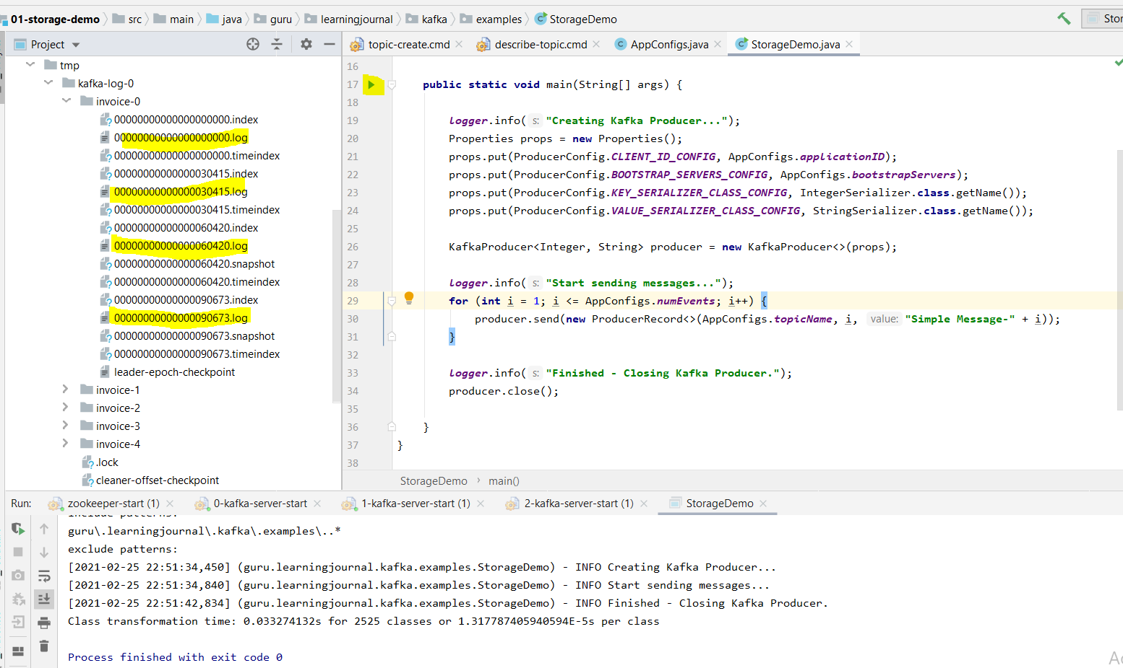

Now we can see the bunch of log segment files in the each invoice partition directories. **But the question arises how it happens?**

So let’s understand the logic behind the splitting log files

When the partition receives its first message, it stores the message in the first segment. The next message also goes in the same segment and the segment file continues to grow until the maximum segment limit is reached. As the Kafka broker writing messages to the partition and if the segment limit is reached then they close the file and start a new segment file. This is how we get multiple segment files in each partition directory.

|  |  |
| --- | --- |
|  | The default maximum segment size is either 1GB of data or a week of data whichever is smaller.  Here in our project we have set the maximum size of segment file is 1 MB that is why we have got several segment file, otherwise the split happens only after  1 GB limit is reached. |

**Section-3- 18: Kafka Storage Architecture: Kafka Message Offset.**

There is one critical thing to understand about Kafka messages which is message Offset.

Each Kafka message in the partition is uniquely identified by a 64 bit integer Offset. Every Kafka message within a single partition is uniquely identified by the Offset. For example the Offset of the first message in the partition would be 0 (zero). The Offset for the second message in the partition would be 1, and so on.

|  |  |
| --- | --- |
|  |  |

This numbering also continues across the segments to keep the Offset unique within the partition. As per the above image let’s assume the Offset of the last message in the first segment is M-30652 and assume that the maximum segment limit is reached. So now the Kafka should close this segment and create a new segment file for the next messages.

The Offset of the first message in the new segment file continues from the earlier segment and hence the offset of the first message in the second segment would start from M-30653.

For easy identification the segment file name is also suffixed by the first offset in that segment file and we can seen in the second column image. First segment log file name is 00000000000000.log and next segment file name is first offset of that segment file i.e. 000000000030415.log and so on.

Note: We should remember, the Offset is unique within the partition. If we look across the partition then the Offset start from zero (0) in each partition. Hence the Offset is a 64-bit integer giving a unique id to the message in a given partition. Since the Offset are not unique across the topic, so if we want to locate a specific message, then we must know at least three things.

1. Topic Name
2. Partition Number
3. Offset Number

**Section-3- 18: Kafka Storage Architecture: Kafka Message Index.**

As we already known that if want to locate a specific message then we must know (Topic Name, Partition Name, Offset Number). At first sight this arrangement of uniqueness looks strange. Let’s try to understand.

If we think in database term, this unique identification does not make any sense for locating a message. The topic name is like a table name in the database, but partition and offset are just numbers. In database applications we can access data from some columns, such as invoice number, customer name or customer id just by writing simple conditional query. However we cannot do the same in Kafka because messages are not structured in the column name and that is why this arrangement of uniqueness looks strange. However the number may not be a problem in real time stream processing in application. How? Let’s understand with an example.

In a stream processing application the requirement is different. A stream processing application wants to read all messages in a sequence. Let’s assume we have a stream processing application that computes loyalty point for the customer in real time. The application should read each invoice and calculate loyalty points, while computing loyalty points then we need customer id and amount but you must read all the events.

|  |  |
| --- | --- |
|  |  |
|  |  |

Let’s looks at the sequence of activities. The application connects to the broker and asked for the messages starting from the Offset zero (0), let’s assume broker sends ten (10) (0 to 9) messages to the application, the application takes few milliseconds and compute loyalty points on those then invoices and now it is again read to process few more messages, so it goes back to the brokers and request for more messages starting from Offset ten (10). The broker provides another batch of 15 (10 – 24) messages. Next time the application request for another set of messages and this process continues to the life of the application.

The process explained in the example shows how the stream processing works. In this process we must have noticed that the consumer application requesting messages based on the Offset. Now the point is straight forward, Kafka allows consumers to starts fetching messages from a given Offset number. It means if consumer demands for messages beginning at Offset 100, the broker must be able to locate the message for Offset 100.

To help broker rapidly find the message for a given Offset Kafka maintain an index of Offsets. The index file is also segmented in the segment file for easy management and they are also stored in the partition directory along with log file segments. We can see the same segment index file in the above image.

**Now let’s talk about the last topic of Kafka Storage Architecture: The Time Index:**

As know now that Kafka allows consumer to start fetching messages based on the offset number, however in many use-cases we might want to seek messages based on time stamp. This requirement is as straight forward as we want to read all the events that are created after a specific time stamp. To support such needs Kafka also maintains a timestamp for each messages, builds a time index to quickly seek the first message which arrive after a give timestamp.

The time index is very similar to offset index and it is also segmented and stored in the partition directory along with the Offset index and log file segments.

We might have seen other type of the file in Partition directory, but file has nothing to do with data. Kafka creates those files to keep some control information and clean up them time to time. We don’t have to care much about those files.

**Section 4- 20: Apache Kafka – Cluster Architecture: Understanding Kafka Cluster:**

In the last section we have discussed about Kafka storage, here in this section we will discuss about Kafka scalability i.e. how Kafka cluster is formed. What is Kafka Cluster?

Kafka brokers are often configured to form a Kafka cluster. A cluster is nothing but a group of brokers which works together to share the work load. This is how Kafka becomes distributed and scalable.

We can start with a single broker in a development environment and deploy a cluster of three or five brokers in our production environment. Later as the work load increases, we can increase the number of brokers in the cluster. It can go up to 100 of brokers in a single cluster. However the concept of clustering brings out two critical question.

1. Cluster Membership? Who manages membership
2. Administrative task? Who perform routine administrative task in the cluster.

|  |  |
| --- | --- |
|  | Let’s try to understand the question first then we will discuss about answer.  In a typical distributed system, there is master node that maintains the list of active cluster members. The Master always knows the state of the other members, so the first question about the Master node, who manages the list of active brokers. Now how does it know that the broker has possibly crashed or a new broker has recently joined the cluster? The second question is also related to the administrative activities which are performed by master in a cluster environment. |

Let’s try to understand with an example.

|  |  |
| --- | --- |
|  | Let’s assume a broker is active and it is taking care of some responsibilities in the cluster. Suddenly the broker leaves the cluster or crashed for some reason. Now at this stage, who will perform the responsibility? We need someone to reassign the work to an active broker to ensure that the cluster continues the function. |

**21. Zookeeper in Kafka**

|  |  |
| --- | --- |
|  | Kafka broker is a master less cluster. It does not follow Master-Slaves architecture. However it uses Apache zookeeper to maintain the list of Active brokers. Every Kafka broker has a unique ID that we define in the broker server.properties configuration file. We also specify the zookeeper connection details in the broker configuration file. When the broker starts, it connects to the zookeeper, and creates an ephemeral (temporary) node using broker id to represent an active broker session. The ephemeral node remains intact as long as the broker’s session with the zookeeper is active. When the broker looses the connectivity with the zookeeper for some reason, the zookeeper automatically removes the ephemeral node. So the list of active brokers in the cluster is maintained as the list of ephemeral node under the broker/ids path in the zookeeper. |

Let’s see that list in the Intellij IDE.

Right click on scrits>Open in Terminal. And we will get Unix terminal to run the unix commands.

|  |  |
| --- | --- |
|  |  |

Let’s open the shell terminal to check the number of active broker ids using below script.

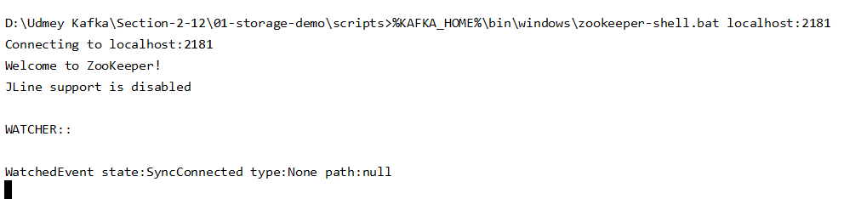



We have got a list of hierarchy

|  |  |  |
| --- | --- | --- |
|  | So we have got three brokers id as shown above  Let’s stop broker with id=0 and check again | So now after stopping one broker we got only to active broker in the list |

So this how the Kafka maintains the list of brokers in the cluster. The list of active broker is maintained as the list of ephemeral nodes under the [brokers/ids] path in the zookeeper.

**22. Kafka Cluster Controller: What is Kafka Controller?**

As we know that Kafka is a master less cluster and the list of active brokers is maintained in the zookeeper. However we still someone to perform routine administrative activities such as monitoring the active list of brokers and reassigning the work when an active broker leaves the cluster.

All these activities are performed by a controller in the Kafka cluster. The controller is not a master, it is simply a broker which is elected as a controller to take up some extra responsibilities i.e. Controller act as regular broker with some extra responsibilities.

So if we have single node cluster then server as controller as well as broker, however there is only one controller in the Kafka cluster at any point in time.

The controller is responsible for monitoring the list of active brokers in the zookeeper. When the controller notices that a broker left the cluster, it knows it is time to re-assign the same work to the other broker in the cluster. The controller election is very simple; the first broker who starts very first in the cluster becomes the controller by creating an ephemeral node in the controller zookeeper.

When other broker starts they also try to create this ephemeral node in the zookeeper to be controller but they receive an exception as Controller node is already exist, which means that the controller is already elected. In that case they start watching and wait the controller node in the zookeeper to be disappearing and if the controller dies or crashed then the ephemeral node disappears. Now every broker again tries to create controller node in the zookeeper, but only one succeeds and others gets an exception once again. This process ensures that there is always controller in the cluster and there exist only one controller.

Let’s see this thing In real in Intellij IDE.

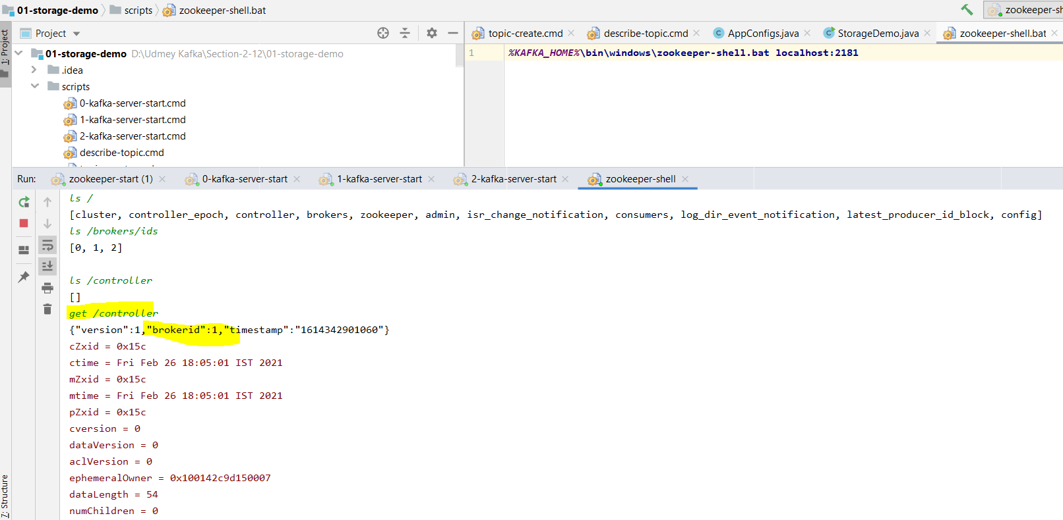

So as we can see that here we have three active brokers and broker id 1 is the controller. Now let’s broker id 1 put down and see

again.

|  |  |
| --- | --- |
|  |  |

Now broker id-0 becomes the controller once the broker id 1 got down. Now again let the broker id -1 put up and see the result. So we can see that once broker id 1 lost the controller it will not get controller position back, here after putting up broker id=1 the controller remains same i.e. broker id 0 is the controller even now broker id -1 is up and running.

|  |  |
| --- | --- |
|  | So this is how Kafka cluster maintains. Now just to summarize, zookeeper is the database of the Kafka cluster controller information and one of the broker in cluster is elected to take up the responsibilities of the controller and takes care of the cluster level activities.  To get the controller information use the query  get /controller |

**23. Partition Allocation and Fault Tolerance**

As we have discussed two core concept of Kafka

1. Partition – log file
2. Cluster formation

Now next logical step is to tie up these two concepts and understand how the work is distributed among the brokers in a Kafka cluster. Basically we want to understand what makes Kafka scalable and fault tolerant system.

Let’s understand first Kafka Fault Tolerant.

|  |  |
| --- | --- |
|  | If we look at the Kafka Topic Organization, it is broken in to independent partition. Each partition is self organized i.e. all the information about the partition such as segment files and indexes are stored inside the same partition directories. This is a very excellent structure because it allows distributing the work among Kafka brokers in a cluster efficiently. All we need to do is to spread the responsibility of partition in the Kafka clusters i.e. when we create topic, the responsibility to create, store and manage partitions is distributed among available brokers in the clusters, it means every Kafka broker in the cluster is responsible for managing one or more partitions which are assigned to that broker and this is how the work is shared by the brokers. |
|  | Now let’s try to understand with the help of example.  As we know that the Kafka cluster is a group of brokers. These brokers may be running on the different individual machines. In a large production cluster, we might have organized those machines in multiple racks. This image shows 6 clusters arranged in two racks. Now question arises, how the partitions are allocated to brokers i.e. how to decide which broker should be maintaining which partition. |

Let’s assume we have decided to create Topic with 10 partition and 3 replication factor. So it means now we have (10x3=30) replicas to allocate to 6 brokers. Kafka tries to achieve just two goals for this partition allocation.

1. **Even Distribution:** Partitions are distributed evenly as much as possible to achieve work load balance.
2. **Fault Tolerance:** Follower partitions (Duplicate Copies) must be placed on different machines achieve fault tolerant.

These are not rule but we can take them as goal that Kafka would want to achieve.

Now let’s see how it got distributed.

To distribute the 30 partition Kafka applies the following steps.

1. Make and ordered list brokers.
2. Assigns the Leaders and followers to the list in order.

|  |  |  |  |
| --- | --- | --- | --- |
|  |  |  |  |

Let’s start with the first step (Making an ordered list of brokers). Kafka begins with the randomly choose broker in a Rack and places it on a list. Let’s say it start with broker zero (0). Now the next broker must be from different rack. So let’s assume Kafka picks broker 3. Now we have two brokers in the ordered list. Now the next one again will be from Rack-1 and let’s say this time it picks broker 1. This goes on as an alternating process for selecting another broker in a different rack. In this we will take broker 4 then broker 2 and finally broker 5.Now we have an ordered list of brokers.

Now let’s come to the second step. Assigning leaders and followers to this ordered list of partition.

As we know we have 30 partitions to allocate to these 6 ordered list of brokers. Ideally Kafka should place 5 partition on each broker to achieve the first goal of the evenly distributing the partitions. However apart from even distribution we have another goal to achieve – Fault-Tolerance. It means we have to make sure if one broker fails for some reason then we should have copy on some other broker. Further making sure that if one of the entire rack fails we still have a copy on a different rack.

|  |  |  |
| --- | --- | --- |
|  |  |  |

For example the first partition has three copies, now we need to make sure that these copies are not allocated to the same broker in the above ordered list.

Once we have ordered list of the brokers, then Kafka uses round robin method to assign each partition to the ordered list of brokers. Kafka starts with the leader partitions and finishes creating or allocating all leaders partition first. So we take the leader partition P0 at first at assign it to broker B0 (B0->P0). Similarly P1 assign to B3 (P1->B3-),(P2->B1), (P3->B4), (P4->B2), (P5->B5) and so on till (P9->B4) .

Once the Leader partitions are assigned to all the brokers, then Kafka start assigning followers to brokers. Now according to round robin method the first followers start from the second broker (B3) in the list, so we skip the first broker in the list and assign first follower (P0) to second Broker B3 (P0->B3) in the list and then (P1->B1),(P2->B4)

|  |  |
| --- | --- |
|  |  |

Once the first line of followers gets allocated to all the 6 brokers then Kafka start assigning the second line of follower to all the brokers by jumping more broker from the previous start. So the P0 of the second line followers will be assigned to B1 (P0-> B1) and so on till (P9->B5) and we are done allocating all the Leaders and followers assignment to the entire list of brokers.

This is what happens when we create a topic. Leaders and followers of the topic are created across the clusters.

|  |  |
| --- | --- |
|  |  |

If we see the outcome of the allocation of the partition then could not achieved perfectly even distribution.Broker B0 got four partitions, Broker B1, B4 has got 6 partitions.However we have got better fault tolerance.

The leader of the fourth partition (P4- Orange) is assigned to Broker B2 and that sits in the first Rack1, however the first line of follower partition 4 (P4- Pink) goes to a different Rack 2 at broker B5.

|  |  |
| --- | --- |
|  | So if one of two Rack (Let’s say Rack 1) is entirely down, we still have one copy of the partition 4 (P4) available on the other Rack 2. Similarly second line of Partition P4 is assigned to B0, so even if two brokers (B2 & B5) are down, we still have one broker available to serve the partition P4. We can check and verify other partition also; they are arranged in such a way that at least two copies are placed on two different Rack and this arrangement is Ideal for fault tolerance. |

So we learned how the replicas are distributed among the brokers in the cluster by making the system fault tolerance. However, distributing the replicas among the brokers is the first half of the work of distribution. The second half of the problem is to define the responsibility of an individual broker

**24. Partition Leader Vs Partition Follower**

Here let’s talk about the responsibilities of Leaders and followers.

We have learned that broker manages two types of partitions.

1. Leader Partition
2. Follower Partition

Depending on the partition type a broker perform two kinds of activities.

1. Leader Activity
2. Follower Activity

Above we have allocated 30 replicas among 6 brokers, and now each broker owns multiple replicas, for example broker B4 holds 6 replicas, and two of these replicas are Leader partitions and remaining 4 are the follower partitions. So in this case the broker B4 act as leader for two partitions (P3 & P9- Orange) and the same broker B4 act as follower for 4 Partitions(P2, P8 & P1, P7).

It means regarding Kafka broker being a leader means- the leader is responsible for the entire request from the producer and consumer.

|  |  |
| --- | --- |
|  |  |
|  |  |

For example let’s assume the producer wants to send some messages to a Kafka topic, so the producer will connect to one of the brokers in the cluster and query for topic Meta data. All Kafka broker can answer Meta data request and hence producer can connect any of the broker query for the Meta data. The Meta data contains the list of all the leader partition and their respective host and port information. Now producer got the list of all leaders, now the producer will decide on which partition it wants to send data and accordingly send the message the respective broker leader, it means producer directly can transfer the message to the leader. Now on receiving the message the leader broker persist the message in the leader partition and sends back an acknowledgement to the producer.

Similarly when a consumer wants to read messages, it always read the message from leader partition.

So in short, the producer and consumer always interact with the leader broker in the Kafka cluster and this is what the responsibility of the Leader broker.

Now let’s talk about followers. As we know that Kafka broker also acts as a follower for the follower partition that is allocated to the broker. As in the 4th fig we can see that Broker B4 has 4 follower partitions and hence broker B4 acts as followers for these four partitions. Followers do not respond the producer and consumer request, their only job is to copy messages from leader partition and keep itself up to date with all the messages.

The aim of the follower is to get elected as a leader when the current leader fails or crashed. So they only one responsibility, just keep sync with the leader.

**Now the question comes how does the follower sync with the leader?**

To stay in sync with the leader, the follower connects with the leader and request for the data, the leader send some messages, and follower store those messages and request for more and this request-response goes on the infinite loop to ensure that the followers are in-sync with the leader.

**25. The ISR List - In Sync Replica** Here now we will talk about ISR list.

We have already learned that the followers continuously copy the messages from the leader and keep in sync with the leader. However some followers becomes fail to be in sync because of various reasons.

1. Network Congestion
2. Follower Broker crash / Restart

|  |  |  |  |
| --- | --- | --- | --- |
|  |  |  |  |

Network congestion can slow down the replication, and hence follower may fall behind. When a follower broker crashes, all the replicas on that broker will begin fall behind until we restart the follower broker and they can start replicating again. Since the replicas may be falling behind, the leader has one more important responsibility to maintain a list of In-sync replicas. This list is known as the ISR list of the partition and persisted in the zookeeper and this list is maintained by the leader broker.

The ISR list is very critical, because all the followers in that list are known to in sync with the leader and they are an excellent candidate to be elected as a new leader when something happens wrong to the current leader. That is why ISR list very critical thing.

However there is one more question comes, how do the leader would know that the follower is in sync or still lagging?

Let’s try to understand that, as we know that the follower will connect to the leader and request for the messages. The first request would ask the leader to send messages starting from the offset=0. Now assume that leader has got ten (10) messages from producer, so now leader send all of them (0-9) to the follower. Now the follower store them into replica, and again request for new messages starting from offset =10. Now in this case since the follower asks for offset 10, it means leader can assume that follower has already persisted all the messages. So by looking at the last request offset by the follower, the leader can tell how far behind the follower replica. In this way ISR list is easy to maintain. If the replica is not too far, the leader would add the follower to the ISR list else follower will be removed from the ISR list. It means ISR list is dynamically maintained by the leader and follower keep getting added and removed from the ISR list dynamically depending on how far they maintain their in-sync status.

However there is doubt here, how do we define replica is not too far to be in sync?

As a matter of fact, the follower will always be little behind the leader, because the messages comes first to the leader and follower ask for the messages to be copied in the replica, and this involves several activities like, receive the message over the network, store them into replica and the again ask for more messages from the leader. All these activities take some times and leader gives them some minimum time as margin to accomplish this. That is where the notion (concept) of too far comes.

The default value, not too far is 10 seconds, however we can increase and decrease in the Kafka configurations.

So the replica kept in the ISR list, if they are not more than 10 second behind the leader. It means if the replica has requested the most recent message in the last 10 second, they deserve to be in the ISR, if not the leader removes the replica from the ISR list.

**26. Committed Vs Un-Committed Records**

The mechanism to maintain the ISR list is very impressive, however we still have (gotcha) caught something here. The maintenance of ISR list leads to some new concept. Let’s try to understand.

|  |  |
| --- | --- |
|  |  |
|  |  |

We already understood that the followers may be lagging behind to the leader for several reasons and they might get removed from ISR list. Let’s assume all the followers in the ISR list are 11 second behind from the leader. It means none of the would be qualified for the ISR list. So the ISR list will become logically empty. And now the messages are only with the leader. Now for some reason, crashed and now we need to elect new leader then whom do we choose?

If we elect a new leader among the followers which are not in the ISR, don’t we lose all the messages which are collected by the leader? Ans: Yes we missed all the messages. Now the question is how do we handle them?

The solution is very simple. Here we have implemented two concepts

1. The first idea is to introduce the notion of **committed and uncommitted messages**.
2. The second idea is to maintain **minimum in-sync replica configuration**.

Let’s try to understand these to concept:

We can configure leader not to consider the messages committed until the messages gets copied at all the followers in the ISR list. If we do this then leader may have some committed as well as some uncommitted messages. The message is committed when it is safely copied in all the replicas in the ISR list. Now if the message is committed then we cannot lose it until we lose all the replicas.

Now if lose the leader we still missed the uncommitted messages. But should not be worried about uncommitted messages, because those can be resent by the producer, because producer can chose the receive an acknowledgement of sent messages only after the messages are fully committed, in that case producer wait for the acknowledgement for given timeout periods and resent the messages in the absence of commit acknowledgement. So uncommitted messages are lost in case of leader fails or crashed, but the newly elected leader will receive those uncommitted messages again from the producer. This is how all the messages can be protected from the lost.

We have understood the first concept – Committed Vs Uncommitted messages and their relation to the ISR list: now let’s try to understand second concept. Minimum ISR List

**27. Minimum ISR List:**

As in the previous concept we have talked about committed Vs uncommitted messages in the replica.

|  |  |
| --- | --- |
|  |  |

The data is said to be committed when it is written to all the In-sync replicas. Let’s assume we have started with three replicas and all are properly listed in the ISR, let’s assume after some time two of them got failed and leader will both of them from ISR (Tow replica (B2 & B4) got removed from the ISR as they both got failed.)

In this case even though we configured a topic to have three In-sync replicas but now we are left with single In-sync replica which is nothing but leader itself. Now data is being considered committed when it is written to all In-sync replicas but here now we have only one replica, so not it is risky scenario, because data could be lost if we lose the leader.

Kafka protects this scenario by setting the minimum number of In-sync replicas for a topic. If we would like to be sure that the committed data is written to at least two replicas, then we need to set the minimum number of In-sync replicas as 2 using this (min.insync.replicas=2).

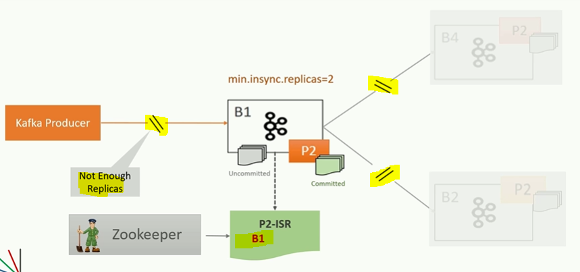

There is one side effect of this setting, If a topic has three replicas and we set (min.insync.replicas=2) then we can only write to the partition in the topic if at least two out of three replicas are In-sync. When at least two replicas are not in sync, the broker will not accept any messages and respond with not-enough replicas exceptions.

In other words, now the leader becomes the read-only partition. We can read but we cannot write until we bring another replica online and wait of it to catch-up and get it in-sync.

**Section 5: Kafka Producer Internals:**

**28. Introducing Kafka Producers:**

In the earlier section we have learned about the following topics: Kafka Broker, Kafka Cluster & Kafka Architecture.

Sending data stream to Kafka is the first step for using Apache Kafka. Here we are going to discuss about this first step in detail.

|  |  |
| --- | --- |
|  | Kafka Producer APIs: It is primarily made available in java, however the APIs are also available in other languages like - c++, .Net, Go, Python  Node.js. |

**29. Creating your first Kafka Producer**

Let’s write some example to understand sending data to the Apache Kafka.

**Creating Kafka Producer:**

|  |  |
| --- | --- |
|  | Let’s try to understand using problem-solution approach, here we will discuss about problem first then we will provide solution for the given problem. |

1. **Let’s create an empty starter project (hello-producer).**
2. **Here we have POM.xml with all dependencies**
3. **We have created one log4j2.xml**
4. **Created on AppConfig class with some static constant for further use**
5. **Added some batch script to start Kafka cluster on the local machine**
6. **Here we will setup three node Kafka cluster in the local machine**
7. **We will write our first producer client**
8. **Create a class with main method with name HelloProducer.java**
9. **Sending data to Apache Kafka is multi step process**
10. **First step is to create java Properties object and put some necessary configurations, because Kafka producer API is highly configurable and we customize behavior by setting different producer configurations. In this example we will setup four basic configuration, which are the bare minimum configuration for the producer to work**
11. **The first configuration is the Producer client config ID, which is simple string passed to the Kafka server. The purpose of the client id is to track the source of the message**
12. **The second one is Bootstrap Server Config. It is a comma separated list of Host, Port pairs. The producer will use this information for establishing the initial connection to the Kafka cluster. If we are running on single node Kafka we can supply individual host, port information. The Bootstrap configuration is used only for initial connection. Once connected the Kafka producer will automatically query for the Meta data and discover the full list of Kafka brokers in the cluster.**
13. **Remaining two mandatory configurations are the Key and the value Serializer. A Kafka message must have a key value structure i.e. each message that we want to send to Kafka server should have a key and value. We can have null key but message should be structured in Key-Value pair. Since the Kafka messages are sent over the network, so the key and value must be serialized bytes before they are streamed over the network.**

**Note: Kafka producer API comes with the bunch of ready to use Serilizer classes. In this example we are setting integer Serilizer for key and a string Serilizer for the message value.**

**This is all about first step.**

**Step 2:**

1. **Here in this step we will create an instance of KafkaProducer constructer<Integer,String> and will pass the properties object that we have set earlier**

**Step 3:**

1. **Start sending messages Kafka using send method of KafkaProducer class**
2. **Here the send method will take ProducerRecord Object, which further takes three parameter (KafkaTopicName, messageKey, MessageValue)**

**Step 4:**

1. **The final step is to Close the Producer instance. Producer does a lot internally. The producer consists of some buffer space and a background IO thread. If do not close the producer after sending all the required messages, it will leak the resources created by producer.**

**In short:** Sending messages to Kafka using Producer API is four step processes. In the first step we will set some configurations which will control the behavior of the producer API. In the second step is to create producer object. The third step is to send all the messages. In the last step when all the messages has been sent then close the producer.

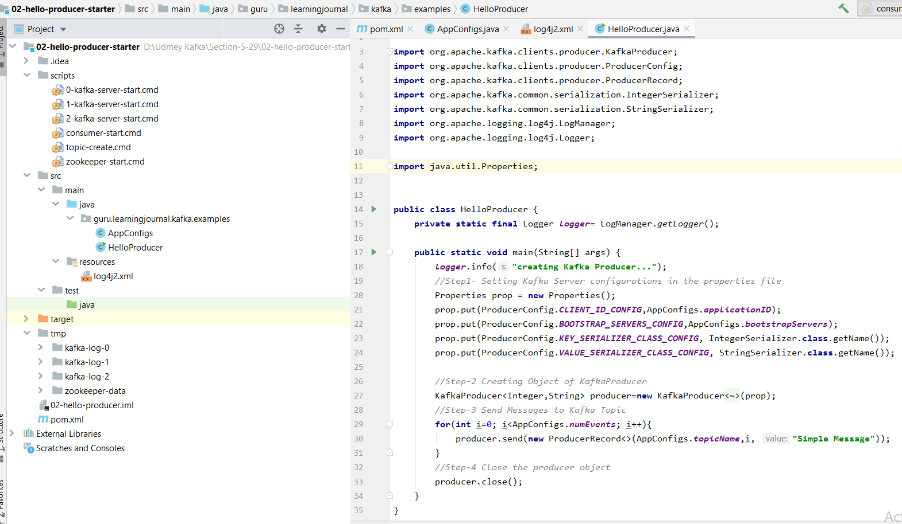

|  |
| --- |
| *Pom.xml*  *<?***xml version="1.0" encoding="UTF-8"***?>* <**project xmlns="http://maven.apache.org/POM/4.0.0"  xmlns:xsi="http://www.w3.org/2001/XMLSchema-instance"  xsi:schemaLocation="http://maven.apache.org/POM/4.0.0 http://maven.apache.org/xsd/maven-4.0.0.xsd"**>  <**modelVersion**>4.0.0</**modelVersion**>  <**groupId**>guru.learningjournal.kafka.examples</**groupId**>  <**artifactId**>hello-producer</**artifactId**>  <**version**>2.3.0</**version**>  <**properties**>  <**java.version**>1.8</**java.version**>  <**kafka.version**>2.3.0</**kafka.version**>  </**properties**>  <**build**>  <**plugins**>  *<!-- Maven Compiler Plugin-->* <**plugin**>  <**groupId**>org.apache.maven.plugins</**groupId**>  <**artifactId**>maven-compiler-plugin</**artifactId**>  <**version**>3.8.0</**version**>  <**configuration**>  <**source**>${java.version}</**source**>  <**target**>${java.version}</**target**>  </**configuration**>  </**plugin**>  </**plugins**>  </**build**>  <**dependencies**>  *<!-- Apache Kafka Clients-->* <**dependency**>  <**groupId**>org.apache.kafka</**groupId**>  <**artifactId**>kafka-clients</**artifactId**>  <**version**>${kafka.version}</**version**>  </**dependency**>  *<!-- Apache Log4J2 binding for SLF4J -->* <**dependency**>  <**groupId**>org.apache.logging.log4j</**groupId**>  <**artifactId**>log4j-slf4j-impl</**artifactId**>  <**version**>2.11.0</**version**>  </**dependency**>  </**dependencies**> </**project**> |
| *Log4j2.xml*  *<?***xml version="1.0" encoding="UTF-8"***?> <!--  ~ Copyright (c) 2018. Prashant Kumar Pandey  ~ Licensed under the Apache License, Version 2.0 (the "License");  ~ You may not use this file except in compliance with the License.  ~ You may obtain a copy of the License at  ~ http://www.apache.org/licenses/LICENSE-2.0  ~ Unless required by applicable law or agreed to in writing,  ~ software distributed under the License is distributed on an "AS IS" BASIS,  ~ WITHOUT WARRANTIES OR CONDITIONS OF ANY KIND, either express or implied.  ~ See the License for the specific language governing permissions and limitations under the License.  -->* <**Configuration status="ERROR"**>  <**Appenders**>  <**Console name="stdout" target="SYSTEM_OUT"**>  <**PatternLayout pattern="[%d] (%c) - %p %m %n"**/>  </**Console**>  </**Appenders**>  <**Loggers**>  <**Root level="error"**>  <**AppenderRef ref="stdout"**/>  </**Root**>  <**Logger name="org.apache.kafka.clients" level="warn" additivity="false"**>  <**AppenderRef ref="stdout"**/>  </**Logger**>  <**Logger name="guru.learningjournal.kafka.examples" level="trace" additivity="false"**>  <**AppenderRef ref="stdout"**/>  </**Logger**>  </**Loggers**> </**Configuration**> |
| **package** guru.learningjournal.kafka.examples;  **class** AppConfigs {  **final static** String ***applicationID*** = **"HelloProducer"**;  **final static** String ***bootstrapServers*** = **"localhost:9092,localhost:9093"**;  **final static** String ***topicName*** = **"hello-producer-topic"**;  **final static int *numEvents*** = 1000000; } |
| ***Kafka Zookeeper***  ***%KAFKA_HOME%*\bin\windows\zookeeper-server-start.bat *%KAFKA_HOME%*\etc\kafka\zookeeper.properties** |
| ***Kafka Node1***  ***%KAFKA_HOME%*\bin\windows\kafka-server-start.bat *%KAFKA_HOME%*\etc\kafka\server-0.properties** |
| ***Kafka Node1***  ***%KAFKA_HOME%*\bin\windows\kafka-server-start.bat *%KAFKA_HOME%*\etc\kafka\server-1.properties** |
| ***Kafka Node1***  ***%KAFKA_HOME%*\bin\windows\kafka-server-start.bat *%KAFKA_HOME%*\etc\kafka\server-2.properties** |
| ***Kafka Topic Creation***  ***%KAFKA_HOME%*\bin\windows\kafka-topics.bat --create --zookeeper localhost:2181 --topic hello-producer-topic --partitions 5 --replication-factor 3** |
| ***Kafka Consumer***  ***%KAFKA_HOME%*\bin\windows\kafka-console-consumer.bat --bootstrap-server localhost:9092 --topic hello-producer-topic --from-beginning** |

**Kafka producer class:**

|  |  |
| --- | --- |
| **package** guru.learningjournal.kafka.examples;  **import** org.apache.kafka.clients.producer.KafkaProducer; **import** org.apache.kafka.clients.producer.ProducerConfig; **import** org.apache.kafka.clients.producer.ProducerRecord; **import** org.apache.kafka.common.serialization.IntegerSerializer; **import** org.apache.kafka.common.serialization.StringSerializer; **import** org.apache.logging.log4j.LogManager; **import** org.apache.logging.log4j.Logger;  **import** java.util.Properties;   **public class** HelloProducer { **private static final** Logger ***logger***= LogManager.*getLogger*();  **public static void** main(String[] args) { ***logger***.info(**"creating Kafka Producer..."**); *//Step1- Setting Kafka Server configurations in the properties file* Properties prop = **new** Properties(); prop.put(ProducerConfig.***CLIENT_ID_CONFIG***,AppConfigs.***applicationID***); prop.put(ProducerConfig.***BOOTSTRAP_SERVERS_CONFIG***,AppConfigs.***bootstrapServers***); prop.put(ProducerConfig.***KEY_SERIALIZER_CLASS_CONFIG***, IntegerSerializer.**class**.getName()); prop.put(ProducerConfig.***VALUE_SERIALIZER_CLASS_CONFIG***, StringSerializer.**class**.getName());  *//Step-2 Creating Object of KafkaProducer* KafkaProducer<Integer,String> producer=**new** KafkaProducer<Integer, String>(prop);  *//Step-3 Send Messages to Kafka Topic* **for**(**int** i=0; i<AppConfigs.***numEvents***; i++){  producer.send(**new** ProducerRecord<>(AppConfigs.***topicName***,i, **"Simple Message"**)); } *//Step-4 Close the producer object* producer.close(); } } | |
|  |  |

**Kafka Producer Internals:**

**30. Producer Record**

Here we will learn how the producer API works.

Kafka producer API is very straight forward. We can create a producer by setting some essential configurations and start sending messages using send method. There is only one restriction that we must package our message in a producer record object.

Here is seems, send method is straight forward but a lot of things behind the scene.

|  |  |  |
| --- | --- | --- |
|  |  |  |

We package the message content in the ProducerRecord object with at least two mandatory arguments (Kafka TopicName, MessageValue). Kafka Topic name is the destination address of the message and the message value is the main content of the message. Other than these two mandatory objects, we can also specify the following options [TargetPartition, TimeStamp, and MessageKey]

The MessageKey is one of the most critical mandatory arguments and it is used for many purposes, such as partitioning, grouping and joins.

TargetPartition and TimeStamp are purely optional and very rarely we will require to set these arguments. The ProducerRecord object wraps our message content with all necessary information such as TopicName, Key & TimeStamp once created, we can hand over it to Kafka producer using the send method.

**31. Producer Serializer**

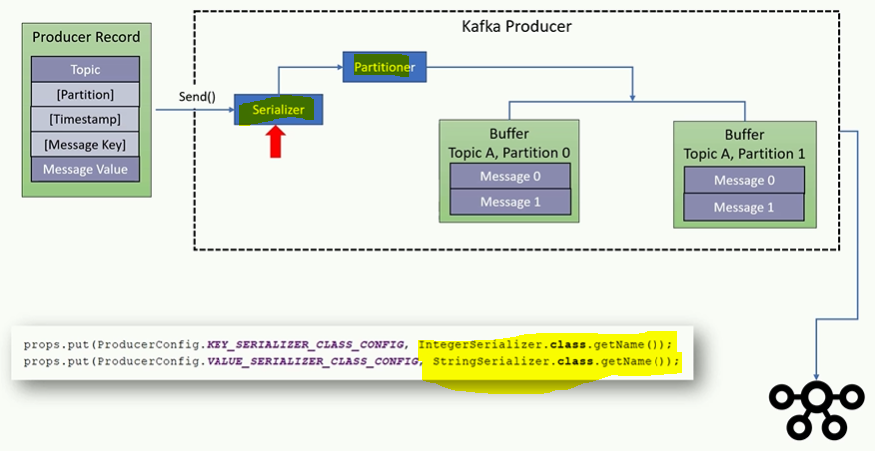

The Kafka producer is supposed to transfer the record to Kafka broker over the network. However it does not immediately transfer the records. Every records goes through serialization, Partitioning and then it is kept into buffer.

The serialization is necessary to send the data over the network. Without serialization we cannot transmit the data to the remote location. However Kafka does not know, how to serialize Message Key and Message value, that is why specifying key serialization and value serialization is mandatory that we supply as the part of Kafka producer configuration as per the diagram.

In the earlier example we have used IntegerSerializer for message key and StringSerializer for message value. These serializer is most basic Serializer and they do not cover most of the use cases. In real life scenario our project values are represented by complex java object and these object must be serialize before the producer can transmit to the remote network. Kafka provides generic Serializer library like Avro and Threft and apart from this we can create our custom Serializer also.

**32. Producer Partitioner**

As we already learned every producer record includes a mandatory TopicName as the destination address of the data and we also know that Kafka Topics are partitioned and hence producer should also decide that on which partition the message should be sent.

There are two approaches to specify the target partition number for the message. Set partition number argument in the ProducerRecord object as mentioned in the above diagram. Or by configuring Partitioner class in the Kafka producer to determine the partition number at run time.

|  |
| --- |
| prop.put(ProducerConfig.***PARTITIONER_CLASS_CONFIG***,MyPartitioner.**class**.getName()); |

As we already know that the partition number is optional in the ProducerRecord object while using producer send method and this approach is rarely used in the ProducerRecord object instead we set the ***PARTITIONER_CLASS_CONFIG*** Partitioner class in the property which implements our desired portioning strategy and assign partition number to each message at runtime. We can specify a custom Partitioner Class using the property object as we have mentioned in the above line.

Even creating custom partition class and configuring using property object is completely optional, because Kafka producer comes with default partitioner which is most commonly used partitioner.

The default partitioner takes two objects to determine the dentition Topic address.

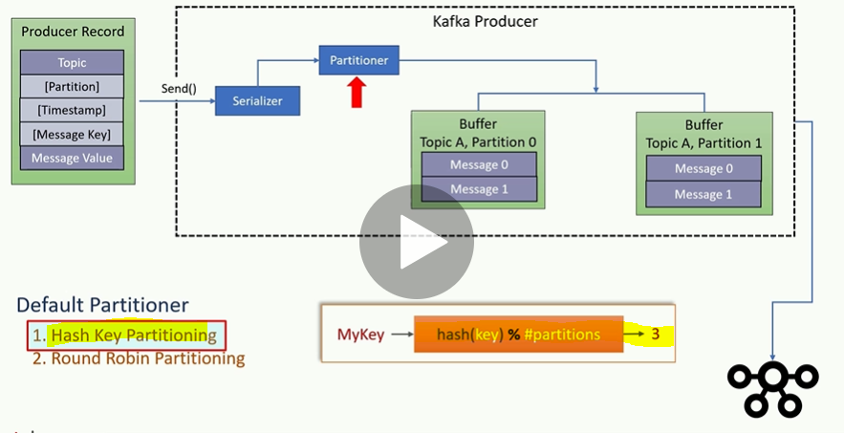

Default Partitioner:

1. Hash Key Partitioning
2. Round Robin Partitioning

**Hash Key Partitioning**

The first approach is approach is based on message key, when the message key exist, the default partitioning use a hashing algorithm on the key to determine the partition number for the message. It is as simple as hashing the key to convert it into a numeric value and then use the hash number. The hashing ensures that all the messages with the same key go to the same partition. However this algorithm also takes the total number of partitions as one of the input. So if we increase the number of partition in the topic, the default partitioner starts giving a different output i.e. if the partition is based on the Key then we should create a topic with enough partitions and never increase it at the later stage.

Note: During partition create we have to be very careful, if we need 100 partitions then we can provisioned with 25% and we can increate 25 more partition. After message sent to topic, if we increase the number of partition then we may have to re-distribute the existing messages.

**Round Robin Partitioning:**

When the message key is null then the default partitioner will use Round Robin Method to achieve an equal distribution among the available partitions. It means the first message goes to first partition, second message goes to second partition, and partitioner repeats it in a loop. The default partitioner is the most commonly used partitioner in most of the use cases. However Kafka allows us to implements portioning strategy by implementing a custom partitioner class. But we may not even need t to implement custom partition class in most of the cases.

**33. Message Timestamp**

As in the earlier discussion and in the figure we already learned that MessageTimeStamp is an optional argument inside the ProducerRecord object. However for a real time stream application the timestamp is the most critical value and for this reason every message in Kafka automatically timestamp even if we do not explicitly specify it.

Kafka allows us one of the two type of message time stamping mechanism

1. Create Time
2. Log append Time

The create time is the time when the message was produced. The log append time is the time when the message received at the Kafka broker. However we cannot use both. Our application must decide between these two timestamping method while creating the topic.

Setting up a default time stamp method for a topic is very simple. We can set as by given syntax: **message.timestamp.type**=0 configuration to zero (0) for using create time and **message.timestamp.type**=1 for Log append time.

The default value is zero (0) means create time. The producer API automatically sets the current producer time to the producer record timestamp field. However we can overwrite the default timestamping by explicitly specifying this argument, So the message is transmitted with a producer time either with the default value (0) or explicitly set by the developer. When using Log append time configuration, the broker will overwrite the producer time stamp with its current local time before appending message to the log. In this case producer time is overwritten by the Kafka broker time. However the message will always have a timestamp either producer time or broker time.

It’s recommended to use default configuration as create time stamp whenever using producer APIs to bring data to Kafka broker, because the producer API automatically assigns a timestamp.

**34. Producer Message Buffer:**

In the previous discussion we understood, Message Key, Value, serialization and partitions regarding Producer, however still a lot is going inside the producer **like Producer Message buffer**.

Once the message is serialized and assigned partition number, the message goes and sits to the buffer and waiting to be transmitted. The Producer Object consists of a partition wise buffer space that holds record which have not yet sent to the Kafka server. Producer also runs a background I/O thread which is responsible for turning these records into request and transferring them to the cluster. **Now question comes why do we have buffering?**

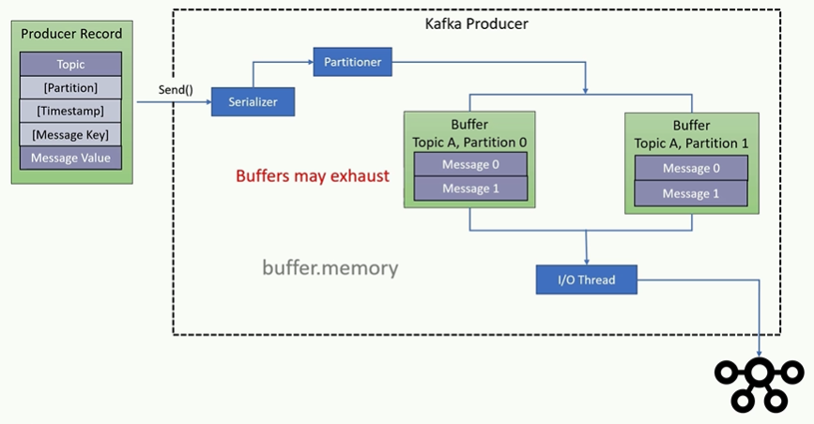

The Buffer of message is designed to offer two advantages

1. To get Asynchronous ability
2. Network round trip optimization

Buffering arrangement makes the send () method Asynchronous, it means the send () method will add the buffer and return without blocking and those record are then transmitted by the background I/O thread. This arrangement looks very convincing as the send () method is not delayed for the network operation.

Buffering also allows the background I/O thread to combine multiple messages from the same buffer and transmit them together as a single packet to achieve better throughput. But there is a critical consideration here, if records are posted faster than transmitted to the server then this buffer space will be exhausted and the next send message will be block for few milliseconds until the buffer is freed by the I/O thread. If I/O thread takes too long to release the buffer then the send method throws a timeout exception. When we are seeing such timeout exception then we need to increase the producer memory. The default producer memory size is 32 MB and we can expand the total memory allocated for the buffer by setting **[buffer.memory]** producer configuration.

**35. Producer IO Thread and Retires**

Here we will discuss about producer Retries which is performed by the background I/O thread. As we know that the producer background I/O thread is responsible for transmitting serialized messages which are waiting in the Topic partition buffer.

When the broker receives the message, it sends back an acknowledgement, if the message is successfully written to Kafka then broker will return a success acknowledgement and if the broker fails to write the message then it would return an error.

When the background I/O thread receives an error and does not receives and acknowledgement then it may retries sending the message a few more times before giving and throwing an error.

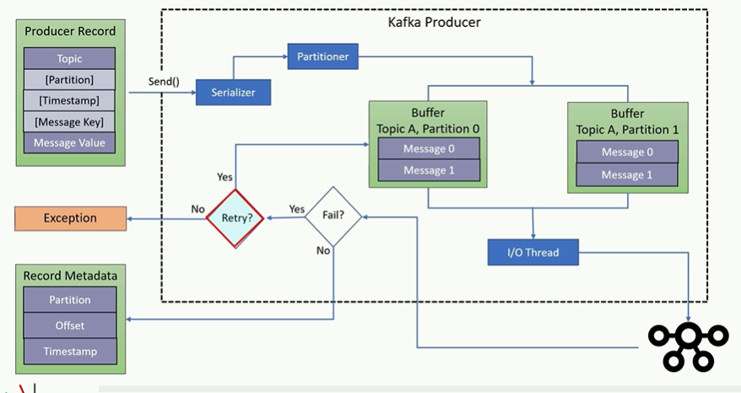

We can control the number of retries by setting the retries producer configuration, when all the retries are fails then the I/O thread will return error to the send () method

**36. Summarizing Producer Internals**

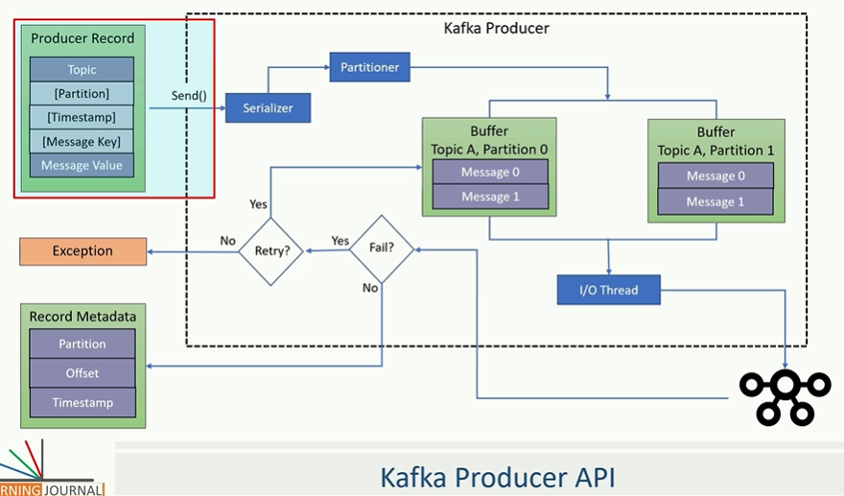

So we learned the Producer Internal working. Now let’s summarize all.

We have used producer.send() method to handover the producer record to the Kafka producer object.

The Kafka Producer Object internally will serialize the message key and message value. And we provide the Serilizer using the property object.

Now the producer will determine the target partition for the message to be delivered. Here we will either provide the custom class or provide the key and let the producer use the default partitioner.

The serilized messages goes and sits to the buffer depending upon the destination address. For each destination we have separate buffer.

Finally an I/O thread which runs in background will pick up some messages from the buffer and combine them to make one single data packets and send it to the broker. The broker will save the data into log file and send back an acknowledgement to the I/O thread.

Now if the I/O thread does not receive an acknowledgement then it will try resending the packet and again wait for an acknowledgement. If we do not get an acknowledgement at all even after some retries or get an error message then I/O thread will send error or exception to the send () method.

**Section 6: Advanced Kafka Producers**

**37. Horizontal Vs. Vertical Scalability**

In the earlier section we have created one simple Kafka producer and sent one million messages to the Kafka server. But Kafka is all about scalability. Here we will discuss about the scaling up the producer.

Apache Kafka is designed with the scalability in mind.

|  |  |
| --- | --- |
|  |  |

As per the figure we can see that multiple producers are sending messages to one Kafka broker in parallel. At the cluster end it is the Kafka broker which receives the messages and acknowledge successful receipt of the message. So if we have 100 of producer sending messages in parallel then we may want to increase the number of broker at the cluster end. In the same can keep increasing Kafka producers and Kafka broker to manage the messages. This approach is called Linier scalability.

|  |
| --- |
|  |

However we also have an option to increase individual producer using multithreading technique. A single producer thread is good enough to support the use cases where the data is being produced at a reasonable pace. However some scenario may require parallelism at the individual producer level and in this can handle using multithreaded Kafka producer. The multithreaded scenario only applicable for the application which frequently generate new messages.

For example a POS system sending invoice messages in every 2 to three minute, in that case only single thread Kafka producer is enough. But if want to send and receive data at a high speed then in that case we may want multithread environment.

38. Producer Multi-Threading Scenario: When to apply multithreading

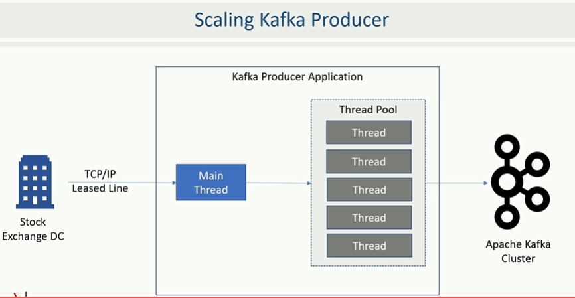

Let’s assume stock market data provider application. The application receives tic by tic data packets from the stock exchange over the TCP/IP socket, the data packets are arriving at high frequency, so we decided to have a multithreaded handler. The main thread listen to the socket and reads the data packet as they arrives, but immediately hand over the data packet to a different thread (thread pool having multiple thread in parallel) for sending data to the Kafka broker and main thread again start reading data packet. The other threads are responsible for un-compressing the packets, reading individual messages from the packet, validating the message and sending it further to the Kafka broker. Similar scenario is common in several other applications also where the data arrives at high speed and we may need multiple application thread to handle the load. Kafka producer is threading safe. So our application can share the same producer object across multiple threads and send messages in parallel using the same producer instance. It is not recommended to create several producer objects within the same application instance. Sharing the same producer object across the thread will be faster and less resource intensive.

**39. Creating Multi-Threaded Kafka Producer: hand-on**

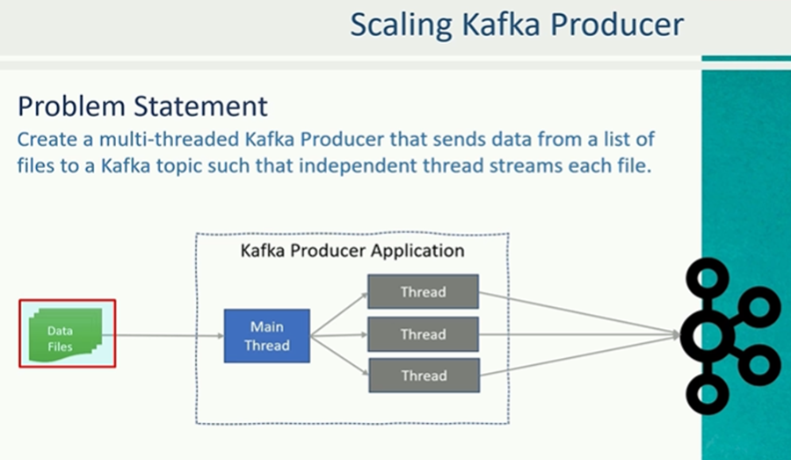

Problem : Assume we have multiple data files and we want to send data from all those files to the Kafka cluster. So basically here we will create one main thread which reads the bunch of data files and create one independent thread which process each data file. For example if we are supplying three data file, then it must create three thread one for each data file. Each thread is responsible for reading data from one file and sending them to Kafka cluster in parallele. In all this we do not want to create Kafka producer instances. But as recommended best practice we want to share the same Kafka producer instance among all threads. So the problem is defined.

Solution: Like an earlier hands on we will have the project for multi-threading-starter.

1. Pom.xml for dependencies
2. Pre-configured log4j
3. Script to start Kafka cluster
4. Script to create Kafka topic
5. Script for console consumer to look the receive messages at Kafka broker.
6. Included two sample file to be read
7. Now we will write multi-threaded producer to send data from these file to the Kafka cluster.
8. We will have one AppConfig.java class where we will define some constant which will be used later in the Kafka producer property configuration.
9. We will have kafka.properties file to help to understand how we can keep some producer level configurations outside the source code. Basically we want to keep the Kafka broker coordinates outside the application code.

To solve this problem we need at least two classes. The first one is required to create a producer thread. So we will implement Java Runnable Interface with class Dispathcer.java implements Runnable. The Dispatcher class will read all the data from the files and then using send() will send all the data into Kafka topic.

**producer**.send(**new** ProducerRecord<>(**topicName**, **null**, line));

Another important class : DispatcherDemo.java

|  |  |
| --- | --- |
|  | *<?***xml version="1.0" encoding="UTF-8"***?>* <**project xmlns="http://maven.apache.org/POM/4.0.0"  xmlns:xsi="http://www.w3.org/2001/XMLSchema-instance"  xsi:schemaLocation="http://maven.apache.org/POM/4.0.0 http://maven.apache.org/xsd/maven-4.0.0.xsd"**>  <**modelVersion**>4.0.0</**modelVersion**>   <**groupId**>guru.learningjournal.kafka.examples</**groupId**>  <**artifactId**>multi-threaded producer</**artifactId**>  <**version**>2.3.0</**version**>  <**properties**>  <**java.version**>1.8</**java.version**>  <**kafka.version**>2.3.0</**kafka.version**>  </**properties**>  <**build**>  <**plugins**>  *<!-- Maven Compiler Plugin-->* <**plugin**>  <**groupId**>org.apache.maven.plugins</**groupId**>  <**artifactId**>maven-compiler-plugin</**artifactId**>  <**version**>3.8.0</**version**>  <**configuration**>  <**source**>${java.version}</**source**>  <**target**>${java.version}</**target**>  </**configuration**>  </**plugin**>  </**plugins**>  </**build**>  <**dependencies**>  *<!-- Apache Kafka Clients-->* <**dependency**>  <**groupId**>org.apache.kafka</**groupId**>  <**artifactId**>kafka-clients</**artifactId**>  <**version**>${kafka.version}</**version**>  </**dependency**>  *<!-- Apache Log4J2 binding for SLF4J -->* <**dependency**>  <**groupId**>org.apache.logging.log4j</**groupId**>  <**artifactId**>log4j-slf4j-impl</**artifactId**>  <**version**>2.11.0</**version**>  </**dependency**>  </**dependencies**> </**project**> |

|  |
| --- |
| Log4j2.xml  <**Configuration status="ERROR"**>  <**Appenders**>  <**Console name="stdout" target="SYSTEM_OUT"**>  <**PatternLayout pattern="[%d] (%c) %p - %m %n"**/>  </**Console**>  </**Appenders**>  <**Loggers**>  <**Root level="error"**>  <**AppenderRef ref="stdout"**/>  </**Root**>  <**Logger name="org.apache.kafka.clients" level="warn" additivity="false"**>  <**AppenderRef ref="stdout"**/>  </**Logger**>  <**Logger name="guru.learningjournal.kafka.examples" level="trace" additivity="false"**>  <**AppenderRef ref="stdout"**/>  </**Logger**>  </**Loggers**> </**Configuration**> |
| **AppConfig.java**  **package** guru.learningjournal.kafka.examples;  **class** AppConfigs {  **final static** String ***applicationID*** = **"Multi-Threaded-Producer"**;  **final static** String ***topicName*** = **"nse-eod-topic"**;  **final static** String ***kafkaConfigFileLocation*** = **"kafka.properties"**;  **final static** String[] ***eventFiles*** = {**"data/NSE05NOV2018BHAV.csv"**,**"data/NSE06NOV2018BHAV.csv"**}; } |
| **package** guru.learningjournal.kafka.examples;  **import** org.apache.kafka.clients.producer.KafkaProducer; **import** org.apache.kafka.clients.producer.ProducerRecord; **import** org.apache.logging.log4j.LogManager; **import** org.apache.logging.log4j.Logger;  **import** java.io.File; **import** java.io.FileNotFoundException; **import** java.util.Scanner;  **public class** Dispatcher **implements** Runnable {  **private static final** Logger ***logger*** = LogManager.*getLogger*();  **private** String **fileLocation**;  **private** String **topicName**;  **private** KafkaProducer<Integer, String> **producer**;   Dispatcher(KafkaProducer<Integer, String> producer, String topicName, String fileLocation){  **this**.**producer** = producer;  **this**.**topicName** = topicName;  **this**.**fileLocation** = fileLocation;  }   @Override  **public void** run() {  ***logger***.info(**"Start Processing "** + **fileLocation**);  File file = **new** File(**fileLocation**);  **int** counter = 0;   **try** (Scanner scanner = **new** Scanner(file)) {  **while** (scanner.hasNextLine()) {  String line = scanner.nextLine();  **producer**.send(**new** ProducerRecord<>(**topicName**, **null**, line));  counter++;  }  ***logger***.info(**"Finished Sending "** + counter + **" messages from "** + **fileLocation**);  } **catch** (FileNotFoundException e) {  **throw new** RuntimeException(e);  }  } } |
| **package** guru.learningjournal.kafka.examples;  **import** org.apache.kafka.clients.producer.KafkaProducer; **import** org.apache.kafka.clients.producer.ProducerConfig; **import** org.apache.kafka.common.serialization.IntegerSerializer; **import** org.apache.kafka.common.serialization.StringSerializer; **import** org.apache.logging.log4j.LogManager; **import** org.apache.logging.log4j.Logger;  **import** java.io.FileInputStream; **import** java.io.IOException; **import** java.io.InputStream; **import** java.util.Properties;  **public class** DispatcherDemo {  **private static final** Logger ***logger*** = LogManager.*getLogger*();  **public static void** main(String[] args){   Properties props = **new** Properties();  **try**{  InputStream inputStream = **new** FileInputStream(AppConfigs.***kafkaConfigFileLocation***);  props.load(inputStream);  props.put(ProducerConfig.***CLIENT_ID_CONFIG***,AppConfigs.***applicationID***);  props.put(ProducerConfig.***KEY_SERIALIZER_CLASS_CONFIG***, IntegerSerializer.**class**);  props.put(ProducerConfig.***VALUE_SERIALIZER_CLASS_CONFIG***, StringSerializer.**class**);  }**catch** (IOException e){  **throw new** RuntimeException(e);  }   KafkaProducer<Integer,String> producer = **new** KafkaProducer<>(props);  Thread[] dispatchers = **new** Thread[AppConfigs.***eventFiles***.**length**];  ***logger***.info(**"Starting Dispatcher threads..."**);  **for**(**int** i=0;i<AppConfigs.***eventFiles***.**length**;i++){  dispatchers[i]=**new** Thread(**new** Dispatcher(producer,AppConfigs.***topicName***,AppConfigs.***eventFiles***[i]));  dispatchers[i].start();  }   **try** {  **for** (Thread t : dispatchers) t.join();  }**catch** (InterruptedException e){  ***logger***.error(**"Main Thread Interrupted"**);  }**finally** {  producer.close();  ***logger***.info(**"Finished Dispatcher Demo"**);  }  } } |

**40. At Least Once Vs. At Most Once Semantics**

So far we have learned to create Kafka producer. In this discussion we will learn about some advance concept.

Apache Kafka provides message durability guarantee by committing the message at the partition log. The durability simple means once the data is persisted by the leader broker in the leader partition then we cannot lose that message till the leader is alive. However if the leader broker goes down then only we may lose the data. To protect the loss of record due to leader failure Kafka implements replication and Kafka implements replication by using followers. The follower will copy messages from the leader and provide fault tolerance in case of leader failure. In other words when the data is persisted to the leader as well as follower in the ISR list then we consider the message fully committed. Once the message is fully committed, we cannot lose the record until leader and all the replicas in ISR are lost and which is unlikely case. However we still have possibility of committing duplicate messages due to producer retries mechanism.

As we have learned in the earlier section if the producer I/O thread fails to get success acknowledgement from the broker then it will retry to send same message.

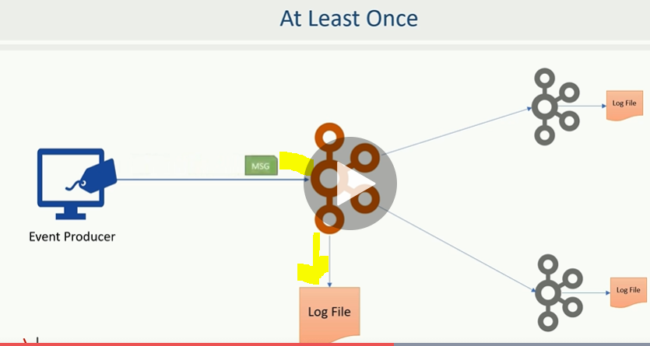

Now let’s assume I/O thread transfer the message to the broker, the broker receives the data and stores it into the partition log. The broker then sends an acknowledgement for the success and let’s assumes response could not reach back to the I/O thread due to network error. In that case the producer I/O thread will wait for the acknowledgment and ultimately send the record to the broker again by assuming a failure. The broker again receives the data but it does not have any mechanism to identify that the message is duplicate of an earlier message. Hence the broker saves the duplicate record and hence causing a duplication problem. **This implementation is known as At Least Once Semantic** where we cannot lose messages because we are retrying until we get a success acknowledgement.However we may have duplicate because we don’t have any method to identify a duplicate message and for that reason Kafka is said to provide at least one Semantic.

**Kafka also allows us to implement at most once Symantec. How?**

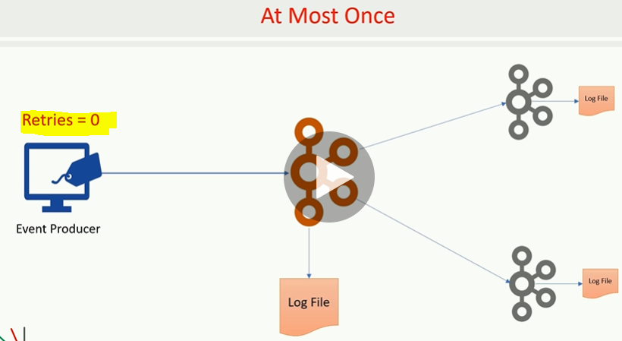

We can achieve at most once by configuring the retries to zero (0) in that case we may lose some records but we will never have a duplicate records committed to Kafka logs.

**41. Exactly Once Semantics- Producer Idempotence**

We already learned Kafka is at least once system by default and we can configure it to get at most once. However some use cases wants to implements exactly once semantics i.e. we don’t want to lose anything and at the same time we don’t want any duplicate record.

How to achieve Exactly Once?

|  |  |
| --- | --- |
|  |  |

To meet exactly once requirement Kafka offers an Idempotence producer configuration, we need to enable Idempotence we need to set [enable.idempotance=true] and Kafka takes care exactly once. Once we configure this changes there are many things internally. But at high level producer API will do two things.

1. It will perform an initial handshake with the leader broker and ask for unique producer id and at the broker side, the broker dynamically assigns a unique Id to each producer.
2. The next thing is Message sequencing: The producer API will start assigning a sequence number to each message. This sequence number starts from zero (0) and monotonically increment per partition. Now as per the second image when the I/O thread sends a message to the leader then the message is uniquely identified by the producer Id and a sequence number.

Now the broker knows the last committed message sequence number is (X) and the next expected message sequence number is (x+1), this allows the broker to identify duplicates as well as missing sequence number. So setting [enable.idempotance=true] will help us to ensure that the messages are neither lost not duplicated. We just need to enable this configuration.

**Note:** We always must remember one thing, if we are sending duplicate messages, at the application level then this configuration cannot protect us from duplicates and that should be considered as bug in the application. Even if two different threads or two producer instances are sending duplicates that is the application design problem. The Idempotence only guarantees for the producer re-tries and we should not try to resend the message at the application level. Idempotence is not guaranteed application level message resends or duplicate send by the application by itself.

**42. Transactions in Kafka Producer**

|  |  |
| --- | --- |
|  |  |

As in the previous discussion we have learned about Idempotence producers. There is another advance producer concept and we call it as Transactional Producer. The transactional producer goes one step ahead of the Idempotence producer and provides the transactional guarantees i.e. an ability to write to several partitions atomically.

The atomicity has the same meaning as in databases i.e. either all messages transactions are committed or none of them are saved. Let’s do hands on for Transactional Producer. Let’s take and existing project hello_producer_starter.

|  |  |
| --- | --- |
|  | In the previous fig we have only one topic. Let’s create another topic. |

So here the first thing that we have done is we have created two topics

topic-create-1.cmd:

***%KAFKA_HOME%*\bin\windows\kafka-topics.bat --create --zookeeper localhost:2181 --topic hello-producer-1 --partitions 5 --replication-factor 3**

Topic-create-2.cmd

***%KAFKA_HOME%*\bin\windows\kafka-topics.bat --create --zookeeper localhost:2181 --topic hello-producer-2 --partitions 5 --replication-factor 3**

Here we are going to do some transaction which will send messages in both the topic. When we will commit the transaction then the message will deliver to both the topic. If we abort or rollback the transaction then message should not be sent to any of these topic and that is what atomicity means.

Transaction implementation requires some mandatory topic level configurations. All topics which are included in a transaction should have mandatory configurations as given below

1. Replication-factor >=3
2. Min-insync-replicas>=2

If we see above topic script then we already have replication-factor 3 but min.insync.replicas is not yet configured. So now the above topic will be like as given below for transaction implementation.

Topic-create-1

***%KAFKA_HOME%*\bin\windows\kafka-topics.bat --create --zookeeper localhost:2181 --topic hello-producer-1 --partitions 5 --replication-factor 3 --config min.insync.replicas=2**

Topic-create-2

***%KAFKA_HOME%*\bin\windows\kafka-topics.bat --create --zookeeper localhost:2181 --topic hello-producer-2 --partitions 5 --replication-factor 3 --config min.insync.replicas=2**

We are now set for topic prospective and now these two topics can participate in transactions.

Second change: AppConfig.java

1. Reduce the number of event so that we can verify with two to three records.
2. Create one more constant for another topic
3. Create one constant for transaction id to config producer.

Note: Setting a transactional id is mandatory for producer is mandatory requirement to implement producer transaction. There are two critical point to remember here.

|  |  |
| --- | --- |
|  |  |

1. When you set the transaction id then producer Idempotence is automatically enabled because transactions are dependent on Idempotence.
2. Second and most important one, transactional_id_config must be unique for each producer instance i.e. we cannot run two instances of a producer with same transactional id and if we do so then one of those transactions will be aborted because two instances with the same transactions are illegal. The primary purpose of transaction id is to rollback the older un-finished transactions for the same transaction id In case of producer application bounces or restarts. Each instance of producer can set its own transaction id. For example two customers performing two transactions in parallel should have two unique transaction ids. It is recommended to keep transaction id outside of the java code, instead we should mention transaction id in kafka.property file.

Let’s implement transaction: Implementing a transaction in producer is a three step process.

Step1- initialize the transaction by calling initTransaction () [producer.initTransactions ();] this method performs the necessary check to ensure that any other transaction initiated by previous instances of the same producer is closed. It means if an application instances dies then the next instance can be guaranteed that any un-finished transaction have been either completed or aborted. It also receives an internal producer id which will be used in all future messages sent by the producer. The producer id is used by the broker to implement Idempotence.

Step2- Wrap all your send API calls within a pair of begin transaction and commit transaction.

|  |
| --- |
| producer.beginTransaction();  **for**(**int** i=0; i<AppConfigs.***numEvents***; i++){  producer.send(**new** ProducerRecord<>(AppConfigs.***topicName***,i, **"Simple Message"**)); } producer.commitTransaction(); |

In case if we receive an exception which we cannot recover then abort the transaction and finally close the transaction.

Note: All messages sent between initTransaction () and commitTransaction () will be the part of single transaction.

Here as per the above code the messages are being sent to only one topic.

|  |
| --- |
| producer.beginTransaction(); **for**(**int** i=0; i<AppConfigs.***numEvents***; i++){  producer.send(**new** ProducerRecord<>(AppConfigs.***topicName-1***,i, **"Simple Message-T1"**));  producer.send(**new** ProducerRecord<>(AppConfigs.***topicName-2***,i, **"Simple Message-T2"**)); } producer.commitTransaction(); |

Step3- Let’s add code for rollback scenario.

Only small change including all above code , instead of using commitTransaction() we will abortTransaction()

|  |
| --- |
| producer.beginTransaction(); **for**(**int** i=0; i<AppConfigs.***numEvents***; i++){  producer.send(**new** ProducerRecord<>(AppConfigs.***topicName-1***,i, **"Simple Message-T1"**));  producer.send(**new** ProducerRecord<>(AppConfigs.***topicName-2***,i, **"Simple Message-T2"**)); } producer.abortTransaction(); |

So the complete code for producer:

|  |
| --- |
| **package** guru.learningjournal.kafka.examples;  **import** org.apache.kafka.clients.producer.KafkaProducer; **import** org.apache.kafka.clients.producer.ProducerConfig; **import** org.apache.kafka.clients.producer.ProducerRecord; **import** org.apache.kafka.common.serialization.IntegerSerializer; **import** org.apache.kafka.common.serialization.StringSerializer; **import** org.apache.logging.log4j.LogManager; **import** org.apache.logging.log4j.Logger;  **import** java.util.Properties;   **public class** HelloProducer { **private static final** Logger ***logger***= LogManager.*getLogger*();  **public static void** main(String[] args) {  ***logger***.info(**"creating Kafka Producer..."**);  *//Step1- Setting Kafka Server configurations in the properties file* Properties prop = **new** Properties();  prop.put(ProducerConfig.***CLIENT_ID_CONFIG***,AppConfigs.***applicationID***);  prop.put(ProducerConfig.***BOOTSTRAP_SERVERS_CONFIG***,AppConfigs.***bootstrapServers***);  prop.put(ProducerConfig.***KEY_SERIALIZER_CLASS_CONFIG***, IntegerSerializer.**class**.getName());  prop.put(ProducerConfig.***VALUE_SERIALIZER_CLASS_CONFIG***, StringSerializer.**class**.getName());  prop.put(ProducerConfig.***TRANSACTIONAL_ID_CONFIG***,AppConfigs.***transaction_id***);  *//prop.put(ProducerConfig.PARTITIONER_CLASS_CONFIG,MyPartitioner.class.getName());   //Step-2 Creating Object of KafkaProducer* KafkaProducer<Integer,String> producer=**new** KafkaProducer<Integer, String>(prop);  producer.initTransactions();  *//Step-3 Send Messages to Kafka Topic* ***logger***.info(**"Start sending messages.."**);  producer.beginTransaction();  **try**{  **for**(**int** i=0; i<AppConfigs.***numEvents***; i++){  producer.send(**new** ProducerRecord<>(AppConfigs.***topicName1***,i, **"Simple Message-T1"**));  producer.send(**new** ProducerRecord<>(AppConfigs.***topicName2***,i, **"Simple Message-T1"**));  }  producer.commitTransaction();  }**catch** (Exception e){  producer.abortTransaction();  producer.close();  **throw new** RuntimeException(e);  }  *//-----------------------------------------------------------------------------------------* ***logger***.info(**"Code for rollback and start second transaction..."**);  **try**{  **for**(**int** i=0; i<AppConfigs.***numEvents***; i++){  producer.send(**new** ProducerRecord<>(AppConfigs.***topicName1***,i, **"Simple Message-T2"**));  producer.send(**new** ProducerRecord<>(AppConfigs.***topicName2***,i, **"Simple Message-T2"**));  }  // Loop will execute and we will get messages, but instead of committing, transaction will be aborted   producer.abortTransaction();  }**catch** (Exception e){  producer.abortTransaction();  producer.close();  **throw new** RuntimeException(e);  }   ***logger***.info(**"Finished closing Kafka Producer..."**);  *//Step-4 Close the producer object* producer.close(); } } |
| **package** guru.learningjournal.kafka.examples;  **class** AppConfigs {  **final static** String ***applicationID*** = **"HelloProducer"**;  **final static** String ***bootstrapServers*** = **"localhost:9092,localhost:9093"**;  **final static** String ***topicName1*** = **"hello-producer-1"**;  **final static** String ***topicName2*** = **"hello-producer-2"**;  **final static** String ***transaction_id***=**"Hello-Producer-Trans"**;  **final static int *numEvents*** = 2; } |

So if init, begin and commit execute properly then we will get four messages from the first transaction only and the messages sent by the second transaction should not be appeared in any of the topic.

Now let’s start the Kafka broker and execute the application

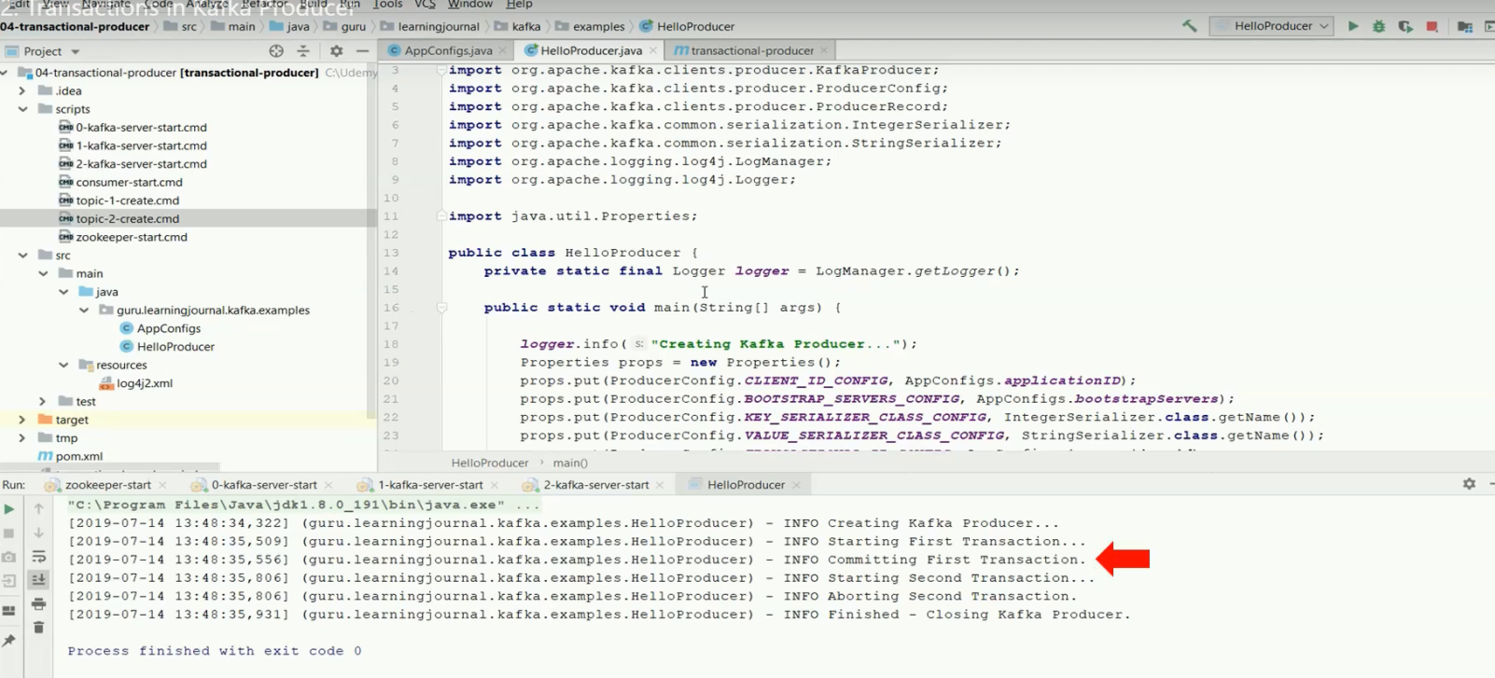

So as per the log first transaction is committed and second transaction is aborted because everything looks good and transaction executed successfully.

Now start console consumer and see the stored messages in the topic.

The previous script for consumer reading data from one topic only:

***%KAFKA_HOME%*\bin\windows\kafka-console-consumer.bat --bootstrap-server localhost:9092 --topic hello-producer-topic --from-beginning**

Now script for consumer reading data from two topics

***%KAFKA_HOME%*\bin\windows\kafka-console-consumer.bat --bootstrap-server localhost:9092**

**--from-beginning --whitelist "hello-producer-1|hello-producer-2"**

The yellow marked mentioning the two topics to be read from the consumer.

Now run the above script having two topics and see the output

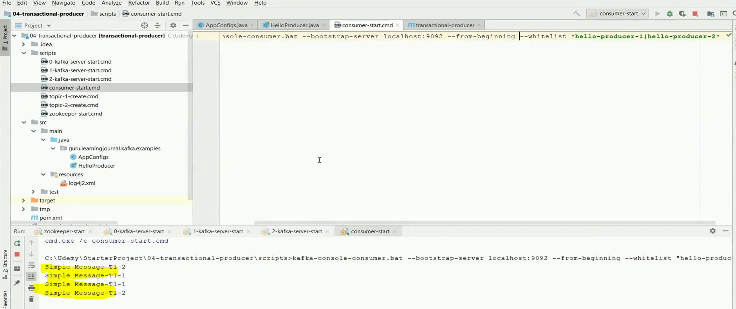

So we have the messages from transaction only in both the topic.

Note: One final note about the transaction : The same producer cannot have multiple open transaction we must either commit or abort the transaction before beginning new transaction. The commit transaction will flush out any unsent records before committing the transaction. If any of the sent call fails with an irrecoverable error i.e. even if not single message deliver to Kafka the commit transaction call will throw the exception and we are suppose to abort whole transaction and that is reasonable because that is what the transaction means, either all or nothing.

In a multithread producer implementation we will call the send API from different thread. However we must call beginTransaction () before starting those threads and either commit or abort when all the threads are complete.

**Section 7: Types and Serialization: 43. Working with Types and Serialization**

We learned how to create Kafka producers and send data to the Kafka cluster. So far we have been sending simple messages but in real life we will not deal with simple string messages. They will be complex java object.

Kafka programming mainly dealing with records in different formats and which brings two questions .

1. How to create java types (POJOs)
2. How to serialize java types (POJOs) for sending them to Kafka

A simple example can manage with 4 to 5 types. However in a real life project the complex data processing requirements can scale up to 100 unique formats. Creating POJOs for message type is a tedious mechanical activity. Can we automate that? Yes.

Yes we can automate using below mechanism.

1. Use schema definition language in message schema
2. Then we need some IDE or tool to generate Java class definition from the schema definition automatically

There are many ways and several tools to achieve this. However we have two alternatives to do this.

1. JSON schema to POJO
2. Avro schema to POJO

We have enough support for both the option.

Note: Generating POJO is just the first half of the problem. The second part of the problem is Serialize and De-serialize the POJOs. As we know every Kafka application would use a bunch of Java complex type object and we must provide Serilizer and De-Serializer for all of them. Creating a Serializer of each kind is a big headache.

Can we develop re-usable Serializer and de-Serializer and apply the same to all of the java type? - Yes we can

There are many object serialization formats but for Kafka application we can suggest two alternatives which are most commonly used formats.

1. JSON Serialization
2. Avro Serialization

Here we will see how we can convert JOSN schema to Java serializable POJO and AVRO schema to serializable java POJO.

**44. Using JSON Schema: Converting JSON Schema to Java Serializable Object:**

Here we will generate JSON schema definition and then will be converting them into Java Serializable Object.

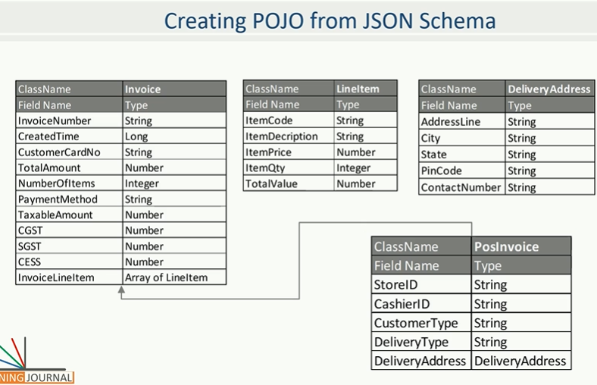

Here we want to model an Invoice event where our invoice is complex java object that contains simple fields as mentioned in the LHS. Here we have an object of Array of LineItem which is defined separately below of this table and contains the fields detail related to Item. Here we also have a separate object for Delivery detail. Finally we want to combine all of these objects to create POS invoice. The POS invoice inherits the Invoice object. So we automatically get all the fields and Array of LineItems from the Invoice object. We have added some additional fields in POS invoice such StoreID, CashierId etc.

Here we will be transmitting POS invoice to Kafka broker. However we have modeled various object separately and also included scenario for extending a class. The example represent java object oriented modeling approach and that is what we wanted to achieve over here .i.e. how we model our event as we model our java classes.

Solution: We will map these into JSON schema definition and then will convert them into serialize java classes.

We are going to use open source project Jsonschema2pojo.

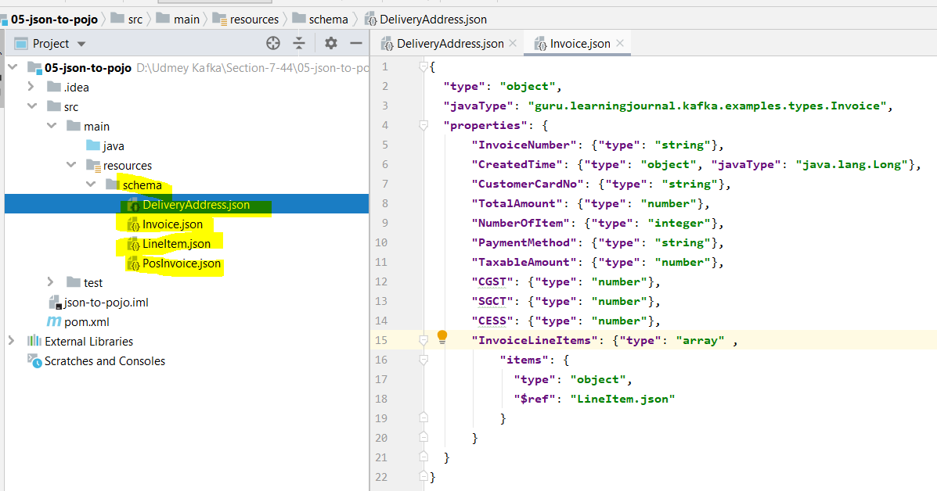

As per the above screen we have created four json file inside schema>resources

Invoice.json

LineItem.json

DeliveryAddress.json

PosInvoice.json

Note: As here we can see that in the Json file,first of all we have defined the Java object and Java package detail as given below.

**"type"**: **"object"**, and then

**"javaType"**: **"guru.learningjournal.kafka.examples.types.Invoice"**, fully qualified name of target java type

These two things are required for every Josn schema definition. After that we have define the fields name and every fields in the target with their data type should be defined inside the **"properties"**: {“FieldName”: {“type”: “string}, .. }

Note will converting this topic after the below topic got covered.

|  |
| --- |
| Invoice.json  {  **"type"**: **"object"**,  **"javaType"**: **"guru.learningjournal.kafka.examples.types.Invoice"**,  **"properties"**: {  **"InvoiceNumber"**: {**"type"**: **"string"**},  **"CreatedTime"**: {**"type"**: **"object"**, **"javaType"**: **"java.lang.Long"**},  **"CustomerCardNo"**: {**"type"**: **"string"**},  **"TotalAmount"**: {**"type"**: **"number"**},  **"NumberOfItem"**: {**"type"**: **"integer"**},  **"PaymentMethod"**: {**"type"**: **"string"**},  **"TaxableAmount"**: {**"type"**: **"number"**},  **"CGST"**: {**"type"**: **"number"**},  **"SGCT"**: {**"type"**: **"number"**},  **"CESS"**: {**"type"**: **"number"**},  **"InvoiceLineItems"**: {**"type"**: **"array"** ,  **"items"**: {  **"type"**: **"object"**,  **"$ref"**: **"LineItem.json"** }  }  } } |
| LineItem.json  {  **"type"**: **"object"**,  **"javaType"**: **"guru.learningjournal.kafka.examples.types.LineItem"**,  **"properties"**: {  **"ItemCode"**: {**"type"**: **"string"**},  **"ItemDescription"**: {**"type"**: **"string"**},  **"ItemPrice"**: {**"type"**: **"number"**},  **"ItemQty"**: {**"type"**: **"integer"**},  **"TotalValue"**: {**"type"**: **"number"**}  } } |
| **PosInvoice.json**  {  **"type"**: **"object"**,  **"javaType"**: **"guru.learningjournal.kafka.examples.types.PosInvoice"**,  **"extends"**: {**"$ref"**: **"Invoice.json"**},  **"properties"**: {  **"StoreID"**: {**"type"**: **"string"**},  **"PosID"**: {**"type"**: **"string"**},  **"CustomerType"**: {**"type"**: **"string"**},  **"DeliveryType"**: {**"type"**: **"string"**},  **"DeliveryAddress"**: {  **"type"**: **"object"**,  **"$ref"**: **"DeliveryAddress.json"** }  } } |
| **DeliveryAddress.json**  {  **"type"**: **"object"**,  **"javaType"**: **"guru.learningjournal.kafka.examples.types.DeliveryAddress"**,  **"properties"**: {  **"AddressLine"**: {**"type"**: **"string"**},  **"City"**: {**"type"**: **"string"**},  **"State"**: {**"type"**: **"string"**},  **"PinCode"**: {**"type"**: **"string"**},  **"ContactNumber"**: {**"type"**: **"string"**}  } } |

So we have defined all the Josn schemas. Now the next thing is to generate java classes from these JSON schemas.

**JSON to Java POJO:** We will use maven plug-in and we need to add plug-in into **POM.xml file.**

|  |
| --- |
| *<?***xml version="1.0" encoding="UTF-8"***?>* <**project xmlns="http://maven.apache.org/POM/4.0.0"  xmlns:xsi="http://www.w3.org/2001/XMLSchema-instance"  xsi:schemaLocation="http://maven.apache.org/POM/4.0.0 http://maven.apache.org/xsd/maven-4.0.0.xsd"**> <**modelVersion**>4.0.0</**modelVersion**>  <**groupId**>guru.learningjournal.kafka.examples</**groupId**> <**artifactId**>json-to-pojo</**artifactId**> <**version**>2.3.0</**version**> <**properties**>  <**java.version**>1.8</**java.version**>  <**project.build.sourceEncoding**>UTF-8</**project.build.sourceEncoding**> </**properties**> <**build**>  <**plugins**>  *<!-- Maven Compiler Plugin-->* <**plugin**>  <**groupId**>org.apache.maven.plugins</**groupId**>  <**artifactId**>maven-compiler-plugin</**artifactId**>  <**version**>3.8.0</**version**>  <**configuration**>  <**source**>${java.version}</**source**>  <**target**>${java.version}</**target**>  </**configuration**>  </**plugin**>  *<!-- Json Schema to POJO plugin-->* <**plugin**>  <**groupId**>org.jsonschema2pojo</**groupId**> <!-- maven plugin coordinate -->  <**artifactId**>jsonschema2pojo-maven-plugin</**artifactId**> <!-- maven plugin coordinate -->  <**version**>0.5.1</**version**>  <**executions**> <!-- Execution detail start. Here we have mentioned source and output -->  <**execution**>  <**goals**>  <**goal**>generate</**goal**>  </**goals**>  <**configuration**>  <**sourceDirectory**>${project.basedir}/src/main/resources/schema/</**sourceDirectory**>  <**outputDirectory**>${project.basedir}/src/main/java/</**outputDirectory**>  <**includeAdditionalProperties**>false</**includeAdditionalProperties**>  <**includeHashcodeAndEquals**>false</**includeHashcodeAndEquals**>  <**generateBuilders**>true</**generateBuilders**>  </**configuration**>  </**execution**>  </**executions**><!-- Execution detail end-->  </**plugin**>  </**plugins**> </**build**> <**dependencies**>  *<!--Apache commons-->* <**dependency**>  <**groupId**>commons-lang</**groupId**>  <**artifactId**>commons-lang</**artifactId**>  <**version**>2.6</**version**>  </**dependency**>  <**dependency**>  <**groupId**>com.fasterxml.jackson.core</**groupId**>  <**artifactId**>jackson-databind</**artifactId**>  <**version**>2.5.4</**version**>  </**dependency**> </**dependencies**> </**project**> |

Now go maven lifecycle and click on compile and run as per the screen shot given below.

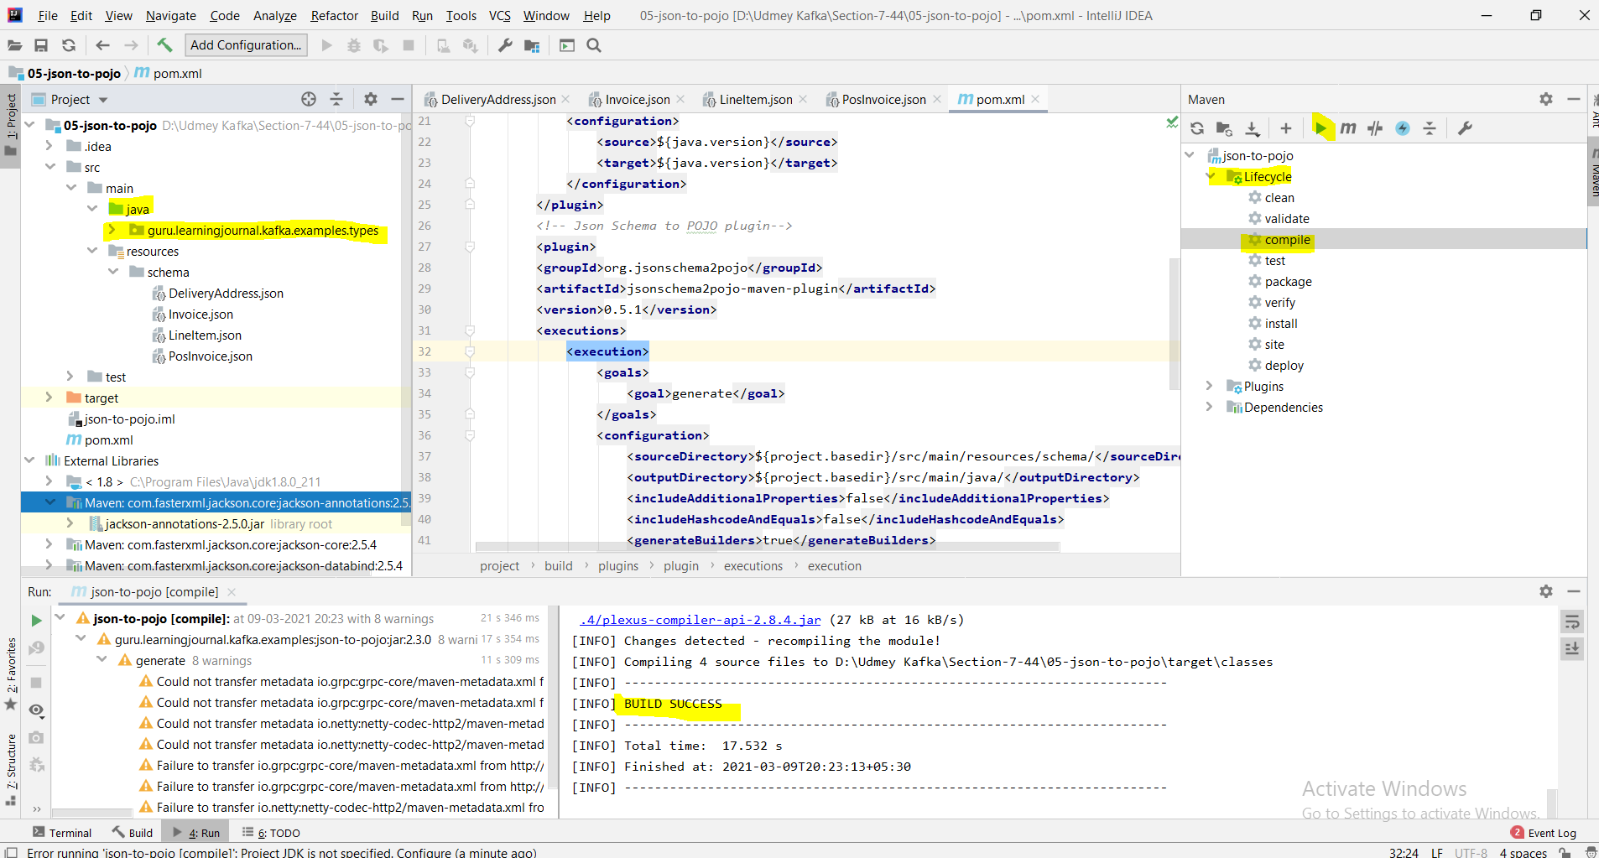

Build success: now let’s check the java package whether java files got generated or not.

So her all the java file got generated as per the screen given below.

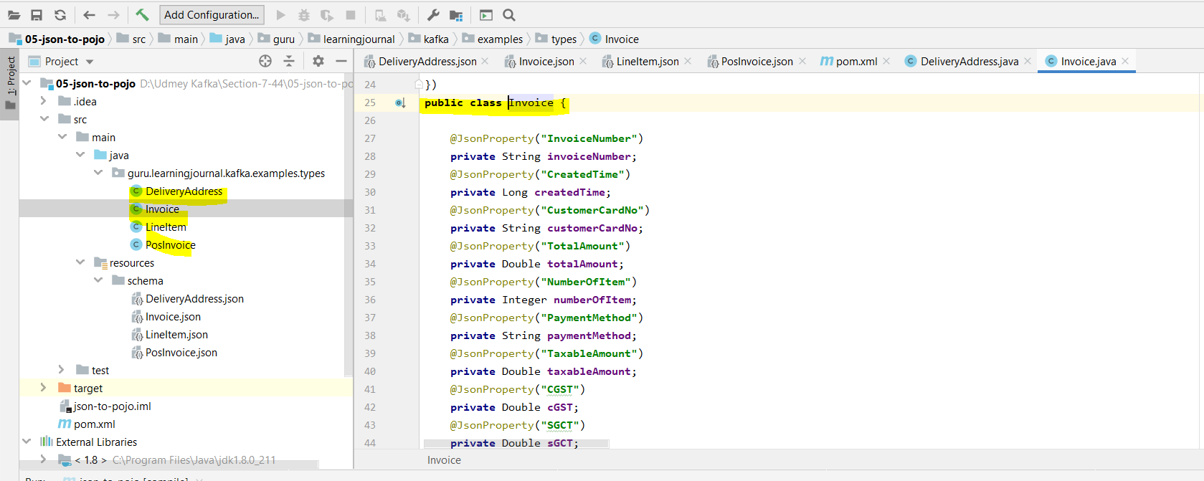

|  |  |
| --- | --- |
| **Invoice.java**  **package** guru.learningjournal.kafka.examples.types;  **import** java.util.ArrayList; **import** java.util.List; **import** com.fasterxml.jackson.annotation.JsonInclude; **import** com.fasterxml.jackson.annotation.JsonProperty; **import** com.fasterxml.jackson.annotation.JsonPropertyOrder; **import** org.apache.commons.lang.builder.ToStringBuilder;  @JsonInclude(JsonInclude.Include.***NON_NULL***) @JsonPropertyOrder({  **"InvoiceNumber"**,  **"CreatedTime"**,  **"CustomerCardNo"**,  **"TotalAmount"**,  **"NumberOfItem"**,  **"PaymentMethod"**,  **"TaxableAmount"**,  **"CGST"**,  **"SGCT"**,  **"CESS"**,  **"InvoiceLineItems"** }) **public class** Invoice {   @JsonProperty(**"InvoiceNumber"**)  **private** String **invoiceNumber**;  @JsonProperty(**"CreatedTime"**)  **private** Long **createdTime**;  @JsonProperty(**"CustomerCardNo"**)  **private** String **customerCardNo**;  @JsonProperty(**"TotalAmount"**)  **private** Double **totalAmount**;  @JsonProperty(**"NumberOfItem"**)  **private** Integer **numberOfItem**;  @JsonProperty(**"PaymentMethod"**)  **private** String **paymentMethod**;  @JsonProperty(**"TaxableAmount"**)  **private** Double **taxableAmount**;  @JsonProperty(**"CGST"**)  **private** Double **cGST**;  @JsonProperty(**"SGCT"**)  **private** Double **sGCT**;  @JsonProperty(**"CESS"**)  **private** Double **cESS**;  @JsonProperty(**"InvoiceLineItems"**)  **private** List<LineItem> **invoiceLineItems** = **new** ArrayList<LineItem>();   @JsonProperty(**"InvoiceNumber"**)  **public** String getInvoiceNumber() {  **return invoiceNumber**;  }   @JsonProperty(**"InvoiceNumber"**)  **public void** setInvoiceNumber(String invoiceNumber) {  **this**.**invoiceNumber** = invoiceNumber;  }   **public** Invoice withInvoiceNumber(String invoiceNumber) {  **this**.**invoiceNumber** = invoiceNumber;  **return this**;  }   @JsonProperty(**"CreatedTime"**)  **public** Long getCreatedTime() {  **return createdTime**;  }   @JsonProperty(**"CreatedTime"**)  **public void** setCreatedTime(Long createdTime) {  **this**.**createdTime** = createdTime;  }   **public** Invoice withCreatedTime(Long createdTime) {  **this**.**createdTime** = createdTime;  **return this**;  }   @JsonProperty(**"CustomerCardNo"**)  **public** String getCustomerCardNo() {  **return customerCardNo**;  }   @JsonProperty(**"CustomerCardNo"**)  **public void** setCustomerCardNo(String customerCardNo) {  **this**.**customerCardNo** = customerCardNo;  }   **public** Invoice withCustomerCardNo(String customerCardNo) {  **this**.**customerCardNo** = customerCardNo;  **return this**;  }   @JsonProperty(**"TotalAmount"**)  **public** Double getTotalAmount() {  **return totalAmount**;  }   @JsonProperty(**"TotalAmount"**)  **public void** setTotalAmount(Double totalAmount) {  **this**.**totalAmount** = totalAmount;  }   **public** Invoice withTotalAmount(Double totalAmount) {  **this**.**totalAmount** = totalAmount;  **return this**;  }   @JsonProperty(**"NumberOfItem"**)  **public** Integer getNumberOfItem() {  **return numberOfItem**;  }   @JsonProperty(**"NumberOfItem"**)  **public void** setNumberOfItem(Integer numberOfItem) {  **this**.**numberOfItem** = numberOfItem;  }   **public** Invoice withNumberOfItem(Integer numberOfItem) {  **this**.**numberOfItem** = numberOfItem;  **return this**;  }   @JsonProperty(**"PaymentMethod"**)  **public** String getPaymentMethod() {  **return paymentMethod**;  }   @JsonProperty(**"PaymentMethod"**)  **public void** setPaymentMethod(String paymentMethod) {  **this**.**paymentMethod** = paymentMethod;  }   **public** Invoice withPaymentMethod(String paymentMethod) {  **this**.**paymentMethod** = paymentMethod;  **return this**;  }   @JsonProperty(**"TaxableAmount"**)  **public** Double getTaxableAmount() {  **return taxableAmount**;  }   @JsonProperty(**"TaxableAmount"**)  **public void** setTaxableAmount(Double taxableAmount) {  **this**.**taxableAmount** = taxableAmount;  }   **public** Invoice withTaxableAmount(Double taxableAmount) {  **this**.**taxableAmount** = taxableAmount;  **return this**;  }   @JsonProperty(**"CGST"**)  **public** Double getCGST() {  **return cGST**;  }   @JsonProperty(**"CGST"**)  **public void** setCGST(Double cGST) {  **this**.**cGST** = cGST;  }   **public** Invoice withCGST(Double cGST) {  **this**.**cGST** = cGST;  **return this**;  }   @JsonProperty(**"SGCT"**)  **public** Double getSGCT() {  **return sGCT**;  }   @JsonProperty(**"SGCT"**)  **public void** setSGCT(Double sGCT) {  **this**.**sGCT** = sGCT;  }   **public** Invoice withSGCT(Double sGCT) {  **this**.**sGCT** = sGCT;  **return this**;  }   @JsonProperty(**"CESS"**)  **public** Double getCESS() {  **return cESS**;  }   @JsonProperty(**"CESS"**)  **public void** setCESS(Double cESS) {  **this**.**cESS** = cESS;  }   **public** Invoice withCESS(Double cESS) {  **this**.**cESS** = cESS;  **return this**;  }   @JsonProperty(**"InvoiceLineItems"**)  **public** List<LineItem> getInvoiceLineItems() {  **return invoiceLineItems**;  }   @JsonProperty(**"InvoiceLineItems"**)  **public void** setInvoiceLineItems(List<LineItem> invoiceLineItems) {  **this**.**invoiceLineItems** = invoiceLineItems;  }   **public** Invoice withInvoiceLineItems(List<LineItem> invoiceLineItems) {  **this**.**invoiceLineItems** = invoiceLineItems;  **return this**;  }   @Override  **public** String toString() {  **return new** ToStringBuilder(**this**).append(**"invoiceNumber"**, **invoiceNumber**).append(**"createdTime"**, **createdTime**).append(**"customerCardNo"**, **customerCardNo**).append(**"totalAmount"**, **totalAmount**).append(**"numberOfItem"**, **numberOfItem**).append(**"paymentMethod"**, **paymentMethod**).append(**"taxableAmount"**, **taxableAmount**).append(**"cGST"**, **cGST**).append(**"sGCT"**, **sGCT**).append(**"cESS"**, **cESS**).append(**"invoiceLineItems"**, **invoiceLineItems**).toString();  }  } | **LineItem.java** **package** guru.learningjournal.kafka.examples.types;  **import** com.fasterxml.jackson.annotation.JsonInclude; **import** com.fasterxml.jackson.annotation.JsonProperty; **import** com.fasterxml.jackson.annotation.JsonPropertyOrder; **import** org.apache.commons.lang.builder.ToStringBuilder;  @JsonInclude(JsonInclude.Include.***NON_NULL***) @JsonPropertyOrder({  **"ItemCode"**,  **"ItemDescription"**,  **"ItemPrice"**,  **"ItemQty"**,  **"TotalValue"** }) **public class** LineItem {   @JsonProperty(**"ItemCode"**)  **private** String **itemCode**;  @JsonProperty(**"ItemDescription"**)  **private** String **itemDescription**;  @JsonProperty(**"ItemPrice"**)  **private** Double **itemPrice**;  @JsonProperty(**"ItemQty"**)  **private** Integer **itemQty**;  @JsonProperty(**"TotalValue"**)  **private** Double **totalValue**;   @JsonProperty(**"ItemCode"**)  **public** String getItemCode() {  **return itemCode**;  }   @JsonProperty(**"ItemCode"**)  **public void** setItemCode(String itemCode) {  **this**.**itemCode** = itemCode;  }   **public** LineItem withItemCode(String itemCode) {  **this**.**itemCode** = itemCode;  **return this**;  }   @JsonProperty(**"ItemDescription"**)  **public** String getItemDescription() {  **return itemDescription**;  }   @JsonProperty(**"ItemDescription"**)  **public void** setItemDescription(String itemDescription) {  **this**.**itemDescription** = itemDescription;  }   **public** LineItem withItemDescription(String itemDescription) {  **this**.**itemDescription** = itemDescription;  **return this**;  }   @JsonProperty(**"ItemPrice"**)  **public** Double getItemPrice() {  **return itemPrice**;  }   @JsonProperty(**"ItemPrice"**)  **public void** setItemPrice(Double itemPrice) {  **this**.**itemPrice** = itemPrice;  }   **public** LineItem withItemPrice(Double itemPrice) {  **this**.**itemPrice** = itemPrice;  **return this**;  }   @JsonProperty(**"ItemQty"**)  **public** Integer getItemQty() {  **return itemQty**;  }  @JsonProperty(**"ItemQty"**)  **public void** setItemQty(Integer itemQty) {  **this**.**itemQty** = itemQty;  }  **public** LineItem withItemQty(Integer itemQty) {  **this**.**itemQty** = itemQty;  **return this**;  }   @JsonProperty(**"TotalValue"**)  **public** Double getTotalValue() {  **return totalValue**;  }   @JsonProperty(**"TotalValue"**)  **public void** setTotalValue(Double totalValue) {  **this**.**totalValue** = totalValue;  }   **public** LineItem withTotalValue(Double totalValue) {  **this**.**totalValue** = totalValue;  **return this**;  }   @Override  **public** String toString() {  **return new** ToStringBuilder(**this**).append(**"itemCode"**, **itemCode**).append(**"itemDescription"**, **itemDescription**).append(**"itemPrice"**, **itemPrice**).append(**"itemQty"**, **itemQty**).append(**"totalValue"**, **totalValue**).toString();  }  }  **DeliveryAddress.java**  **package** guru.learningjournal.kafka.examples.types;  **import** com.fasterxml.jackson.annotation.JsonInclude; **import** com.fasterxml.jackson.annotation.JsonProperty; **import** com.fasterxml.jackson.annotation.JsonPropertyOrder; **import** org.apache.commons.lang.builder.ToStringBuilder;  @JsonInclude(JsonInclude.Include.***NON_NULL***) @JsonPropertyOrder({  **"AddressLine"**,  **"City"**,  **"State"**,  **"PinCode"**,  **"ContactNumber"** }) **public class** DeliveryAddress {   @JsonProperty(**"AddressLine"**)  **private** String **addressLine**;  @JsonProperty(**"City"**)  **private** String **city**;  @JsonProperty(**"State"**)  **private** String **state**;  @JsonProperty(**"PinCode"**)  **private** String **pinCode**;  @JsonProperty(**"ContactNumber"**)  **private** String **contactNumber**;   @JsonProperty(**"AddressLine"**)  **public** String getAddressLine() {  **return addressLine**;  }   @JsonProperty(**"AddressLine"**)  **public void** setAddressLine(String addressLine) {  **this**.**addressLine** = addressLine;  }   **public** DeliveryAddress withAddressLine(String addressLine) {  **this**.**addressLine** = addressLine;  **return this**;  }   @JsonProperty(**"City"**)  **public** String getCity() {  **return city**;  }   @JsonProperty(**"City"**)  **public void** setCity(String city) {  **this**.**city** = city;  }   **public** DeliveryAddress withCity(String city) {  **this**.**city** = city;  **return this**;  }   @JsonProperty(**"State"**)  **public** String getState() {  **return state**;  }   @JsonProperty(**"State"**)  **public void** setState(String state) {  **this**.**state** = state;  }   **public** DeliveryAddress withState(String state) {  **this**.**state** = state;  **return this**;  }   @JsonProperty(**"PinCode"**)  **public** String getPinCode() {  **return pinCode**;  }   @JsonProperty(**"PinCode"**)  **public void** setPinCode(String pinCode) {  **this**.**pinCode** = pinCode;  }   **public** DeliveryAddress withPinCode(String pinCode) {  **this**.**pinCode** = pinCode;  **return this**;  }   @JsonProperty(**"ContactNumber"**)  **public** String getContactNumber() {  **return contactNumber**;  }   @JsonProperty(**"ContactNumber"**)  **public void** setContactNumber(String contactNumber) {  **this**.**contactNumber** = contactNumber;  }   **public** DeliveryAddress withContactNumber(String contactNumber) {  **this**.**contactNumber** = contactNumber;  **return this**;  }   @Override  **public** String toString() {  **return new** ToStringBuilder(**this**).append(**"addressLine"**, **addressLine**).append(**"city"**, **city**).append(**"state"**, **state**).append(**"pinCode"**, **pinCode**).append(**"contactNumber"**, **contactNumber**).toString();  } } |
| **PosInvoice.java** **package** guru.learningjournal.kafka.examples.types;  **import** java.util.List; **import** com.fasterxml.jackson.annotation.JsonInclude; **import** com.fasterxml.jackson.annotation.JsonProperty; **import** com.fasterxml.jackson.annotation.JsonPropertyOrder; **import** org.apache.commons.lang.builder.ToStringBuilder;  @JsonInclude(JsonInclude.Include.***NON_NULL***) @JsonPropertyOrder({  **"StoreID"**,  **"PosID"**,  **"CustomerType"**,  **"DeliveryType"**,  **"DeliveryAddress"** }) **public class** PosInvoice **extends** Invoice {   @JsonProperty(**"StoreID"**)  **private** String **storeID**;  @JsonProperty(**"PosID"**)  **private** String **posID**;  @JsonProperty(**"CustomerType"**)  **private** String **customerType**;  @JsonProperty(**"DeliveryType"**)  **private** String **deliveryType**;  @JsonProperty(**"DeliveryAddress"**)  **private** DeliveryAddress **deliveryAddress**;   @JsonProperty(**"StoreID"**)  **public** String getStoreID() {  **return storeID**;  }   @JsonProperty(**"StoreID"**)  **public void** setStoreID(String storeID) {  **this**.**storeID** = storeID;  }   **public** PosInvoice withStoreID(String storeID) {  **this**.**storeID** = storeID;  **return this**;  }   @JsonProperty(**"PosID"**)  **public** String getPosID() {  **return posID**;  }   @JsonProperty(**"PosID"**)  **public void** setPosID(String posID) {  **this**.**posID** = posID;  }   **public** PosInvoice withPosID(String posID) {  **this**.**posID** = posID;  **return this**;  }   @JsonProperty(**"CustomerType"**)  **public** String getCustomerType() {  **return customerType**;  }   @JsonProperty(**"CustomerType"**)  **public void** setCustomerType(String customerType) {  **this**.**customerType** = customerType;  }   **public** PosInvoice withCustomerType(String customerType) {  **this**.**customerType** = customerType;  **return this**;  }   @JsonProperty(**"DeliveryType"**)  **public** String getDeliveryType() {  **return deliveryType**;  }   @JsonProperty(**"DeliveryType"**)  **public void** setDeliveryType(String deliveryType) {  **this**.**deliveryType** = deliveryType;  }   **public** PosInvoice withDeliveryType(String deliveryType) {  **this**.**deliveryType** = deliveryType;  **return this**;  }   @JsonProperty(**"DeliveryAddress"**)  **public** DeliveryAddress getDeliveryAddress() {  **return deliveryAddress**;  }   @JsonProperty(**"DeliveryAddress"**) | **public void** setDeliveryAddress(DeliveryAddress deliveryAddress) {  **this**.**deliveryAddress** = deliveryAddress;  }   **public** PosInvoice withDeliveryAddress(DeliveryAddress deliveryAddress) {  **this**.**deliveryAddress** = deliveryAddress;  **return this**;  }   @Override  **public** PosInvoice withInvoiceNumber(String invoiceNumber) {  **super**.withInvoiceNumber(invoiceNumber);  **return this**;  }   @Override  **public** PosInvoice withCreatedTime(Long createdTime) {  **super**.withCreatedTime(createdTime);  **return this**;  }   @Override  **public** PosInvoice withCustomerCardNo(String customerCardNo) {  **super**.withCustomerCardNo(customerCardNo);  **return this**;  }   @Override  **public** PosInvoice withTotalAmount(Double totalAmount) {  **super**.withTotalAmount(totalAmount);  **return this**;  }   @Override  **public** PosInvoice withNumberOfItem(Integer numberOfItem) {  **super**.withNumberOfItem(numberOfItem);  **return this**;  }   @Override  **public** PosInvoice withPaymentMethod(String paymentMethod) {  **super**.withPaymentMethod(paymentMethod);  **return this**;  }   @Override  **public** PosInvoice withTaxableAmount(Double taxableAmount) {  **super**.withTaxableAmount(taxableAmount);  **return this**;  }   @Override  **public** PosInvoice withCGST(Double cGST) {  **super**.withCGST(cGST);  **return this**;  }   @Override  **public** PosInvoice withSGCT(Double sGCT) {  **super**.withSGCT(sGCT);  **return this**;  }   @Override  **public** PosInvoice withCESS(Double cESS) {  **super**.withCESS(cESS);  **return this**;  }   @Override  **public** PosInvoice withInvoiceLineItems(List<LineItem> invoiceLineItems) {  **super**.withInvoiceLineItems(invoiceLineItems);  **return this**;  }   @Override  **public** String toString() {  **return new** ToStringBuilder(**this**).appendSuper(**super**.toString()).append(**"storeID"**, **storeID**).append(**"posID"**, **posID**).append(**"customerType"**, **customerType**).append(**"deliveryType"**, **deliveryType**).append(**"deliveryAddress"**, **deliveryAddress**).toString();  }  } |

So finally we have converted JSON to Pojo and these POJO comes with Jackson annotations and these annotations make these classes serializable using the JSON serializable and de-serializable which we have included in the example later.

|  |  |
| --- | --- |
|  | Now we have learned to generate pPojos from Josn schema. |

**46. POS Simulator using JSON Serialized Invoices**

Here we are going to create Point Of Sale simulator.

|  |  |
| --- | --- |
|  | The POS simulator is a producer which generates an infinite number of random but realistic invoices and sends it to the Kafka broker. The simulator takes three arguments from the command line.  **Topic Name:** It tells which topic the producer will send the invoices  **Number of Producer Thread:** It says how many parallel threads we want to create for this application.  **Producer Speed:** It tells the number of milliseconds that each thread will wait between two invoices. So if we are creating 10 threads giving a 100 milliseconds sleep time then it means each thread will send 10 messages in one second and since we have 10 threads then it will generate 100 messages per second. |

The only thing that we are not configuring is the size of each message otherwise this application could be an excellent tool for generating specific workload on our Kafka cluster and perform some load testing and monitoring. However this application wound not generate random text string but it will generate Json formatted realistic invoices.

**Section 9: Kafka Consumers: 48. Introducing Kafka Consumers**

So far we have learned a lot of bringing data into Kafka and we have learned almost every aspect of Kafka producer and created a bunch of Kafka producer. Kafka producer is very important part of any streaming application because these producer are responsible for originating data stream and brining them into Kafka cluster. Once the stream start flowing into Kafka, we are ready to consume these streams and plug-in our stream processing applications.

|  |  |
| --- | --- |
|  |  |
|  | |

How to process Kafka stream?

There are many ways to process Kafka streams. As per the above diagram Kafka offers three tools for that purpose.

1. **Consumer API:** Can be used to consume data from Kafka brokers, here we will have to create our own stream processing application, which we are going to learn into this section.
2. **Streams API:** Beyond to Basic course
3. **KSQL:** Beyond to Basic course

**49. Creating Kafka Consumer - Transform -Produce Pipeline**

**Here we will do some hands-on about Kafka Consumer API. How to create Kafka Consumer?**

**Same as earlier let’s take a problem solution approach to learn Kafka consumer.**

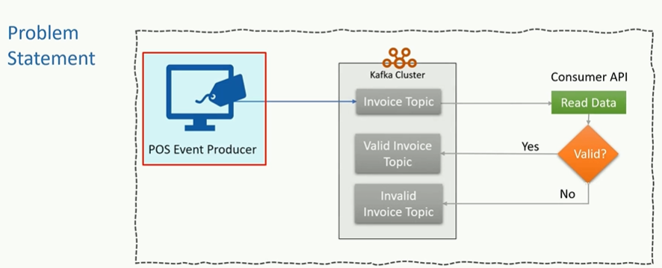

**In the earlier lecture we created a POS simulater applications which generate a series of invoices and sends them to Kafka topic. Now in this example we want to implement a miniatucher form of real time data validation service for invoices. Here we want to read all invoices in real time, will apply some business rules to validate the invoice if the validation passed (yes) then send them to Kafka topic “Valid Invoice Topic” If the validation fails, then send them to Kafka topic “Invalid Invoice Topic”. As a result we will be able to segregate valid and invalid invoices into two different topics. However the above structure will look like as below .**

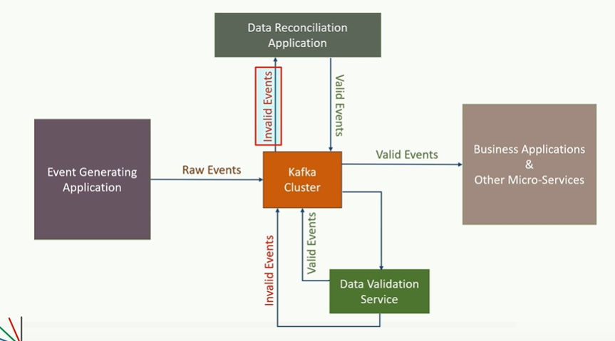

**In this figure all valid records are consumed by a Reconciliation application where the invoices are worked upon to rectify the issues and send them in the pool of valid records. All the correct valid records are consumed by other business application & other-micro-services to achieve some business objectives.**

**Let’s build real time data validation service. The first thing that we need is business rule to define an invalid invoice.**

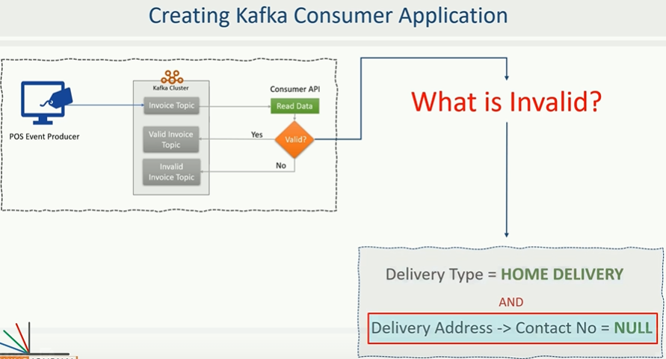

**For our purpose let’s define a rule. An invoice is considered is invalid if it is marked for home delivery but the contact number for home delivery is missing.**

**Project need to be added here!**

Let’s create a consumer class. Creating a Kafka consumer is a four step process and it is very similar to create a Kafka producer.

**Step1-** Create a Java.util.properties and set required Kafka consumer configurations. Same as producer APIs, Kafka consumer API is also highly configurable and we customize the behavior by setting the config parameters.

1. The first setting is the client Id config,
2. The second is the Bootstrap Servers Config,
3. And other two are key and value de-Serializer.

**Note:** The Kafka producer transmit a message after serializing them to raw bytes, and now at the consumer side we must de-serialize the records to an appropriate object. Since the example is intending to read the messages sent by the POS simulator and the POS simulator have used JSON Serializer, hence the corresponding consumer must be using a JsonDeserializer.

1. The next configuration is value_class_name_config which is target java de-serialized class name whose messages we want to de-serialized (PosInvoice.class)
2. Few more configuration like Group_Id_Config & Auto_Offset_Reset_Config is for Kafka Consumer Group & Kafka Offset and Consumer Position.

**Step2-** Create an instance of **KafkaConsumer** & Pass the properties configuration in the above created instance that we have set in step1[ **KafkaConsumer<String, PosInvoice> consumer = new KafkaConsumer<String, PosInvoice>(supplyConfiguration);** ]

**Step3-** Subscript to the topic using **KafkaConsumer class object created in step 2 [Consumer.subscribe(Arrays.asList(TopicName)].**

**A Kafka consumer can subscribe to a list of topic but here we have only one topic to be subscribed.**

**Step4-** Read the messages in a loop. Mostly this loop would be infinite loop, because we are expected to keep reading the records and process them in real time for life of the application, this thing should never stop. After subscribing the topic the consumer can start requesting the message records by making a call to **poll (Duration.ofMillis (1000)** method. The poll method will immediately return an iterable consumer records. If there are no records at the broker then it will wait for the timeout passed in the poll method, when the timeout expires then an empty consumer record will be returned.

**Example to be mentioned:**

**Section-9-50.Kafka Consumer Group and Scalability**

**In the earlier discussion we created a real time data validation pipeline. As per the first figure there Consumer API reads messages from Kafka topic, runs some validation and writes valid and invalid messages in a separate Kafka topic. Instead of writing them into Kafka topic we can write them into data base**

|  |  |
| --- | --- |
| **Here we are writing valid and In-valid invoices into Kafka topic** | **Here we are writing valid and In-valid invoices into data base instead of Kafka topic.** |

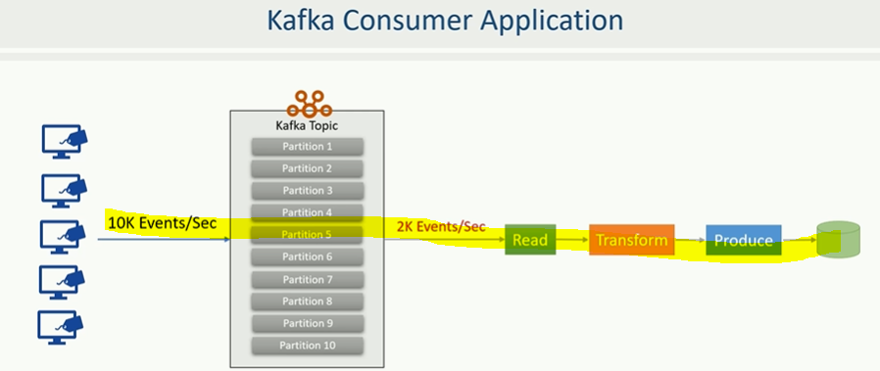

**As per the above diagram in all such consumed (read), transformed, and producer pipelines our application will create a Kafka consumer object, subscribe to the appropriate topic and start receiving messages, transforming them and start writing. This process should be seamless. However our application will begin falling behind if the rate at which the producer write messages to the topic exceeds the rate at which we can transform and write them to the external storage.**

**If we are limited to single consumer then in reading and processing the data our application may fall farther behind and would no longer real time application. In this scenario we need to scale consumption from Kafka topics. But how?**

**How to scale Kafka Consumer process?**

**We can scale up the consumer by dividing the work on the multiple consumers. Just like multiple producers which can write to the same topic in the same we need to allow various consumers to read from the same Kafka topic. However we also need mechanism to split the data among the consumers so that they work with their own set of data and do not interfere with each other. But how we can do that?**

**This is where the partition topic are handy, when we have multiple consumers working in a group and reading data from same topic then we can easily split the data among consumers by assigning them to one or more partitions.**

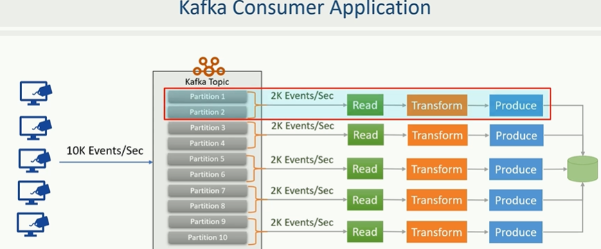

**In the above figure arrangement each consumer is attached with the set of two partitions and they read data only from the assigned partitions.**

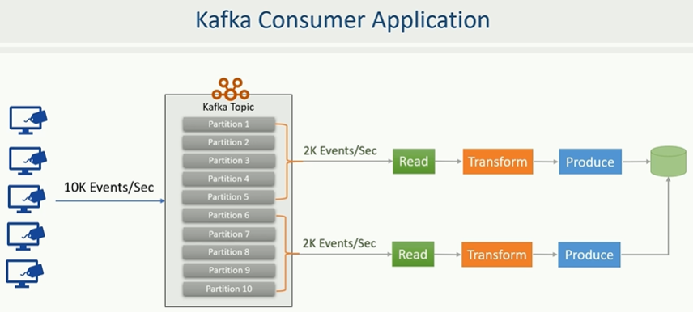

**For example if we have 10 partitions in the topic and there are two consumer in the same consumer group reading data from the same topic then Kafka would assign 5 topic partitions to each consumer. This arrangement clearly divides the data among consumer to ensure that they do not read the same message. In this arrangement every record is delivered to one and only consumer in the group and there is no duplicate processing of data. This arrangement also adds restriction on scalability that would be equal to number of partitions in a given topic.**

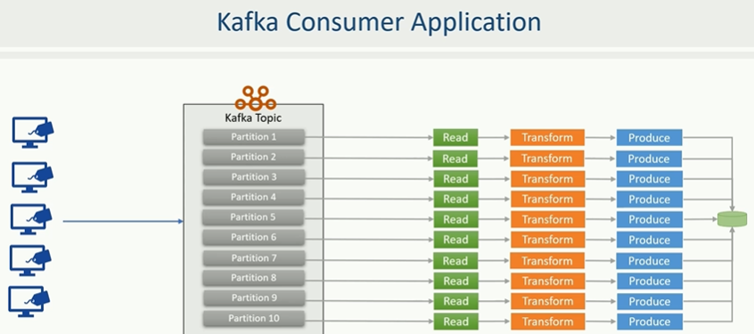

**For example if we have 10 partitions in the topic then we can add maximum of 10 consumers in the group, each assigned with the single partition to read. However these limitations can be avoided by carefully planning and creating enough number of partitions when we create a new Kafka topic.**

**Now the question comes, how we can create a consumer group and add new consumer in the same group? Do we also need to do something for assigning to the partition?**

**Kafka offers automatic group management and re-balancing the workload in a consumer group. We just need to set the group id configurations. Kafka automatically forms a consumer group and it would also add consumer to the same group if they have the same group ID. Kafka will also take care of assigning partition to the consumer in the same group. Membership in a consumer group is maintained dynamically.**

|  |  |
| --- | --- |
|  |  |

**If a consumer fails (fig-1) then the partition assigned to it will be reassigned to other consumer in the other group (fig-2).**

**Similarly if new consumer joins the group the partition will be moved existing consumer to the new one to maintain the workload balance.**

**Conceptually we can think of a consumer group as being a single logical consumer that happens to be made up of multiple processes sharing the workload. Kafka automatically manages all of this and the whole process is transparent to users.**

**We as a programmer is responsible for setting the group id configuration and starting a new consumer process either on the same machine on or a separate computer.**

**51. Consumer Positions - Current Offset Vs. Committed Offset**

**So the problem of scalability of the consumers is taken care by consumer group. The issue of fault tolerance is also taken care by the re-balancing within the consumer group. However we still have one open question.**

**Let’s assume that partition was initially assigned to a consumer, the consumer processed some messages for a while and crashed. Kafka automatically re-balancing by detecting the failure of the consumer and re-assign the un-attended partition to some other consumer in the group. This is where we got a new doubt. The new consumer should not re-process the event which is already processed by the earlier consumer before it crashed. So how would Kafka handle this?**

**What is consumer current position?**

|  |  |
| --- | --- |
|  |  |

**We already learned in the earlier discussions that an offset uniquely identifies every message in a partition. Kafka also maintains two offset positions for each partition. Current offset position & Committed Offset position. These positions are maintained for the consumer. The current offset position of the consumer is the offset of the next record that will be given out to the consumer for the next poll. In the beginning the current offset might be unknown or null for a new consumer subscription, in that case we can set the auto-offset-reset configuration to the earliest or latest. If we set to earliest then Kafka will set the current offset position to the first record in the partition and start giving us all the messages from the beginning otherwise the default value is the latest which will send us only upcoming messages after the consumer subscribed and ignore all earlier messages. This all happens only in the beginning when the current offset as well as the committed offset is undefined. Once the initial current offset is determined it automatically advanced every time we poll some messages.**

|  |  |
| --- | --- |
|  |  |

**The current offset is persisted to the consumer’s sessions. If the consumer fails or restarts then the current offset is determined once again. For that reason if we restart the consumer after a failure then we may start getting the records once again that where already sent in the earlier session. To avoid that situations Kafka also maintains a committed offset position.**

|  |  |
| --- | --- |
|  |  |

**Every time we poll then the consumer will automatically commit the earlier current offset and sends some more records, these new records are then automatically committed by the next poll. This mechanism is known as auto commit. The committed offset position is the last offset which has been stored securely at the broker.**

|  |  |
| --- | --- |
|  |  |

So when the consumer process fails or restarts or partition is re-assigned to some other consumer in the group then the committed offset is used to overwrite the current offset position for the consumer.

So in summary, the committed offset is securely stored with the broker, when the consumer restarts or the partition is re-assigned to another consumer then the committed offset is used to avoid duplicate processing and all this happens automatically in most of the cases but we have option to take control in our hand and do it manually using commit API.

The current offset is determine as latest or earliest only when there is no committed offset otherwise the committed offset is used to set the current offset.

**52. Challenges with Kafka Consumers?**

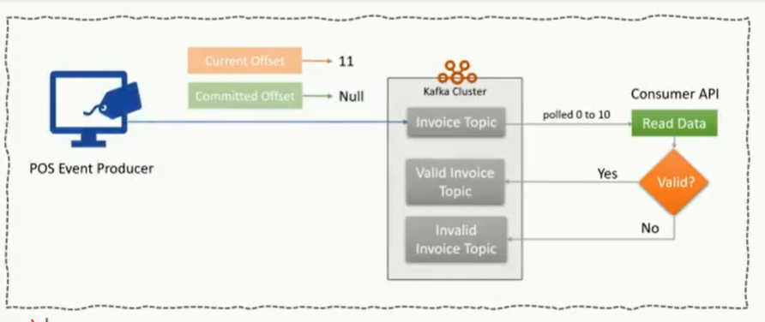

Let’s look at the scenario that we have implemented in our earlier example, here we have a consumer, we poll some messages from topic, segregate them into valid and invalid and send them into their respective topics. Now let’s assume before we poll again for more messages the consumer gets crashed as shown below in the image. What will happen now?

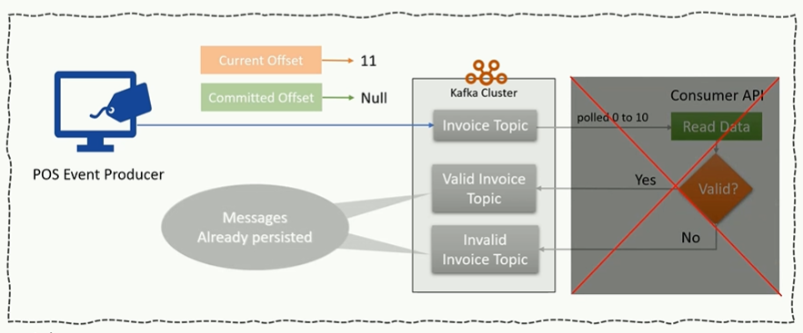

The committed offset at the broker is still null. Why?

Because the committed offset gets updated when we poll again and on that time broker assumes that we successfully processed the earlier messages and hence those messages should be committed to avoid resend and duplicate. But here in our case we already processed but consumer got crashed before polling next messages to let the broker know that we have successfully process the messages. This situation is going to created duplicate for sure. How do we handle this gotcha?

Answer: We learned about implementation Kafka transactions, so we can execute transaction to handle this scenario. However that requires extra custom coding & testing.

Similarly let’s assume another scenario where instead of performing only validation we wanted to compute total sales by store Id. How do we do it?

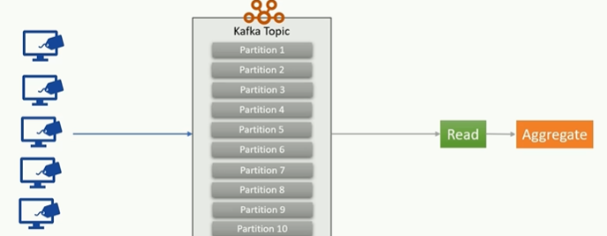

At first sight it looks simple read the store Id and total sale value from the invoice. Insert it into Key-Value map, where the key is the store id and the value is the total sales. For the next invoice do the same, but this time sum it with the previous amount. It looks very simple but what about fault tolerance, what if our application crashed; we will lose the in-memory map. So to solve this we need to save these map somewhere may be in our local disk , but what if disk itself get fail. Ok, in that case we can maintain database into remote database.

|  |  |
| --- | --- |
|  |  |

It looks safe. But we have to write lot of custom code again and extend our transaction up to the remote database to avoid duplicate processing. We also need handle database concurrency, performance and additional network latency. Now thing about computing store wise total sale in 5 minute window i.e. adding one more dimension – time in whatever we are computing

|  |  |
| --- | --- |
|  |  |

Similarly thing about topic joining in real time i.e. two consumer reading two different topic and then join these two topic and perform some computations.

So all that can be done but these are not that kind of easy work. We will have to write lot of complex code and increasing the cost and complexity of our application.

The point is straight forward, basic features and facilities for creating real time stream processing application are missing from the Kafka consumer API and that is where Kafka Streams API comes into picture and help to model and helps us in most of the stream processing requirements easily.

